Unit 3 Lesson 23: Use a Ten to Subtract

WU Number Talk: Subtract to Make 10 (Warm up)

Student Task Statement
Find the value of each expression mentally.
- $17−7$
- $17−7−1$
- $17−8$
- $17−9$

1 Number Card Subtraction with 10-frames

Student Task Statement
- Choose a teen number card.
- Build the number on 10-frames.
- Choose a number card to subtract.
- Find the difference.
- Write an equation.
My equations:
Pick your favorite equation.
Show how you found the value of the difference using drawings, numbers, or words.

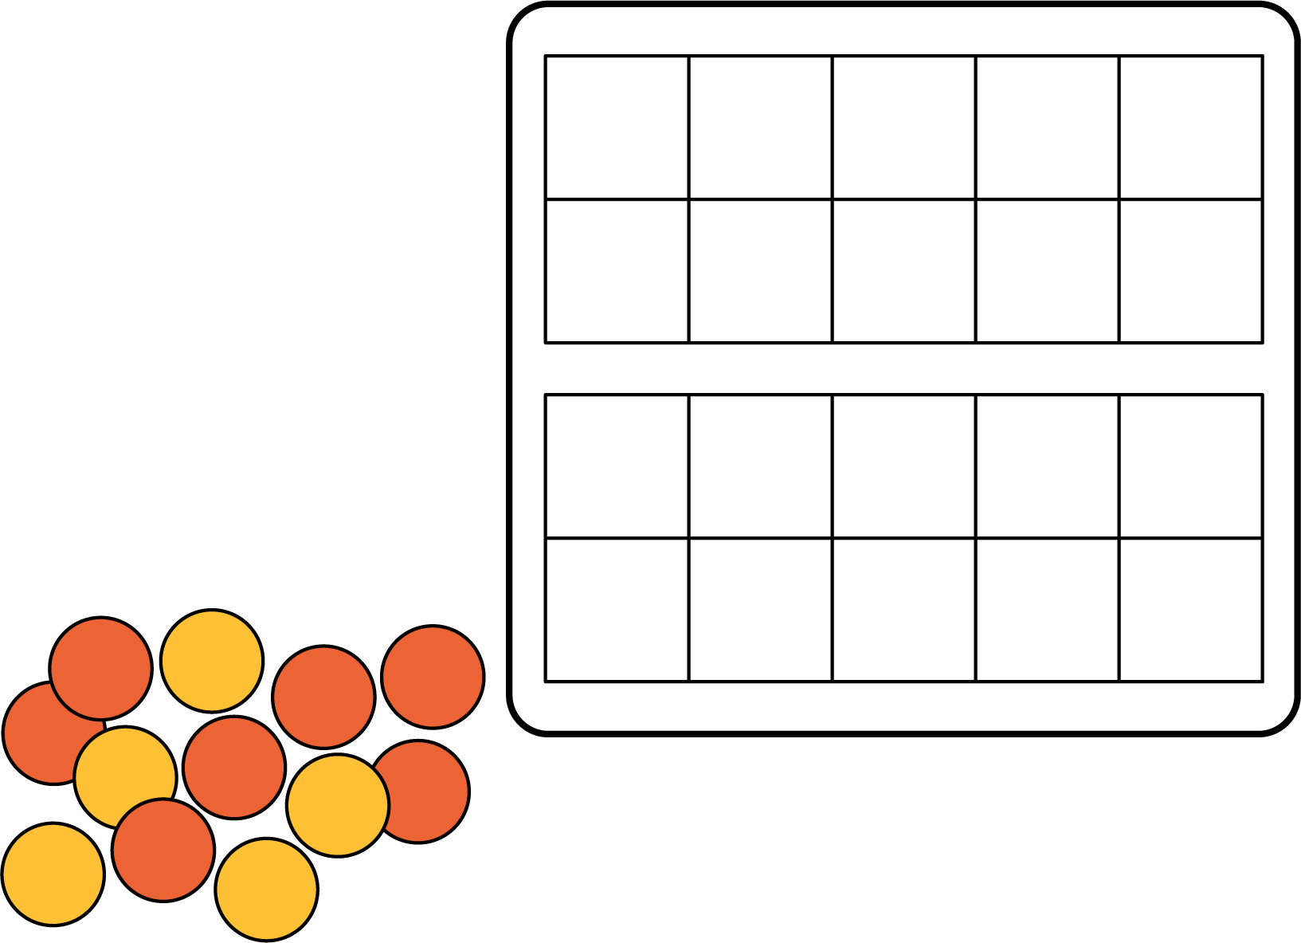

2 Diego and Andre Find the Difference

Student Task Statement
Diego is playing Number Card Subtraction.
He started with 15 and then picked an 8.
He started out by doing this:
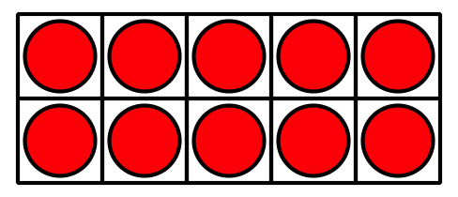
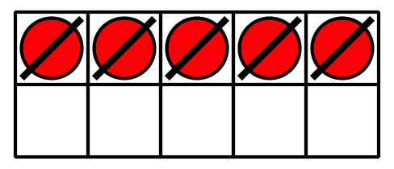
What could Diego do next to find the difference?
Andre was also finding the value of $15−8$.
He started out by doing this:
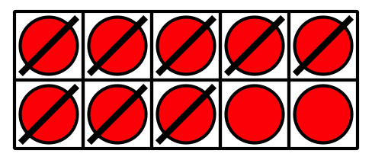
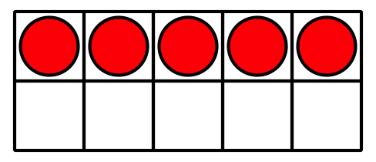
What could Andre do next to find the difference?
Find the value of each difference using Diego’s way or Andre’s way.
- $14−5$
Show your thinking using drawings, numbers, or words.
- $13−6$
Show your thinking using drawings, numbers, or words.
© CC BY 2021 Illustrative Mathematics®

