Unit 2 Lesson 12: Story Problems and Diagrams

WU Notice and Wonder: Mancala (Warm up)

Student Task Statement
What do you notice? What do you wonder?
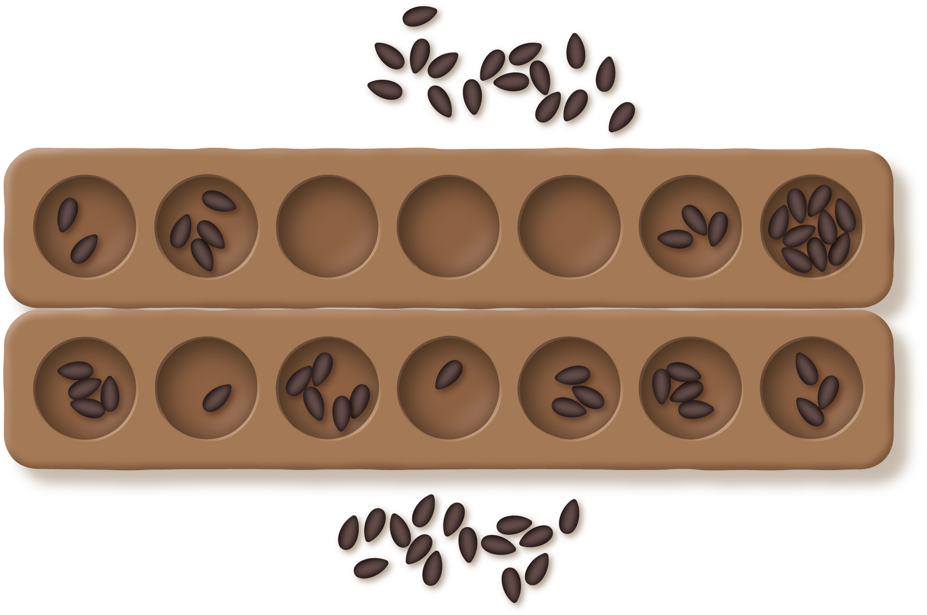

1 Interpret the Diagram

Student Task Statement
Circle the diagrams that match each story. Then explain your match to your partner.
- Clare captured 54 seeds. Han captured 16 fewer seeds than Clare. How many seeds did Han capture?
- 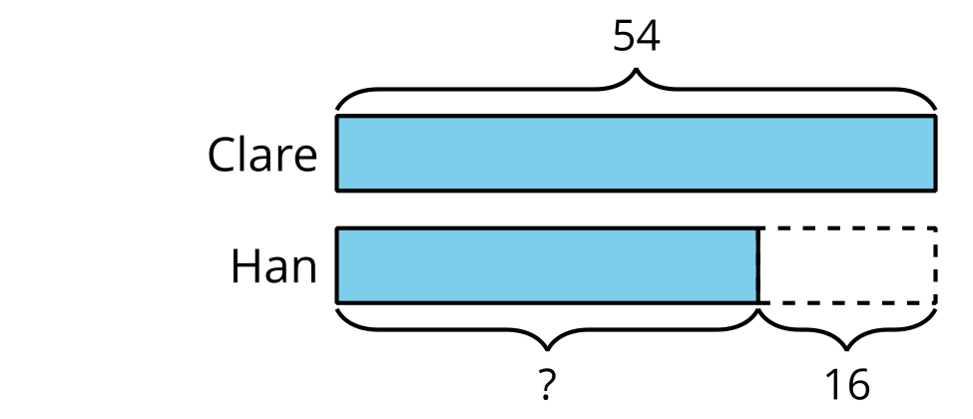
- 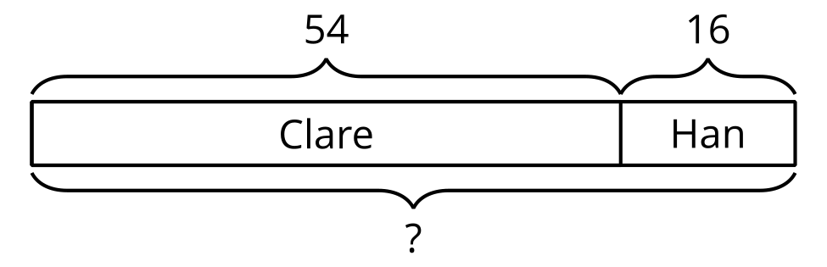
- 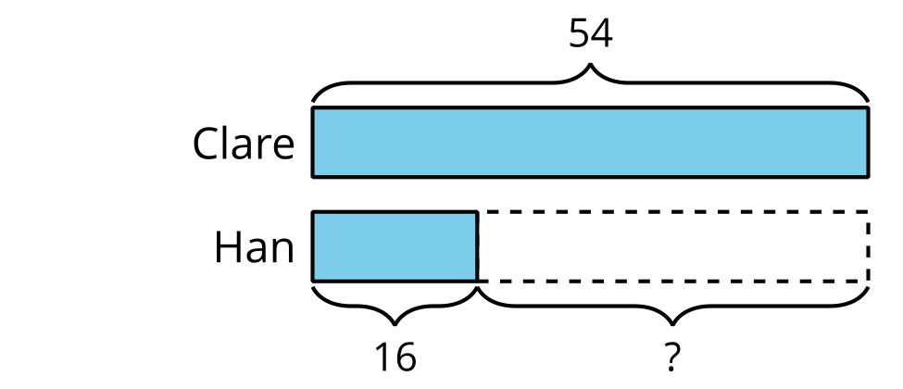
- Clare has 54 seeds on her side of the board. Han has 16 seeds on his side. How many seeds are on the board in all?
- Clare has 54 seeds. 16 seeds are in her hand. The rest of her seeds are on the game board. How many of her seeds are on the game board?
- 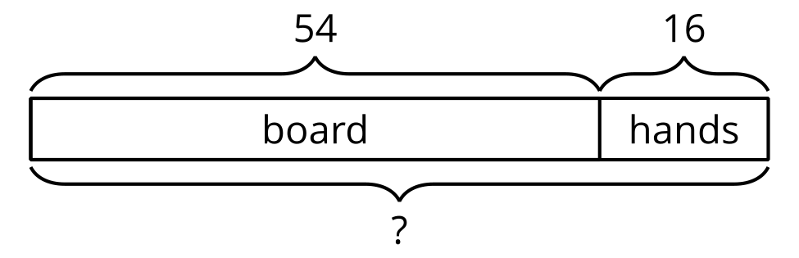
- 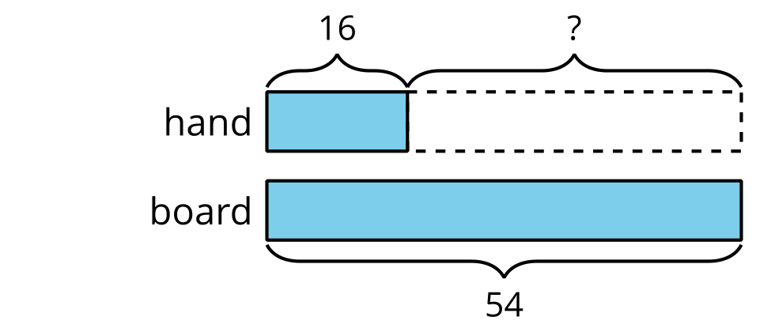
- 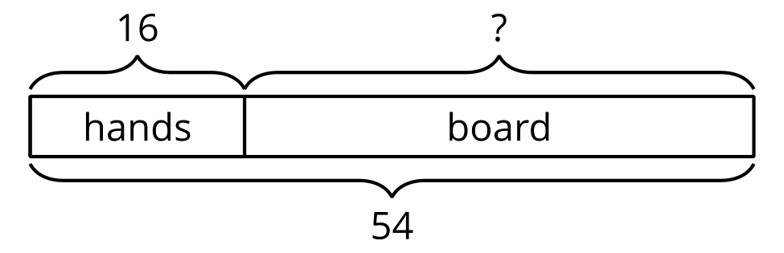
- There are 54 seeds on the game board. Some seeds are on Han’s side. 16 seeds are on Clare’s side. How many seeds are on Han’s side of the board?
- Choose the 2 diagrams that match.
- 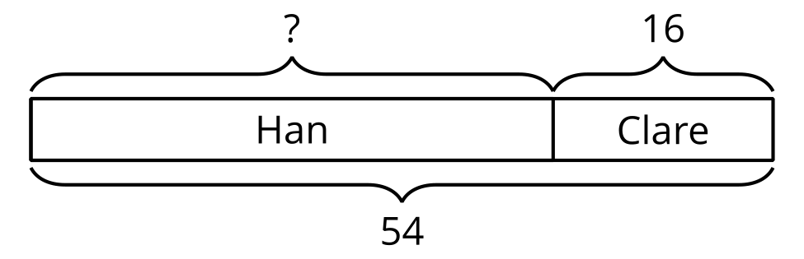
- 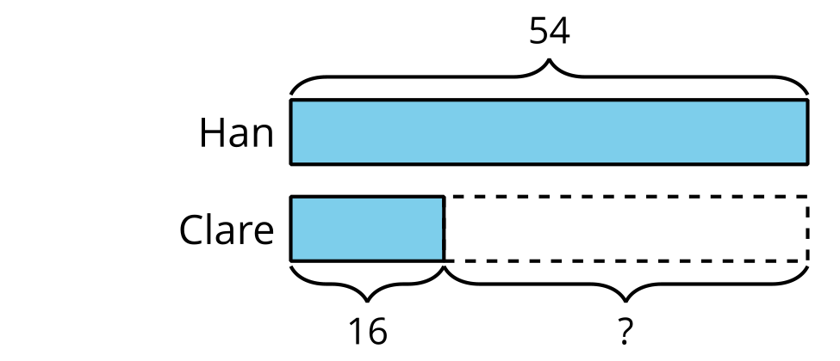
- 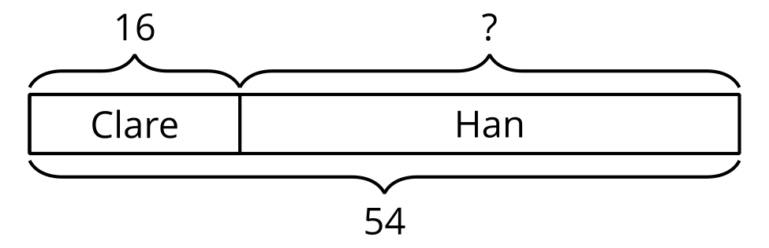

2 Card Sort: Story Problems and Diagrams

Student Task Statement
- Match each story problem with a diagram. Explain why the cards match.
- Choose 2 story problems and solve them. Show your thinking.

Images for Activity Synthesis
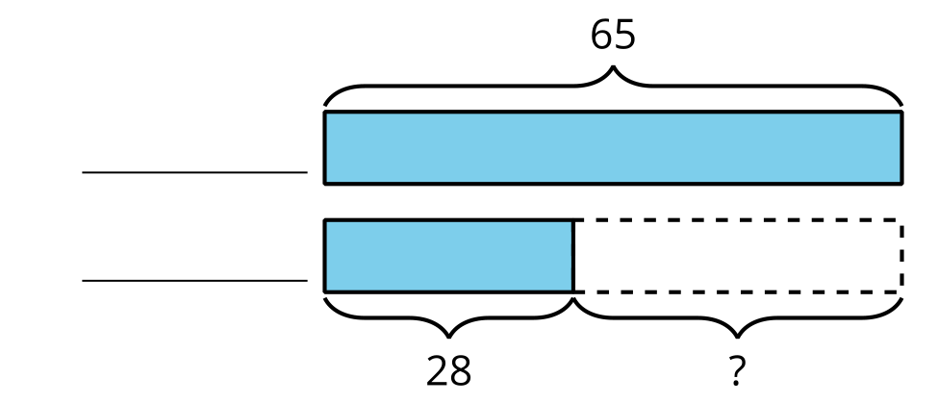
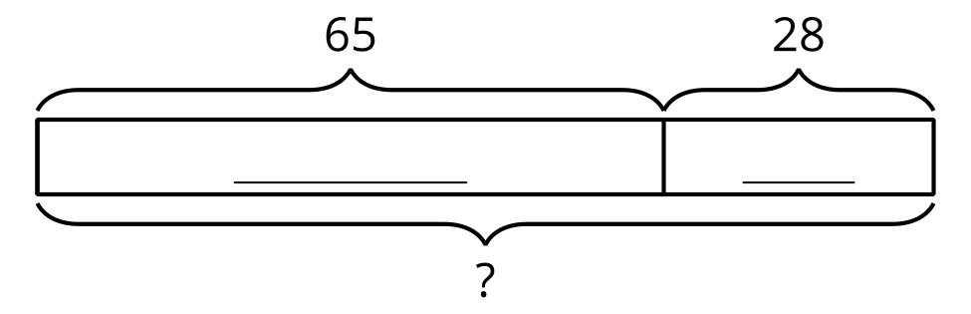
© CC BY 2021 Illustrative Mathematics®

