Unit 5 Lesson 2 Cumulative Practice Problems
- Select all figures for which there exists a direction such that all cross sections taken at that direction are congruent.
  - triangular pyramid
  - square pyramid
  - rectangular prism
  - cube
  - cone
  - cylinder
  - sphere
- Imagine an upright cone with its base resting on your horizontal desk. Sketch the cross section formed by intersecting each plane with the cone.
  - vertical plane not passing through the cone’s topmost point
  - horizontal plane
  - diagonal plane
- Name 2 figures for which a circle can be a cross section.
- Sketch the solid of rotation formed by rotating the given two-dimensional figure using the dashed vertical line as an axis of rotation.
- 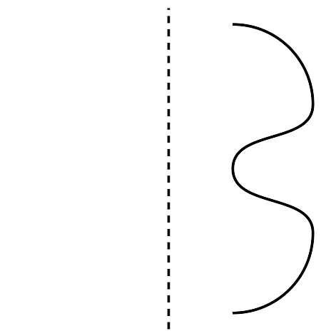
- (From Unit 5, Lesson 1.)
- Draw a two-dimensional figure that could be rotated using a vertical axis of rotation to give the cone shown.
- 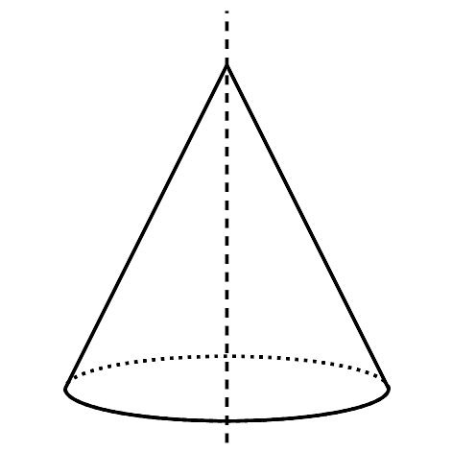
- (From Unit 5, Lesson 1.)
- A regular hexagon and a regular octagon are both inscribed in the same circle. Which of these statements is true?
  - The perimeter of the hexagon is less than the perimeter of the octagon, and each perimeter is less than the circumference of the circle.
  - The perimeter of the octagon is less than the perimeter of the hexagon, and each perimeter is less than the circumference of the circle.
  - The perimeter of the hexagon is greater than the perimeter of the octagon, and each perimeter is greater than the circumference of the circle.
  - The perimeter of the octagon is greater than the perimeter of the hexagon, and each perimeter is greater than the circumference of the circle.
- (From Unit 4, Lesson 11.)
- Technology required. Find the perimeter of the figure.
- 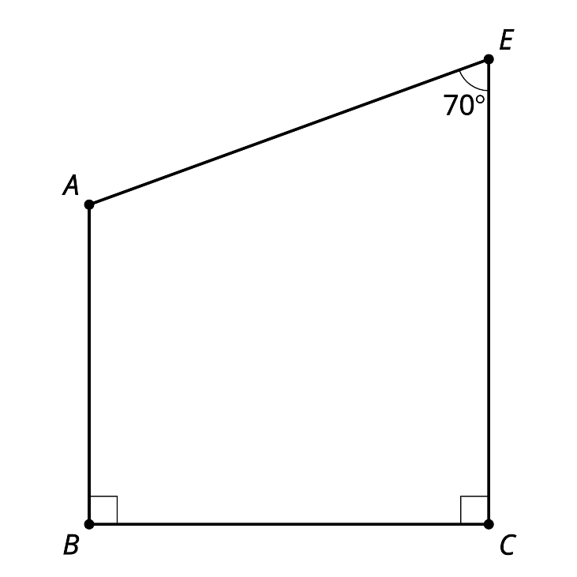
- (From Unit 4, Lesson 10.)
- Match each trigonometric function to a ratio. You may use ratios more than once.
- 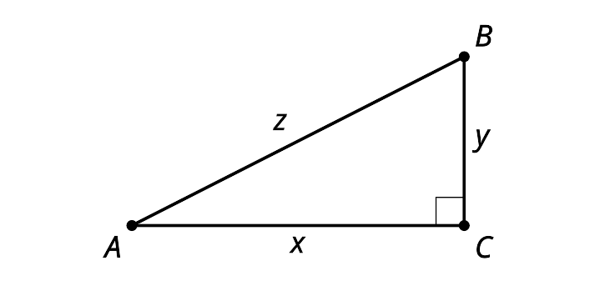
  - $\text{tan}(A)$
  - $\text{tan}(B)$
  - $\text{cos}(A)$
  - $\text{cos}(B)$
  - $\text{sin}(A)$
  - $\text{sin}(B)$
  - $\frac{y}{z}$
  - $\frac{x}{z}$
  - $\frac{x}{y}$
  - $\frac{y}{x}$
- (From Unit 4, Lesson 6.)
- Explain how you know lines $m$ and $l$ are parallel.
- 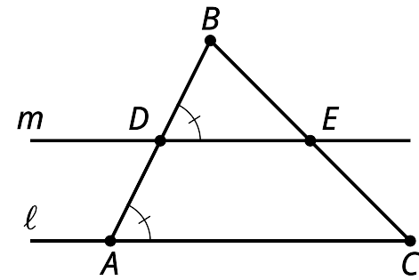
- (From Unit 1, Lesson 20.)
© CC BY 2019 by Illustrative Mathematics

