Lesson 10: Center Day 2
- Let’s measure the length of objects.

Warm-up: True or False: Adding within 100
Is each statement true or false?
Be prepared to explain your reasoning.
- $24+30=44$
- $24+40=64$
- $30+45=75$
- $32+45=76$

10.2: Centers: Choice Time
Choose a center.
How Close?
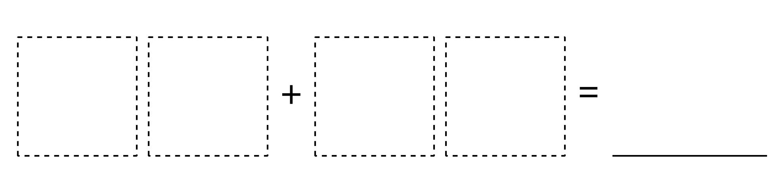
Target Numbers
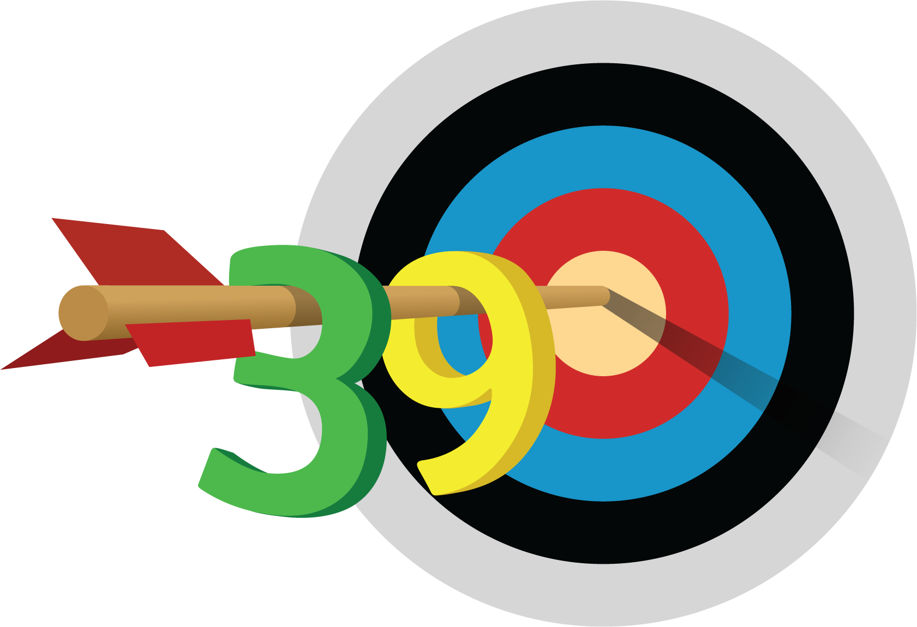
Five in a Row
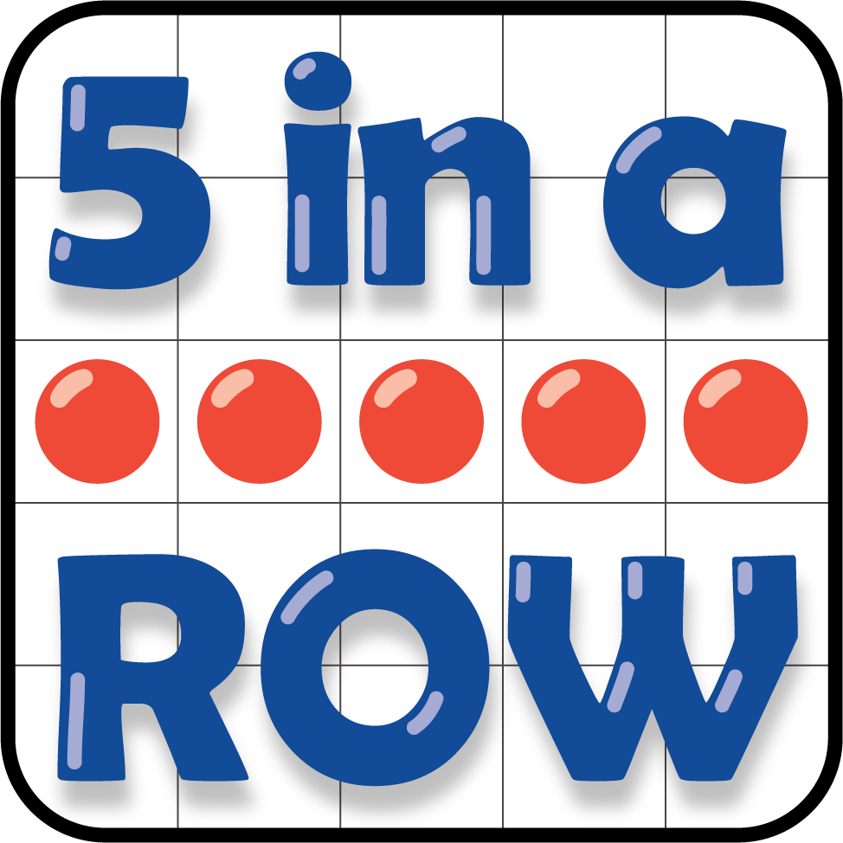
© CC BY 2021 Illustrative Mathematics®

