Lesson 1: Measure in Halves of an Inch
- Let’s measure the length of objects around the room.

Warm-up: What Do You Know About Inches?
What do you know about inches?

1.1: Measure Around the Room
Use the ruler from your teacher to measure the length of objects in the room. Be prepared to discuss your reasoning.
object | length (inches)
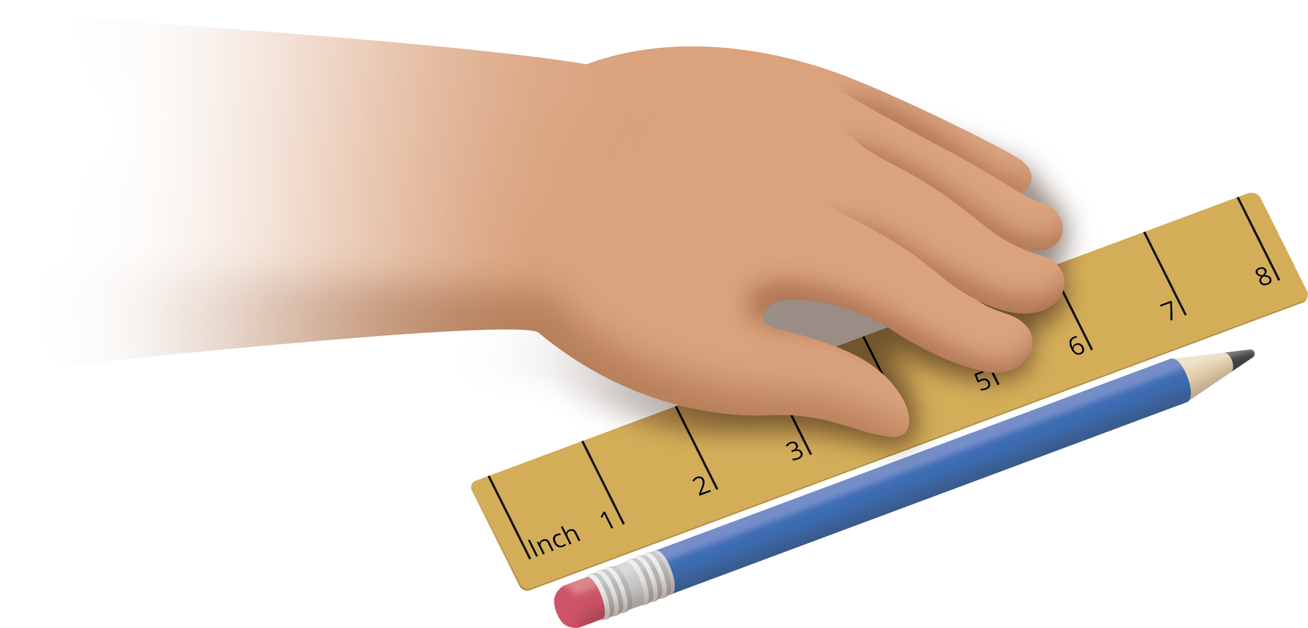

1.2: Partition Inches into Halves
You will need one ruler from an earlier activity.
- Work with your partner to partition every inch on the ruler into halves of an inch.
- Use the ruler marked with halves of an inch to measure some lengths around the room.
object | length (inches)
© CC BY 2021 Illustrative Mathematics®

