Lesson 11 Practice Problems
- Which of these constructions would construct a line of reflection that takes the point $A$ to point $B$?
  - Construct the perpendicular bisector of segment $AB$.
  - Construct a line through $B$ perpendicular to segment $AB$.
  - Construct the line passing through $A$ and $B$.
  - Construct a line parallel to line $AB$.
- A point $P$ stays in the same location when it is reflected over line $ℓ$.
- What can you conclude about $P$?

- Lines $ℓ$ and $m$ are perpendicular with point of intersection $P$.
- Noah says that a 180 degree rotation, with center $P$, has the same effect on points in the plane as reflecting over line $m$. Do you agree with Noah? Explain your reasoning.

- $m⊥ℓ$
- 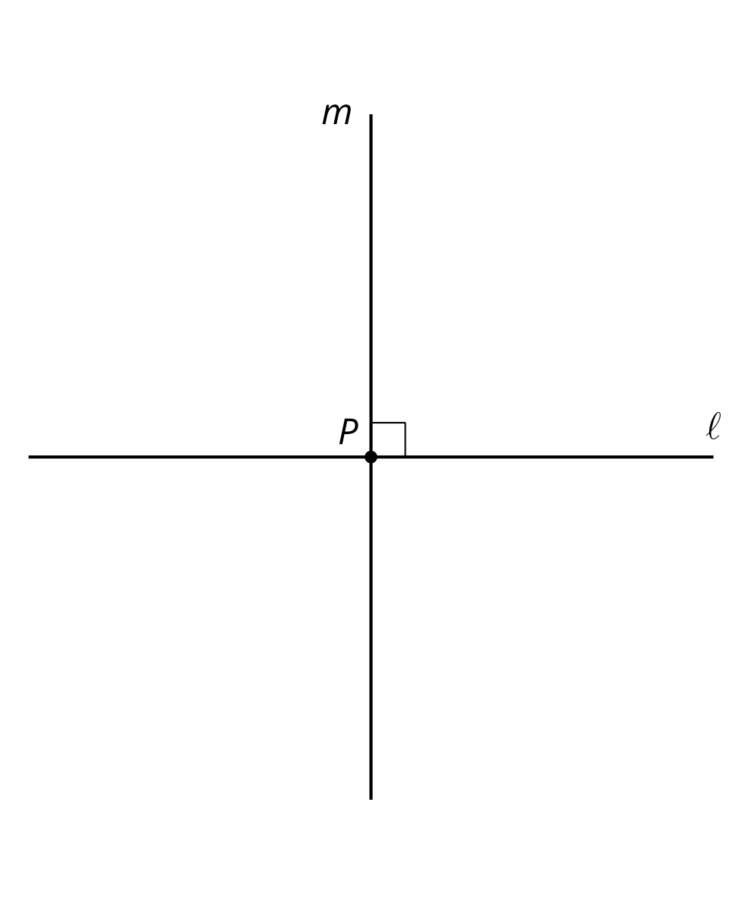

- Here are 4 triangles that have each been transformed by a different transformation. Which transformation is not a rigid transformation?
  - 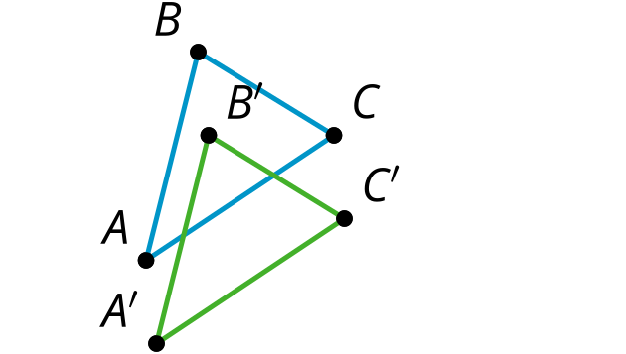
  - 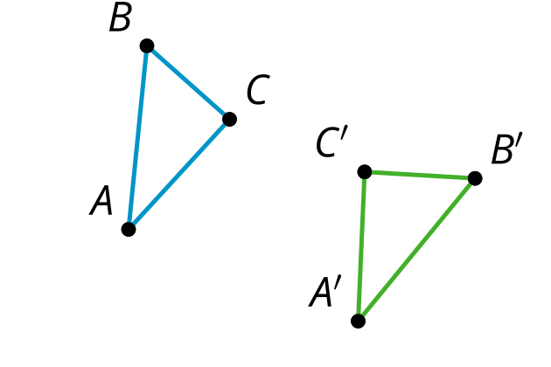
  - 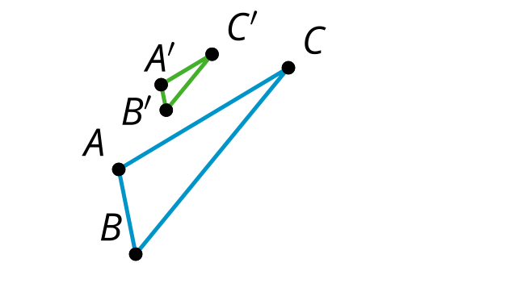
  - 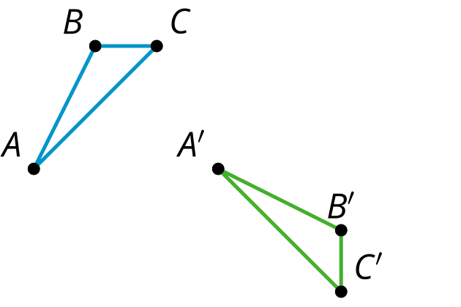
- (From Unit 1, Lesson 10.)
- There is a sequence of rigid transformations that takes $A$ to $A^{′}$, $B$ to $B^{′}$, and $C$ to $C^{′}$. The same sequence takes $D$ to $D^{′}$. Draw and label $D^{′}$:
- 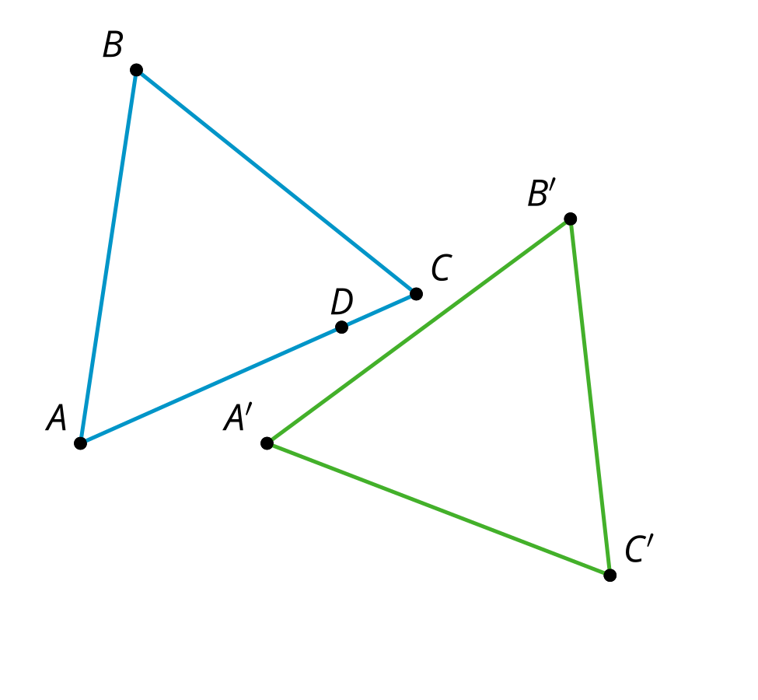
- (From Unit 1, Lesson 10.)
- Here are 3 points in the plane. Explain how to determine whether point $C$ is closer to point $A$ or point $B$.
- 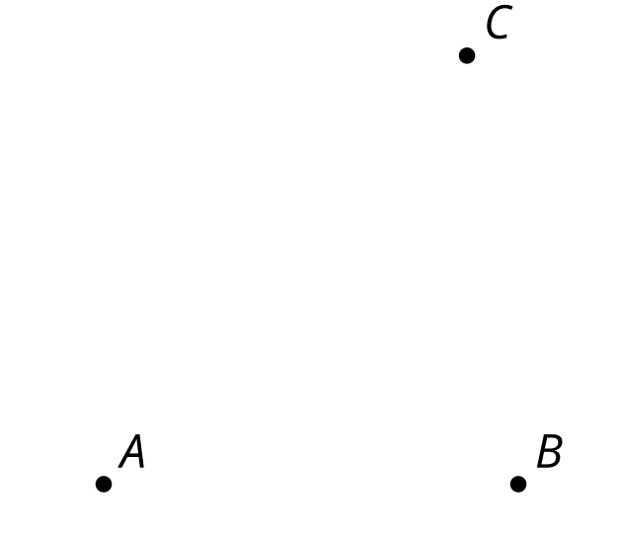
- (From Unit 1, Lesson 9.)
- Diego says a quadrilateral with 4 congruent sides is always a regular polygon. Mai say it never is one. Do you agree with either of them?
- (From Unit 1, Lesson 7.)
© CC BY 2019 by Illustrative Mathematics®

