Lesson 1: What are Scaled Copies?

1.1: Printing Portraits
Here is a portrait of a student.
- Look at Portraits A–E. How is each one the same as or different from the original portrait of the student?
- 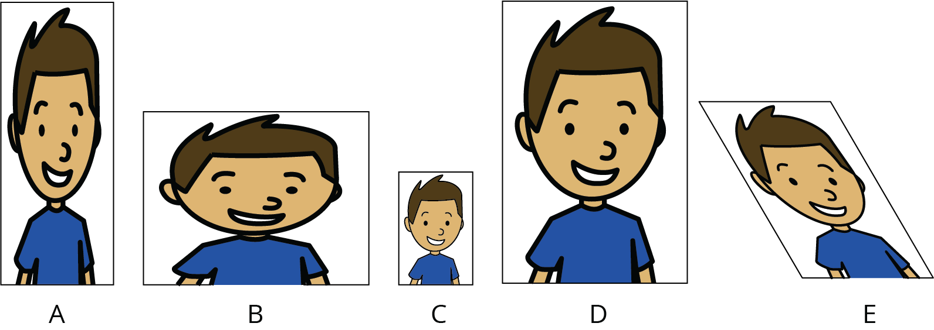
- Some of the Portraits A–E are scaled copies of the original portrait. Which ones do you think are scaled copies? Explain your reasoning.
- What do you think “scaled copy” means?

1.2: Scaling F
Here is an original drawing of the letter F and some other drawings.
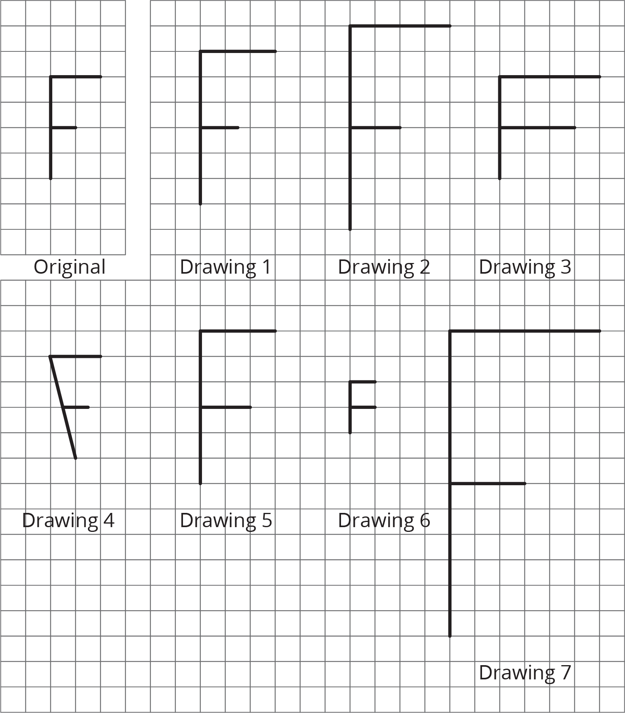
- Identify all the drawings that are scaled copies of the original letter F. Explain how you know.
- Examine all the scaled copies more closely, specifically the lengths of each part of the letter F. How do they compare to the original? What do you notice?
- On the grid, draw a different scaled copy of the original letter F.

1.3: Pairs of Scaled Polygons
Your teacher will give you a set of cards that have polygons drawn on a grid. Mix up the cards and place them all face up.
- Take turns with your partner to match a pair of polygons that are scaled copies of one another.
  - For each match you find, explain to your partner how you know it’s a match.
  - For each match your partner finds, listen carefully to their explanation, and if you disagree, explain your thinking.
- When you agree on all of the matches, check your answers with the answer key. If there are any errors, discuss why and revise your matches.
- Select one pair of polygons to examine further. Draw both polygons on the grid. Explain or show how you know that one polygon is a scaled copy of the other.

Are you ready for more?
Is it possible to draw a polygon that is a scaled copy of both Polygon A and Polygon B? Either draw such a polygon, or explain how you know this is impossible.

Lesson 1 Summary
What is a scaled copy of a figure? Let’s look at some examples.
The second and third drawings are both scaled copies of the original Y.
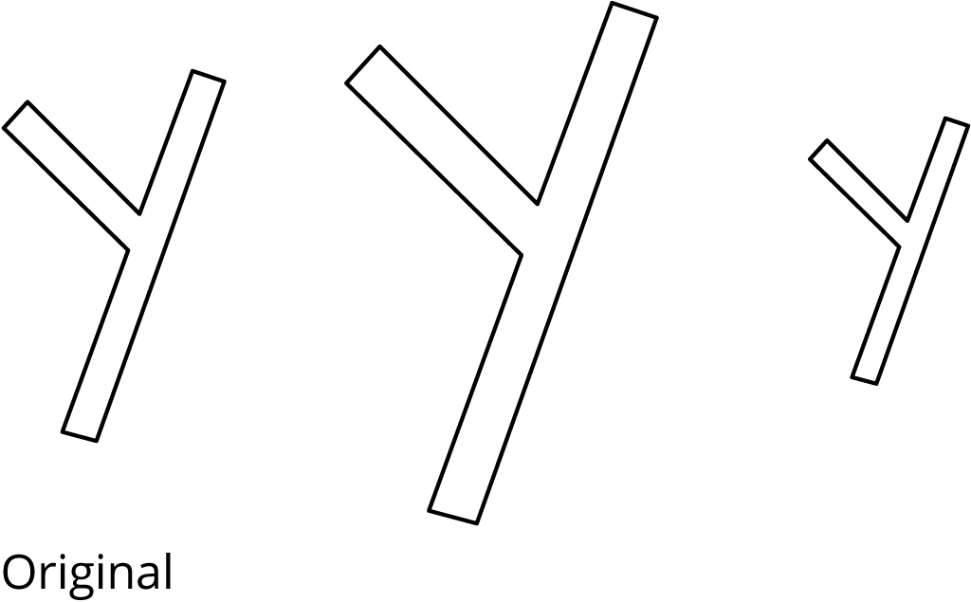
However, here, the second and third drawings are not scaled copies of the original W.
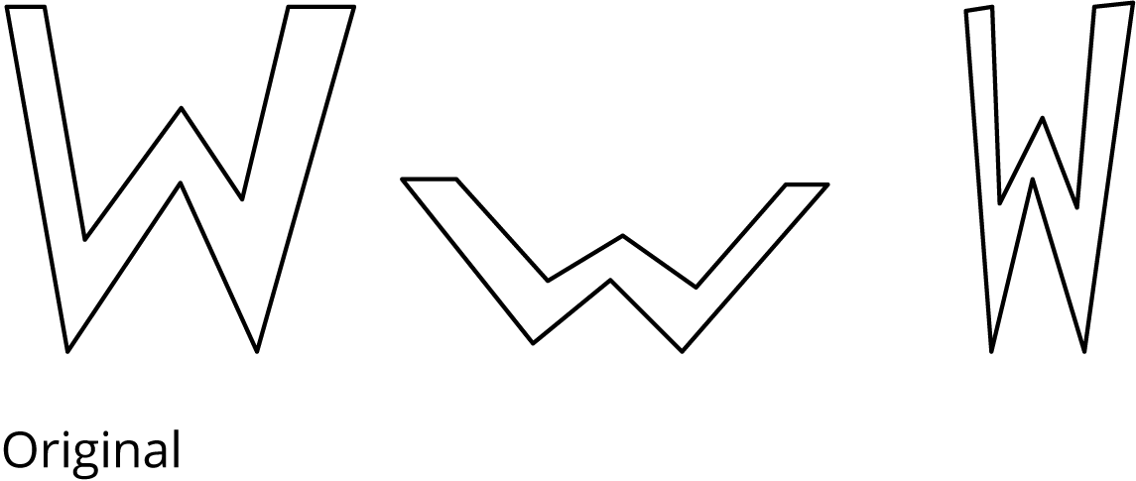
The second drawing is spread out (wider and shorter). The third drawing is squished in (narrower, but the same height).
We will learn more about what it means for one figure to be a scaled copy of another in upcoming lessons.
© CC BY Open Up Resources. Adaptations CC BY IM.

