Lesson 15: Diagramas con todo tipo de problemas de comparación

Standards Alignments
Addressing | 2.OA.A.1, 2.OA.B.2

Teacher-facing Learning Goals
- Interpret tape diagrams that represent Compare problems, with unknowns in all positions within 100.

Student-facing Learning Goals
- Conectemos problemas de comparación con diagramas.

Lesson Purpose
The purpose of this lesson is for students to connect Compare problems with unknowns in all positions to tape diagrams.
In this lesson, students continue to make sense of tape diagrams as they connect them to story problems. The story problems in this lesson include Compare problems with an unknown difference, an unknown larger number, or an unknown smaller number. Because these problem types are familiar from grade 1, students also begin to work with numbers within 100 in this lesson. This gives students an opportunity to notice how the tape diagram can be used to quickly visualize story problems with larger quantities. Students use tape diagrams to make sense of Compare problems. When students connect situations, tape diagrams, and equations, they deepen their understanding of the problem type and develop strategies they can use to make sense of and persevere in solving these problems in future lessons (MP1, MP2).

Access for:

Students with Disabilities
- Action and Expression (Activity 1)

English Learners
- MLR8 (Activity 2)

Instructional Routines
Card Sort (Activity 2), Number Talk (Warm-up)

Materials to Copy
- Card Sort: At the Beach, Spanish (groups of 2): Activity 2

Lesson Timeline
Warm-up | 10 min
Activity 1 | 15 min
Activity 2 | 20 min
Lesson Synthesis | 10 min
Cool-down | 5 min

Teacher Reflection Question
As students worked in their small groups today, whose ideas were heard, valued, and accepted? How can you adjust the group structure in future lessons to ensure each student’s ideas are a part of the collective learning?

Cool-down
(to be completed at the end of the lesson) 5min
En la playa

Standards Alignments
Addressing | 2.OA.A.1

Student-facing Task Statement
Unos niños encontraron conchas marinas y piedras en la playa. Encontraron 8 conchas marinas más que piedras. Encontraron 19 piedras. ¿Cuántas conchas marinas encontraron los niños?
- Escoge el diagrama que corresponde al problema-historia.
- 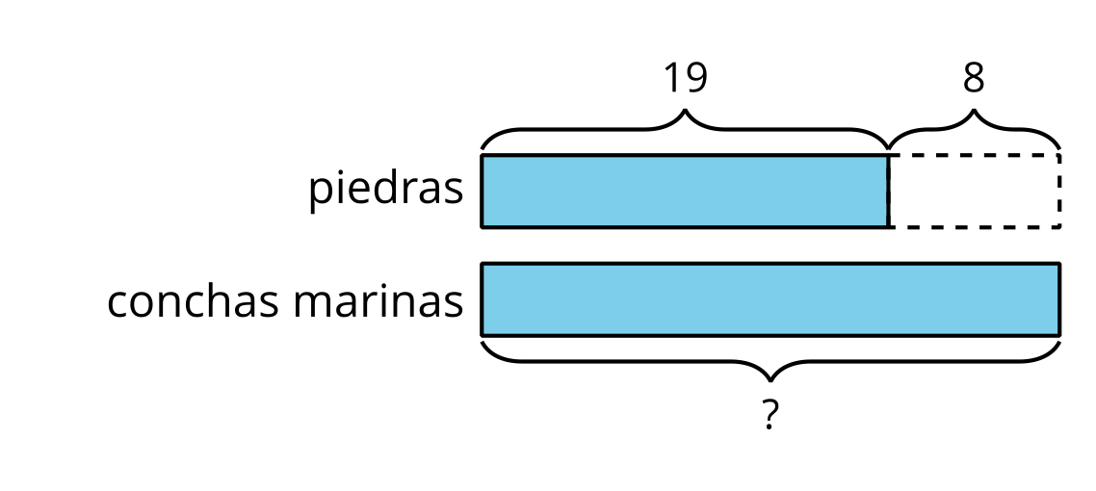
- 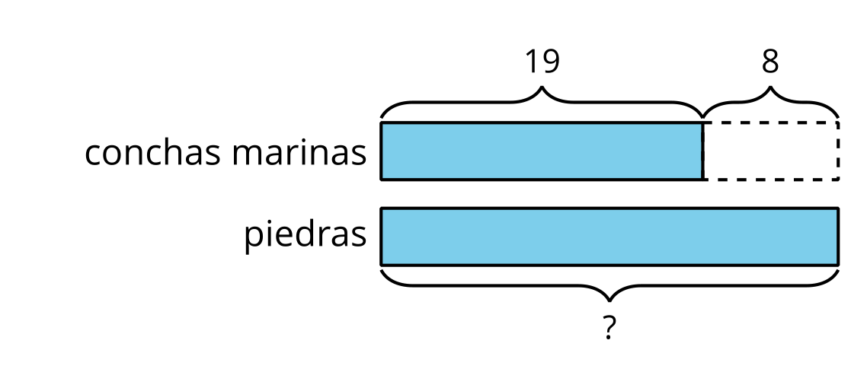
- Explica cómo sabes que el diagrama corresponde a la historia.

Student Responses
- Circles left choice.
- Sample response: The diagram matches because it shows that there will be more shells than rocks. It doesn’t tell how many shells so that’s why it has a ?

