Lesson 8: Números de tres dígitos en la recta numérica

Standards Alignments
Addressing | 2.MD.B.6, 2.NBT.A.1, 2.NBT.A.2

Teacher-facing Learning Goals
- Represent whole numbers up to 1,000 as lengths from 0 on a number line.
- Use skip-counting by tens and hundreds to locate whole numbers up to 1,000 on a number line.

Student-facing Learning Goals
- Ubiquemos y representemos números de tres dígitos en la recta numérica.
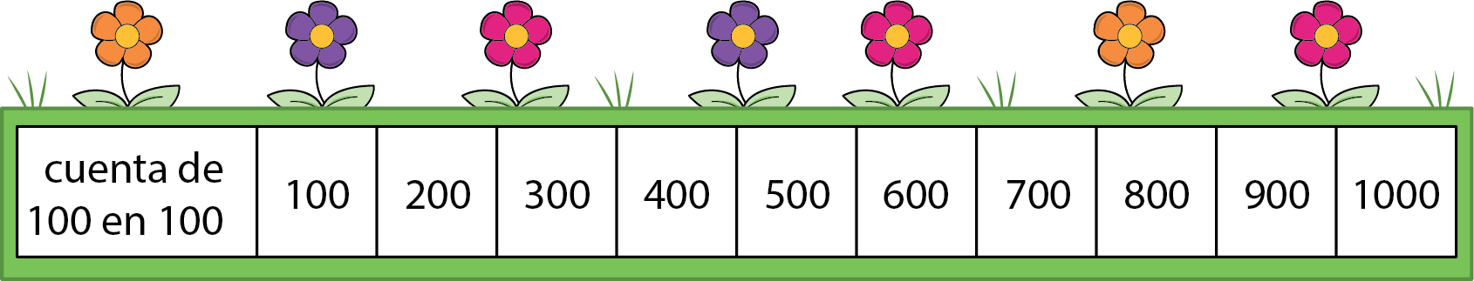

Lesson Purpose
The purpose of this lesson is for students to locate and label three-digit numbers on number lines.
In previous lessons, students learned different ways to represent three-digit numbers. They also located numbers within 100 on a number line.
In this lesson, students revisit the structure of the number line and use what they know about place value and counting by 10 and 100 to locate three-digit numbers on a number line (MP7). Throughout the lesson, students work with number lines that show 10 length units. The only labeled tick marks are the starting and ending numbers. Students locate and label numbers on these number lines by reasoning about the size of each length unit using what they know about counting within 1,000 and place value. They are encouraged to connect the structure of the number line to a representation of 10 ones, 10 tens, or 10 hundreds. This understanding will be important when students compare three-digit numbers in upcoming lessons.

Access for:

Students with Disabilities
- Representation (Activity 2)

English Learners
- MLR8 (Activity 1)

Instructional Routines
Choral Count (Warm-up)

Lesson Timeline
Warm-up | 10 min
Activity 1 | 20 min
Activity 2 | 15 min
Lesson Synthesis | 10 min
Cool-down | 5 min

Teacher Reflection Question
In an earlier unit, students learned to locate and represent numbers as lengths from 0 on the number line. How did students draw on their earlier experiences with number lines, counting, and place value to reason about how to locate and label three-digit numbers on the number line? What ideas or connections might need to be made more explicit to help all students deepen their understanding of three-digit numbers?

Cool-down
(to be completed at the end of the lesson) 5min
Números grandes en la recta numérica

Standards Alignments
Addressing | 2.MD.B.6, 2.NBT.A.2

Student-facing Task Statement
- Marca cada punto con el número que el punto representa.

- Ubica y marca 370 en la recta numérica.

Student Responses

  - 600
  - 60

