Lesson 6: Diez veces

Standards Alignments
Addressing | 4.NBT.B.5, 4.OA.A.1, 4.OA.A.2

Teacher-facing Learning Goals
- Write, represent, and solve multiplicative comparison problems involving “10 times as many.”

Student-facing Learning Goals
- Representemos “10 veces una cantidad”.

Lesson Purpose
The purpose of this lesson is for students to represent and solve multiplicative comparison problems involving multiples of 10.
In this lesson, students apply place value understanding, where they look for and make use of structure, to what they have learned about representing and solving multiplicative comparison problems (MP7). They use tape diagrams and equations to represent multiplicative comparisons that are “10 times as many”.
Students will build on this understanding in the next section as they convert measurements from larger metric units into smaller ones (for instance, from meters to centimeters, kilograms to grams, or liters to milliliters).
This lesson has a Student Section Summary.

Access for:

Students with Disabilities
- Representation (Activity 2)

English Learners
- MLR8 (Activity 2)

Instructional Routines
Choral Count (Warm-up)

Lesson Timeline
Warm-up | 10 min
Activity 1 | 20 min
Activity 2 | 15 min
Lesson Synthesis | 10 min
Cool-down | 5 min

Teacher Reflection Question
In today’s lesson, students considered multiplication with products greater than 100. What vocabulary did you hear students using that indicated a use of place value and beginning understanding of multiplication of multi-digit numbers?

Cool-down
(to be completed at the end of the lesson) 5min
¿Cuál es el valor?

Standards Alignments
Addressing | 4.OA.A.1, 4.OA.A.2

Student-facing Task Statement
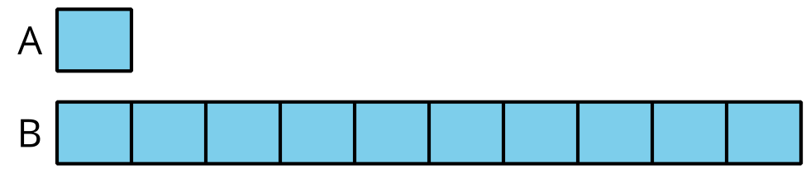
- A tiene un valor de 3. ¿Cuál es el valor de B?
- A tiene un valor de 30. ¿Cuál es el valor de B?
- A tiene un valor de 300. ¿Cuál es el valor de B?
- Escribe una afirmación verdadera en la que se compare 3, 30 y 300. Usa la palabra “veces”.

Student Responses
- 30
- 300
- 3,000
- Sample response: 300 is ten times as much as 30, which is ten times as much as 3.

