Unit 8 Lesson 4: Square Roots on the Number Line

1 Notice and Wonder: Diagonals (Warm up)

Student Task Statement
What do you notice? What do you wonder?
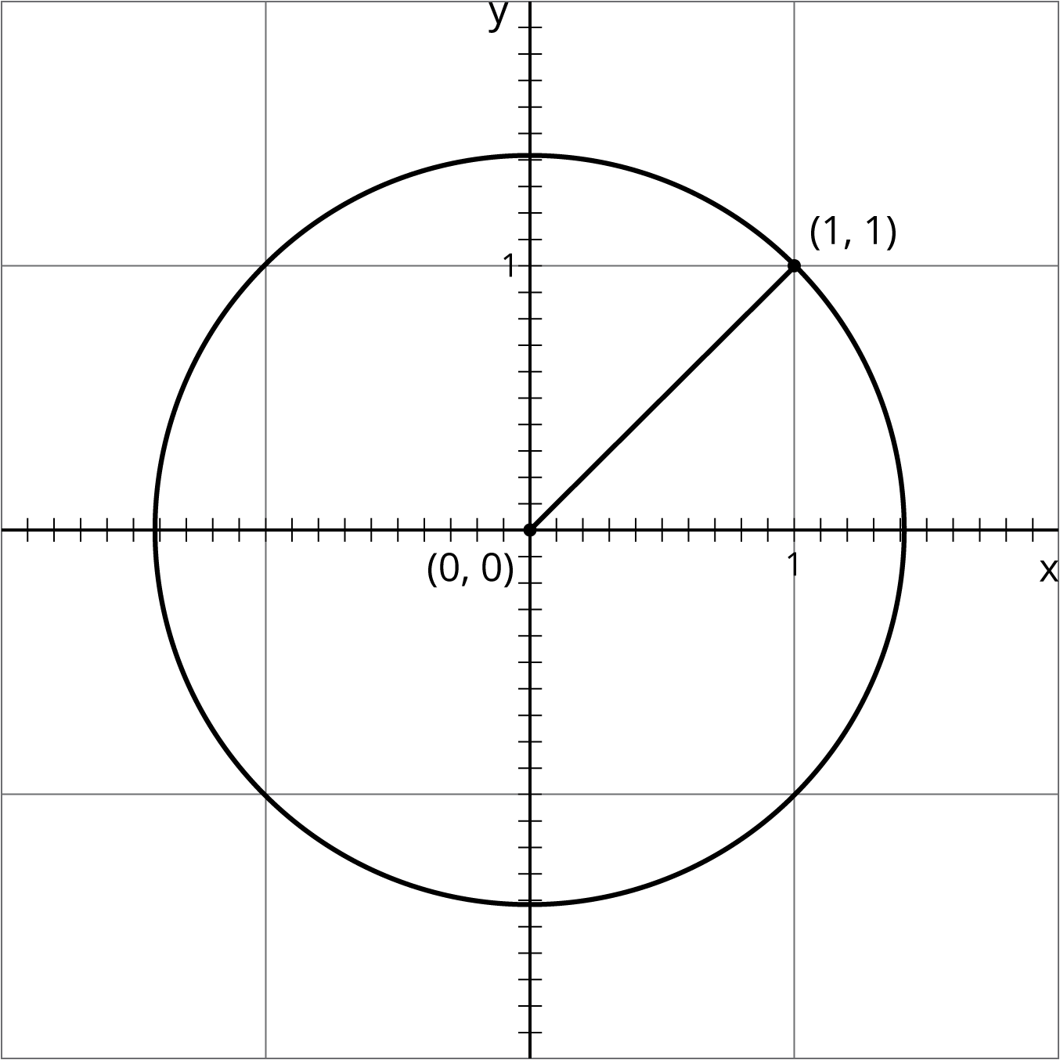

2 Squaring Lines

Student Task Statement
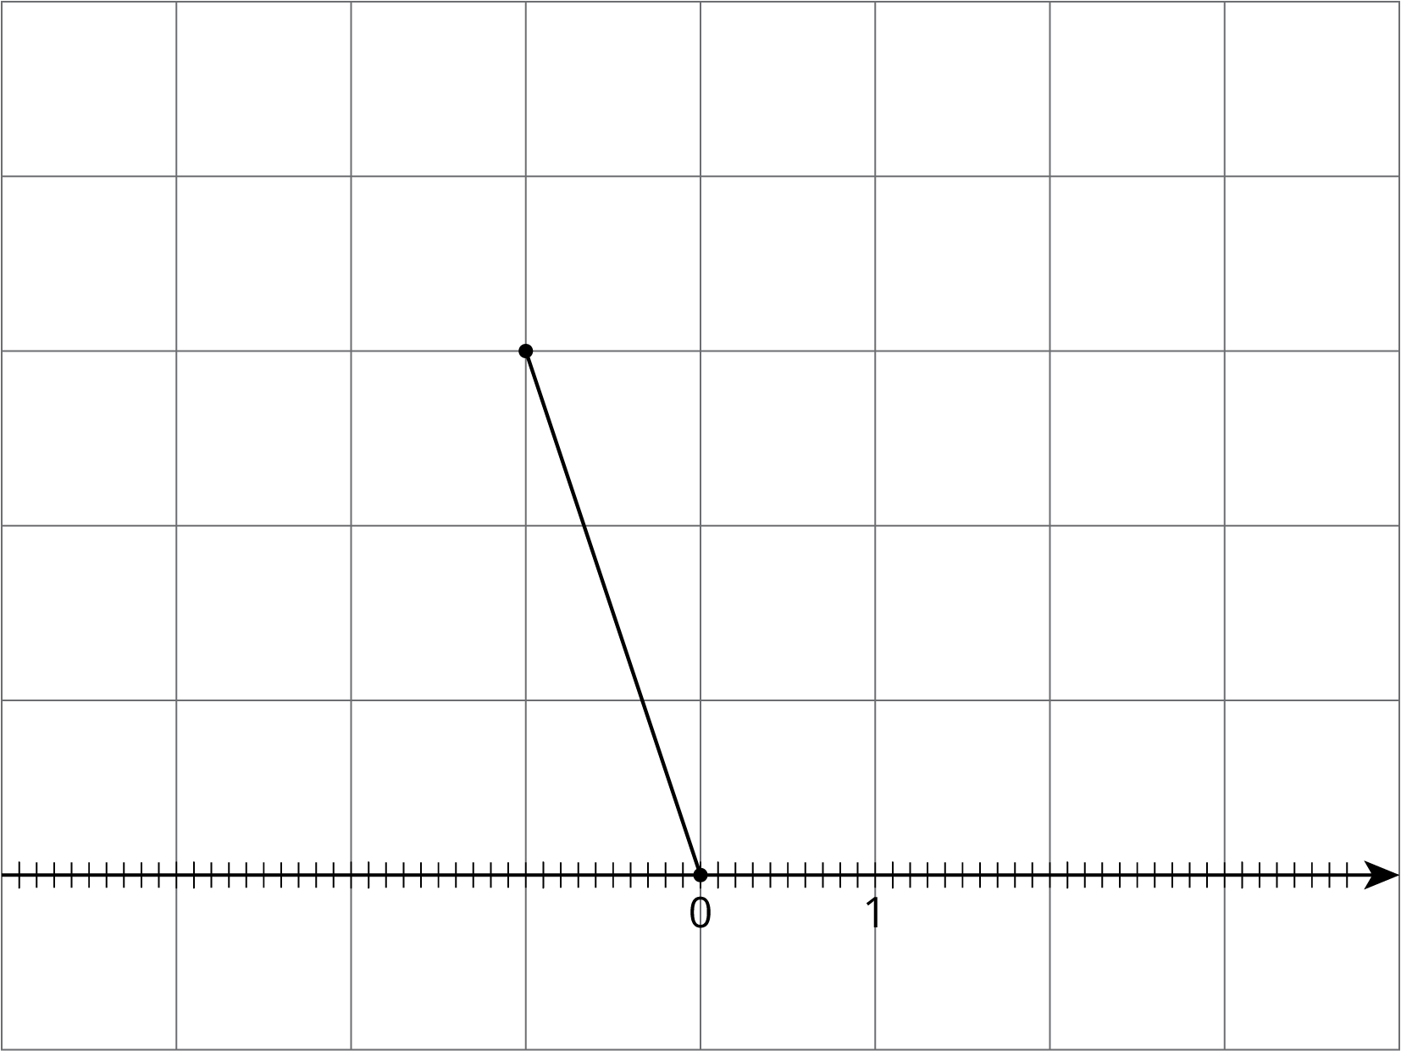
- Estimate the length of the line segment to the nearest tenth of a unit (each grid square is 1 square unit).
- Find the exact length of the segment.

3 Square Root of 3

Student Task Statement
Diego said that he thinks that $\sqrt{3}≈2.5$.
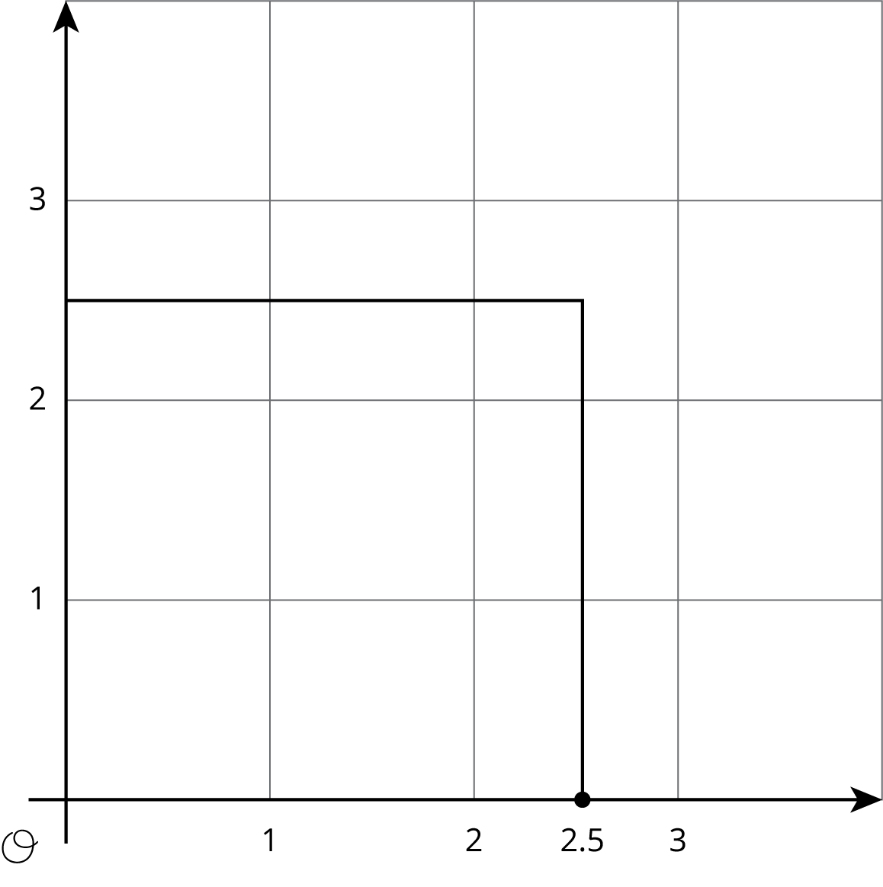
- Use the square to explain why 2.5 is not a very good approximation for $\sqrt{3}$. Find a point on the number line that is closer to $\sqrt{3}$. Draw a new square on the axes and use it to explain how you know the point you plotted is a good approximation for $\sqrt{3}$.
- Use the fact that $\sqrt{3}$ is a solution to the equation $x^{2}=3$ to find a decimal approximation of $\sqrt{3}$ whose square is between 2.9 and 3.1.

4 Solutions on a Number Line

Student Task Statement
The numbers $x$, $y$, and $z$ are positive, and $x^{2}=3$, $y^{2}=16$, and $z^{2}=30$.
- Plot $x$, $y$, and $z$ on the number line. Be prepared to share your reasoning with the class.
- Plot $\text{-}\sqrt{2}$ on the number line.
© CC BY Open Up Resources. Adaptations CC BY IM.

