Lesson 2: Representations of Growth and Decay
- Let’s revisit ways to represent exponential change.

2.1: One Fourth at a Time
Priya borrowed $160 from her grandmother. Each month, she pays off one fourth of the remaining balance that she owes.
- What amount will Priya pay her grandmother in the third month?
- Discuss with a partner why the expression $160⋅{\left(\frac{3}{4}\right)}^{3}$ represents the balance Priya owes her grandmother at the end of the third month.

2.2: Climbing Cost
The tuition at a college was $30,000 in 2012, $31,200 in 2013, and $32,448 in 2014. The tuition has been increasing by the same percentage since the year 2000.
- The equation $c\left(t\right)=30,​000⋅{\left(1.04\right)}^{t}$ represents the cost of tuition, in dollars, as a function of $t$, the number of years since 2012. Explain what the 30,000 and 1.04 tell us about this situation.
- What is the percent increase in tuition from year to year?
- What does $c\left(3\right)$ mean in this situation? Find its value and show your reasoning.

  - Write an expression to represent the cost of tuition in 2007.
  - How much did tuition cost that year?

Are you ready for more?
Jada thinks that the college tuition will increase by 40% each decade. Do you agree with Jada? Explain your reasoning.

2.3: Two Vans and Their Values
A small business bought a van for $40,000 in 2008. The van depreciates by 15% every year after its purchase.
- Which graph correctly represents the value of the van as a function of years since its purchase? Be prepared to explain why each of the other graphs could not represent the function.

- Graph A
- 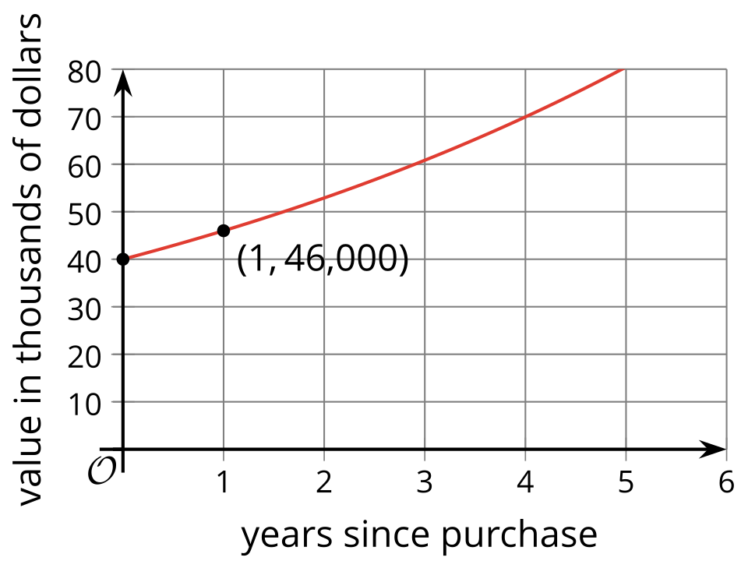

- Graph B
- 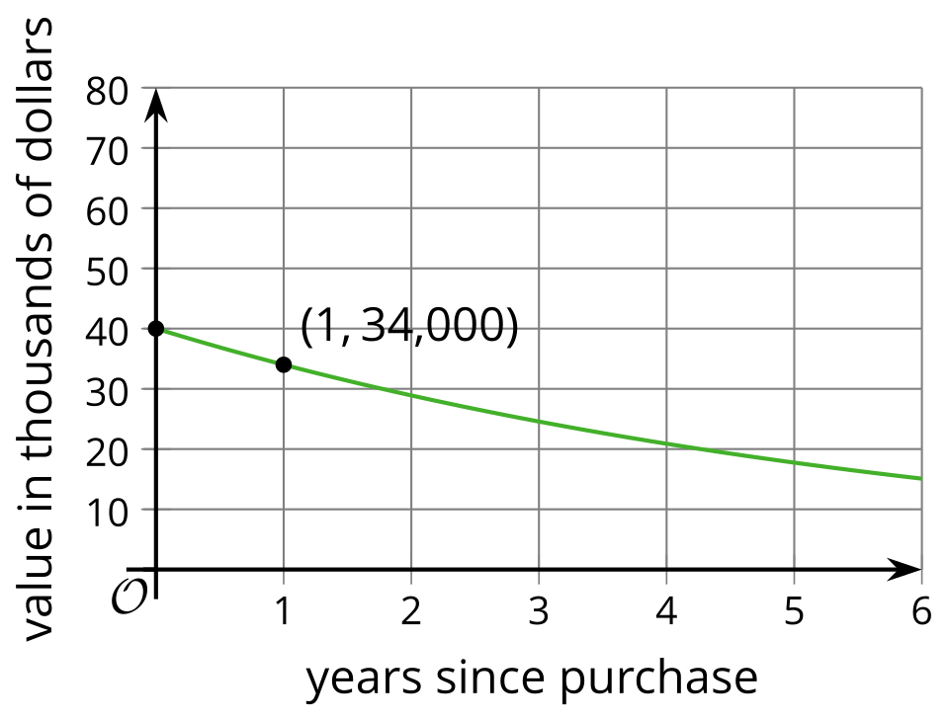

- Graph C
- 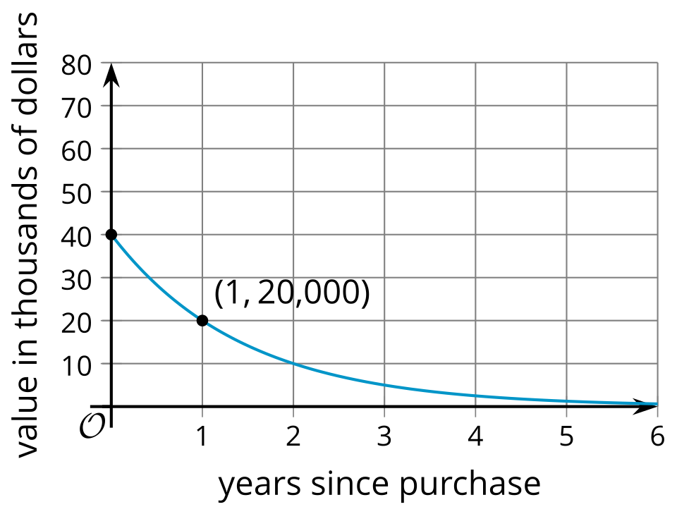

- Graph D
- 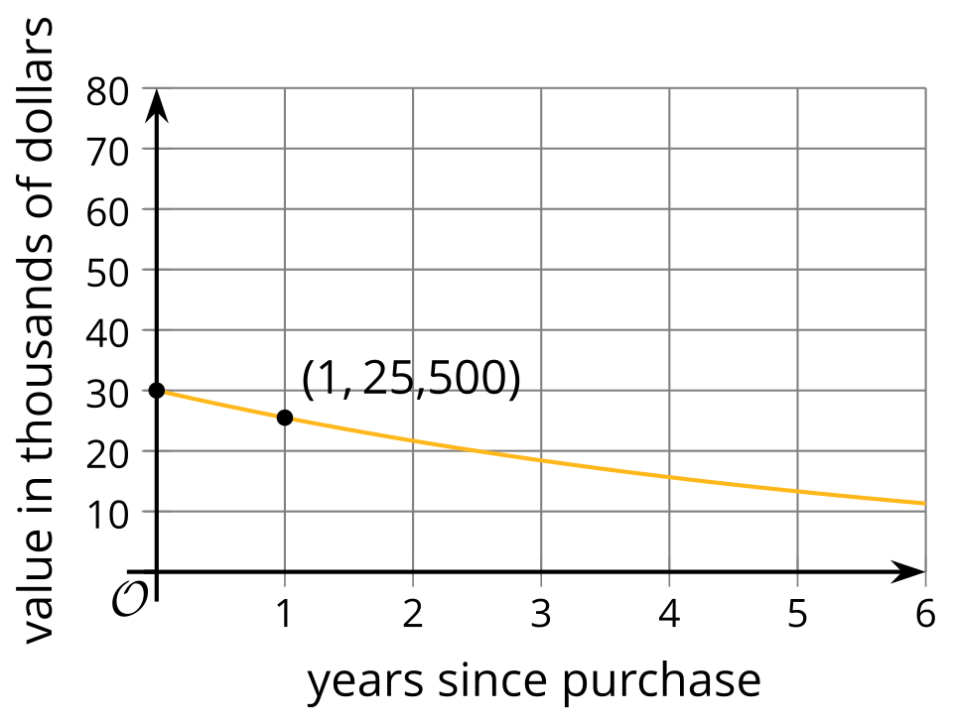
- Find the value of the van 8 years after its purchase. Show your reasoning.
- In the same year (2008), the business bought a second van that cost $10,000 less than the first van and depreciates at 10% per year. Would the second van be worth more or less than the first van 8 years after the purchase? Explain or show your reasoning.
- On the same coordinate plane as the graph you chose in the first question, sketch a graph that shows the value of the second van, in dollars, as a function of years since its purchase.

Lesson 2 Summary
There are lots of ways to represent an exponential function. Suppose the population of a city was 20,000 in 1990 and that it increased by 10% each year.
We can represent this situation with a table of values and show, for instance, that the population increased by a factor of 1.1 each year.
year | population
1990 | 20,000
1991 | 22,000
1992 | 24,200
1993 | 26,620
We can also use a graph to show how the population was changing.​​​​​ While the graph looks almost linear, it has a slight upward curve since the population is increasing by a factor of 1.1 and not a constant value each year.
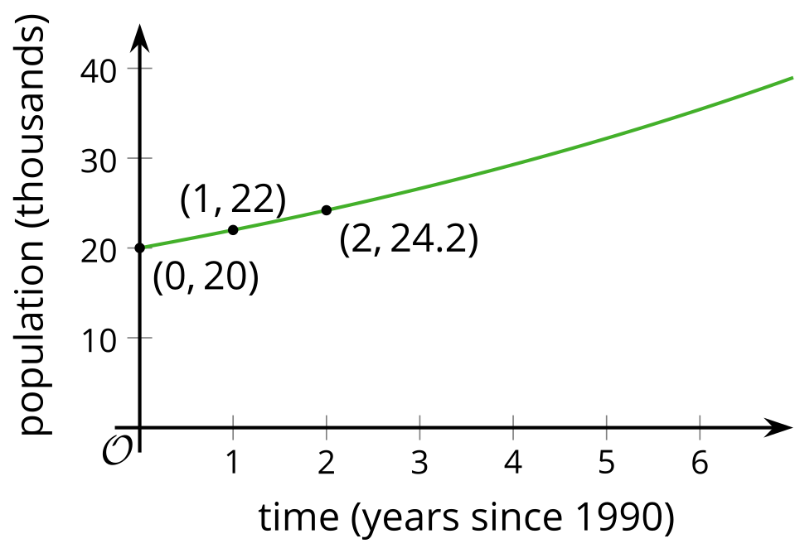
An equation is another useful representation. In this case, if $t$ is the number of years since 1990, then the population is a function $f$ of $t$ where $f\left(t\right)=20,​000⋅{\left(1.1\right)}^{t}$. Here we can see the 20,000 in the expression represents the population in 1990, while 1.1 represents the growth factor due to the 10% annual increase each year. We can even use the equation to calculate the population predicted by the model in 1985. Since 1985 is 5 years before 1990, we use an input of -5 to get $f\left(\text{-}5\right)=20,​000⋅{\left(1.1\right)}^{\text{-}5}$, which is about 12,418 people.
Throughout this unit, we will examine many exponential functions. All four representations—descriptions, tables, graphs, and equations—will be useful for determining different information about the function and the situation the function models.
© CC BY 2019 by Illustrative Mathematics®

