Lesson 15: Vertex Form
- Let’s find out about the vertex form.

15.1: Notice and Wonder: Two Sets of Equations
What do you notice? What do you wonder?
Set 1:
$f\left(x\right)=x^{2}+4x$
$g\left(x\right)=x\left(x+4\right)$
$h\left(x\right)={\left(x+2\right)}^{2}−4$
Set 2:
$p\left(x\right)=\text{-}x^{2}+6x−5$
$q\left(x\right)=\left(5−x\right)\left(x−1\right)$
$r\left(x\right)=\text{-}1{\left(x−3\right)}^{2}+4$

15.2: A Whole New Form
Here are two sets of equations for quadratic functions you saw earlier. In each set, the expressions that define the output are equivalent.
Set 1:
$f\left(x\right)=x^{2}+4x$
$g\left(x\right)=x\left(x+4\right)$
$h\left(x\right)={\left(x+2\right)}^{2}−4$
Set 2:
$p\left(x\right)=\text{-}x^{2}+6x−5$
$q\left(x\right)=\left(5−x\right)\left(x−1\right)$
$r\left(x\right)=\text{-}1{\left(x−3\right)}^{2}+4$
The expression that defines $h$ is written in vertex form. We can show that it is equivalent to the expression defining $f$ by expanding the expression:
$\begin{matrix}{\left(x+2\right)}^{2}−4 & =\left(x+2\right)\left(x+2\right)−4 \\ & =x^{2}+2x+2x+4−4 \\ & =x^{2}+4x\end{matrix}$
- Show that the expressions defining $r$ and $p$ are equivalent.
- Here are graphs representing the quadratic functions. Why do you think expressions such as those defining $h$ and $r$ are said to be written in vertex form?

- Graph of $h$
- 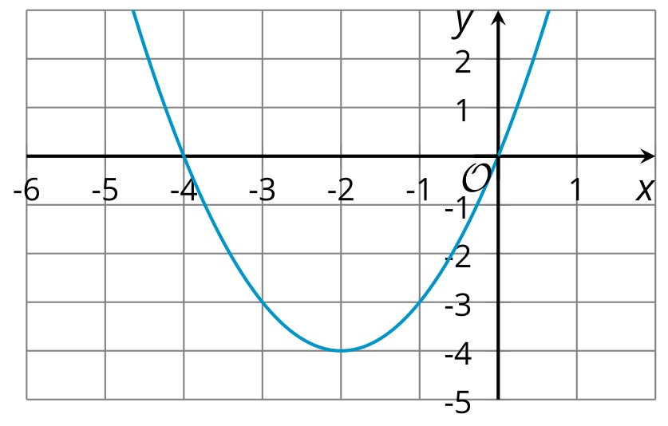

- Graph of $r$
- 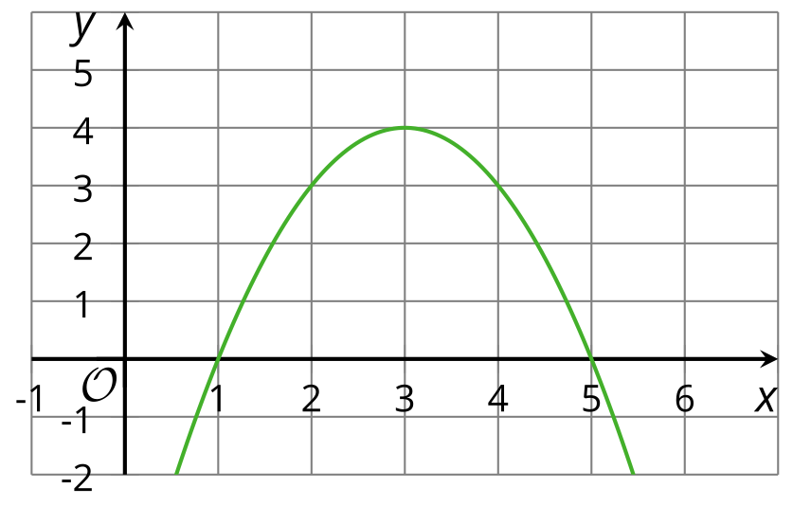

15.3: Playing with Parameters
- Using graphing technology, graph $y=x^{2}$. Then, add different numbers to $x$ before it is squared (for example, $y={\left(x+4\right)}^{2}$, $y={\left(x−3\right)}^{2}$) and observe how the graph changes. Record your observations.
- Graph $y={\left(x−1\right)}^{2}$. Then, experiment with each of the following changes to the function and see how they affect the graph and the vertex:
  - Adding different constant terms to ${\left(x−1\right)}^{2}$ (for example: ${\left(x−1\right)}^{2}+5$, ${\left(x−1\right)}^{2}−9$).
  - Multiplying ${\left(x−1\right)}^{2}$ by different coefficients (for example: $y=3{\left(x−1\right)}^{2}$, $y=\text{-}2{\left(x−1\right)}^{2}$).
- Without graphing, predict the coordinates of the vertex of the graphs of these quadratic functions, and predict whether the graph opens up or opens down. Ignore the last row until the next question.
- equations | - coordinates of vertex | - graph opens up or down?
- $y={\left(x+10\right)}^{2}$
- $y={\left(x−4\right)}^{2}+8$
- $y=\text{-}{\left(x−4\right)}^{2}+8$
- $y=x^{2}−7$
- $y=\frac{1}{2}{\left(x+3\right)}^{2}−5$
- $y=\text{-}{\left(x+100\right)}^{2}+50$
- $y=a{\left(x+m\right)}^{2}+n$
- Use graphing technology to check your predictions. If they are incorrect, revise them. Then, complete the last row of the table.

Are you ready for more?
- What is the vertex of this graph?
- Find a quadratic equation whose graph has the same vertex and adjust it, if needed, so that it has the graph provided.
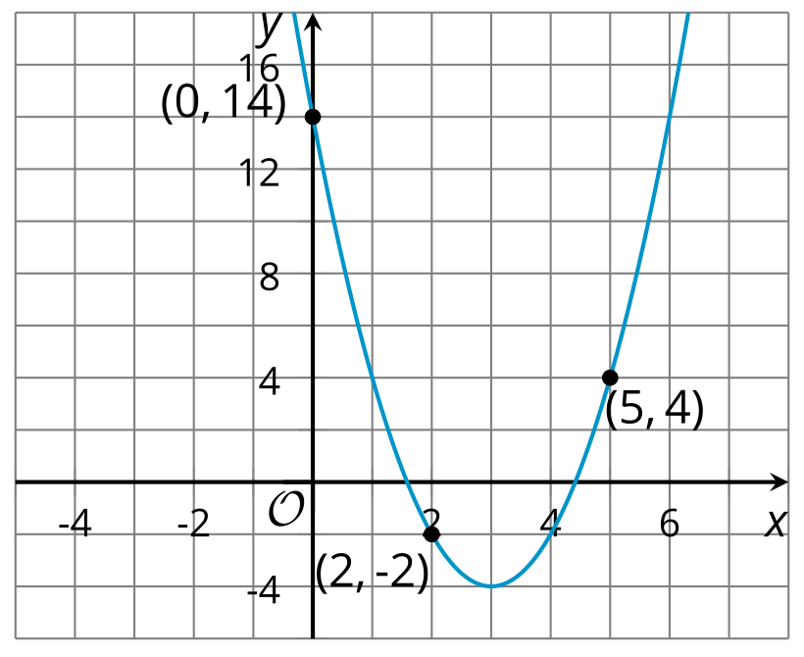

Lesson 15 Summary
Sometimes the expressions that define quadratic functions are written in vertex form. For example, if the function $f$ is defined by ${\left(x−3\right)}^{2}+4$, which is in vertex form, we can write $f\left(x\right)={\left(x−3\right)}^{2}+4$ and draw this graph to represent $f$.
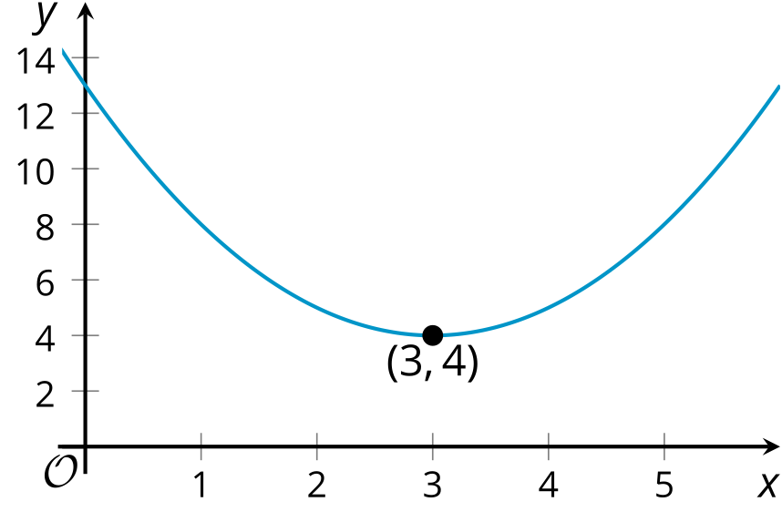
The vertex form can tell us about the coordinates of the vertex of the graph of a quadratic function. The expression ${\left(x−3\right)}^{2}$ reveals that the vertex has $x$-coordinate 3, and the constant term of 4 reveals its $y$-coordinate. Here the vertex represents the minimum value of the function $f$, and its graph opens upward.
In general, a quadratic function expressed in vertex form is written as: $y=a{\left(x−h\right)}^{2}+k$ The vertex of its graph is at $\left(h,k\right)$. The graph of the quadratic function opens upward when the coefficient $a$ is positive and opens downward when $a$ is negative.
In future lessons, we will explore further how $a$, $h$, and $k$ affect the graph of a quadratic function.
© CC BY 2019 by Illustrative Mathematics®

