Lesson 8: Groups Up to 110
- Let’s measure lengths that are longer than 100 cubes.

8.1: Long Lengths with Small Cubes
Represent your measurement using drawings, numbers, or words.

8.2: Representations of Large Numbers
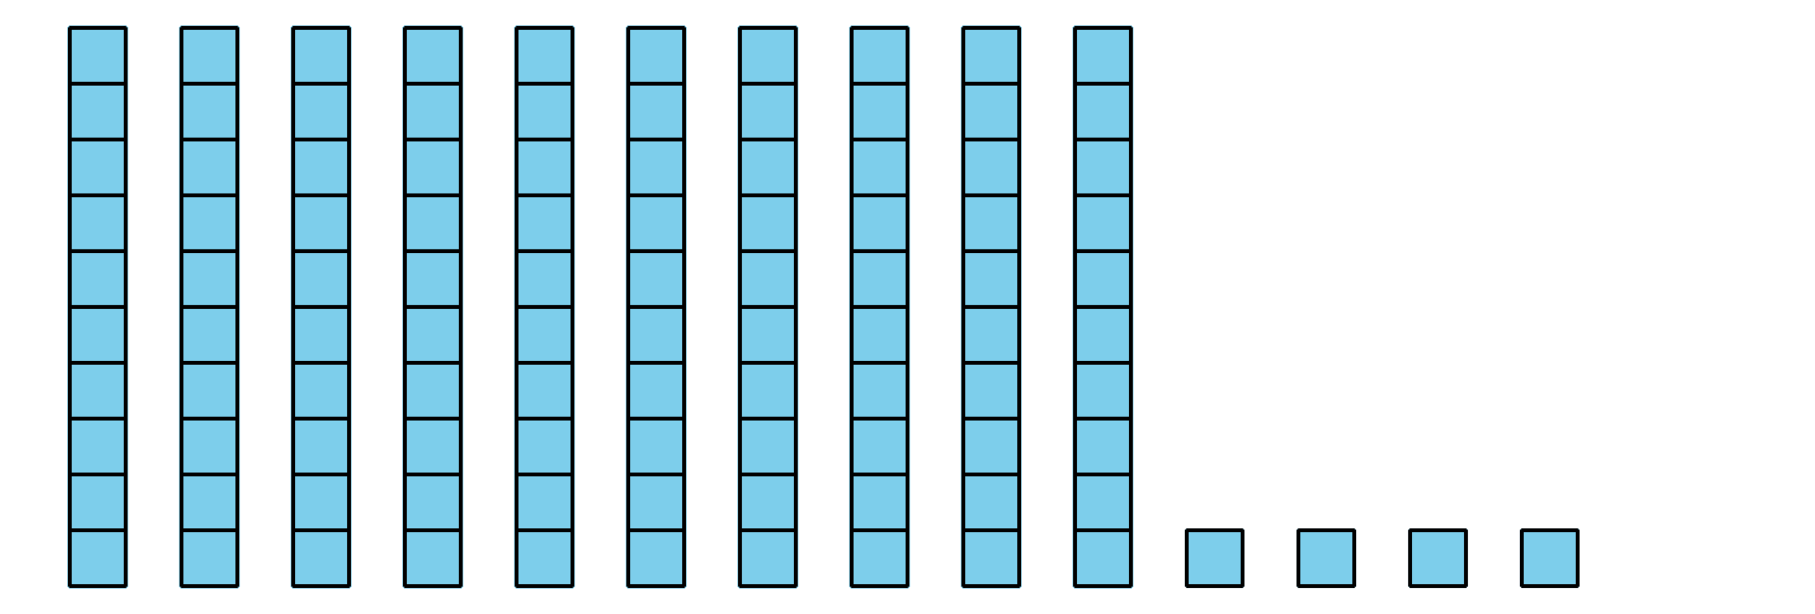
© CC BY 2021 Illustrative Mathematics®

