Unit 7 Lesson 16: Hard Times

WU Number Talk: Tens and Ones (Warm up)

Student Task Statement
Find the value of each expression mentally.
- $8+32$
- $8+33$
- $8+38$
- $8+48$

1 What’s the Time?

Student Task Statement

2 What’s the Time, Again?

Student Task Statement

- 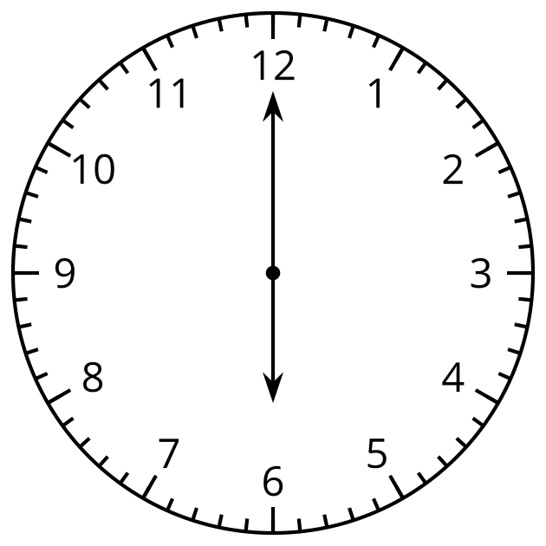
- Diego says this clock shows 6:00.
- Priya says the clock shows 12:30.
- Who do you agree with? Why?

Synthesis:
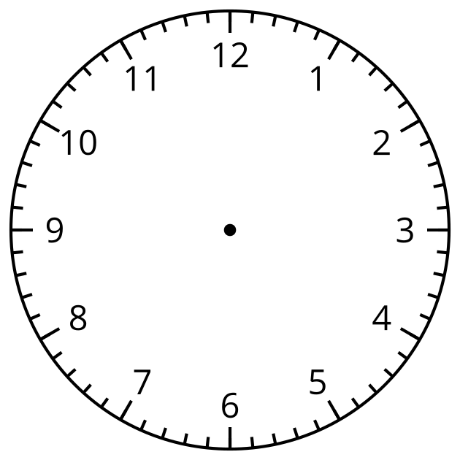
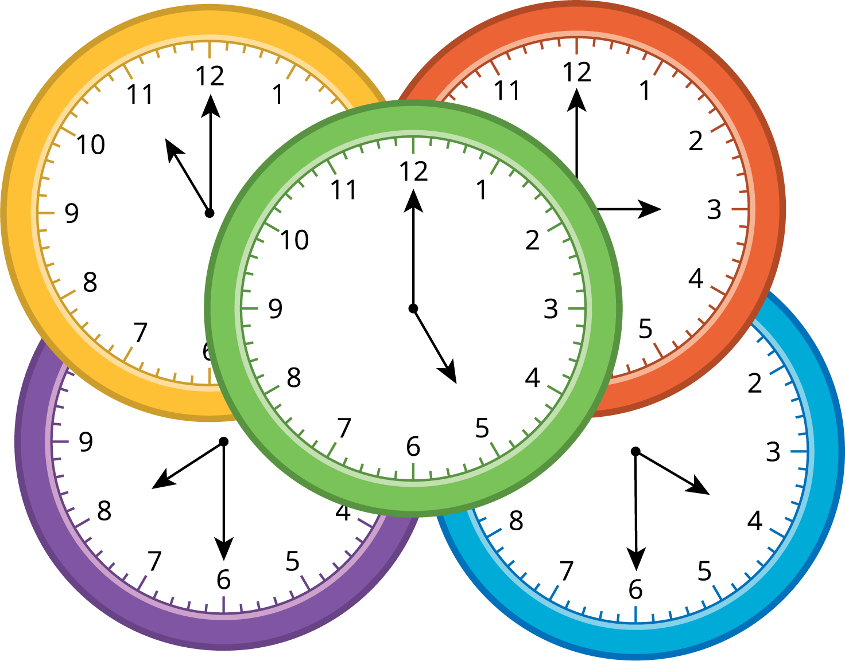

3 Sunday Schedule

Student Task Statement
Fill in the blanks to show your ideal Sunday schedule.
Time
Activity
Clock
© CC BY 2021 Illustrative Mathematics®

