Unit 8 Lesson 5: Tiny House: Cost

WU Estimation Exploration: Cost of a Room (Warm up)

Student Task Statement
What is the cost of all the labeled items in the bus?
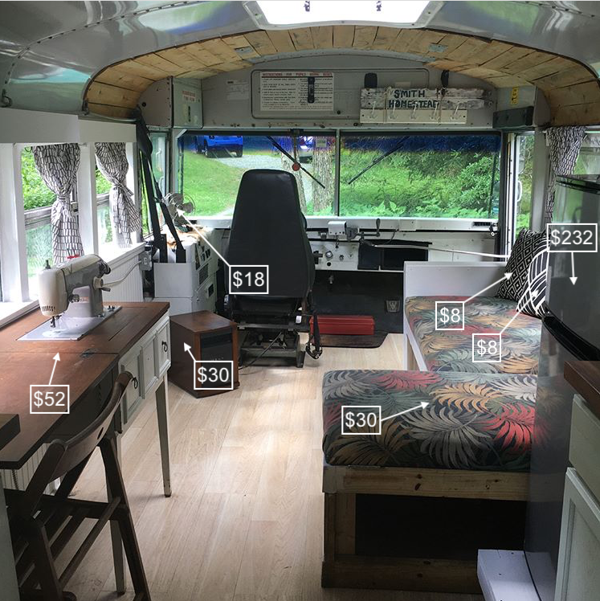
Record an estimate that is:
too low | about right | too high

1 What’s the Cost?

Student Task Statement
Choose a room from your tiny house to finish. Use the cost sheet to calculate the cost of finishing the room in your tiny house. Your budget is $1,000.
item | cost
flooring:  tile  wood  carpet | $5 for each square foot  $4 for each square foot  $2 for each square foot
paint | $25 for each gallon (up to 400 square feet)
bathroom plumbing | $379
toilet | $138
bathroom sink and faucet | $112
kitchen plumbing | $253
kitchen sink and faucet | $227
cabinets | $90 for each foot
shelving | $20 for each foot
dishes, cups, forks, spoons, etc. | Prices vary. Research or estimate cost.
dishwasher | $389
portable stove | $174
furniture | Prices vary. Research or estimate cost.
compact washer/dryer combination | $225
bed | $189
© CC BY 2021 Illustrative Mathematics®

