Lesson 16: Resolvamos todo tipo de problemas de comparación

Standards Alignments
Addressing | 2.OA.A.1, 2.OA.B.2

Teacher-facing Learning Goals
- Solve Compare problems with unknowns in all positions within 100.

Student-facing Learning Goals
- Resolvamos problemas de comparación.

Lesson Purpose
The purpose of this lesson is for students to solve Compare problems with an unknown in all positions.
The number choices in the Compare problems in this lesson encourage students to use methods based on place value to find the unknown value. Students may look for ways to compose a ten or subtract multiples of ten when finding unknown values within 100. Students will subtract numbers other than multiples of ten within 100 in future lessons. Encourage students to use a tape diagram to make sense of the problem if it is helpful.
This lesson has a Student Section Summary.

Access for:

Students with Disabilities
- Engagement (Activity 1)

English Learners
- MLR8 (Activity 1)

Instructional Routines
MLR6 Three Reads (Activity 2), True or False (Warm-up)

Lesson Timeline
Warm-up | 10 min
Activity 1 | 20 min
Activity 2 | 20 min
Lesson Synthesis | 10 min
Cool-down | 5 min

Teacher Reflection Question
What connections did students make between story problem contexts and the placement of the question mark in tape diagrams? How are students using tape diagrams to make sense of Compare problems?

Cool-down
(to be completed at the end of the lesson) 5min
Compara las páginas

Standards Alignments
Addressing | 2.OA.B.2

Student-facing Task Statement
Jada leyó 17 páginas. Noah leyó 9 páginas más que Jada. ¿Cuántas páginas leyó Noah?
Muestra cómo pensaste. Usa dibujos, números, palabras o una ecuación. Si te ayuda, puedes usar el diagrama.
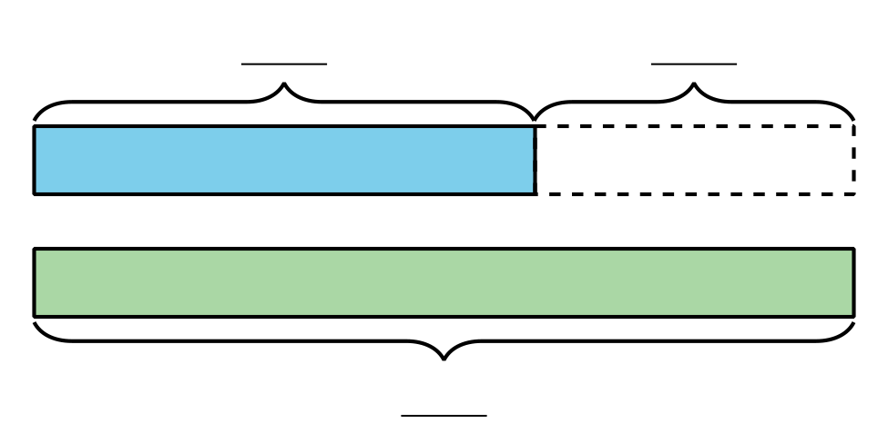

Student Responses
Noah read 26 pages.
Sample responses:
$17+9=?$
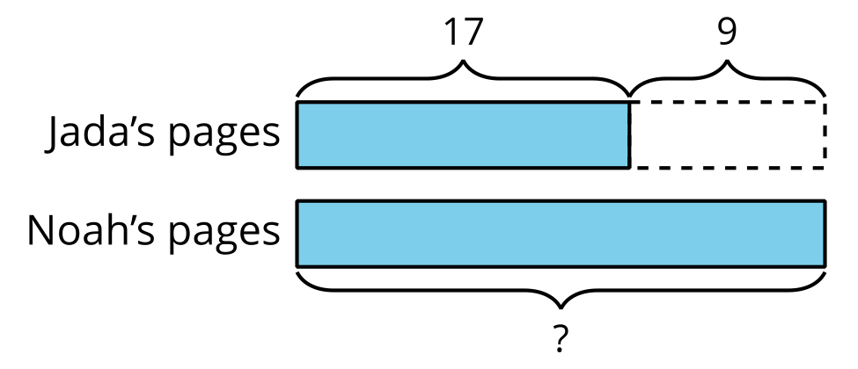
$16+1+9=26$

