Teacher Presentation Materials

Unit 6 Lesson 9: The Distributive Property, Part 1

1 Number Talk: Ways to Multiply (Warm up)

Student Task Statement
Find each product mentally.
$5⋅102$
$5⋅98$
$5⋅999$

2 Ways to Represent Area of a Rectangle

Student Task Statement
- Select all the expressions that represent the area of the large, outer rectangle in figure A. Explain your reasoning.
  - $6+3+2$
  - $6⋅3+6⋅2$
  - $6⋅3+2$
  - $6⋅5$
  - $6(3+2)$
  - $6⋅3⋅2$
- 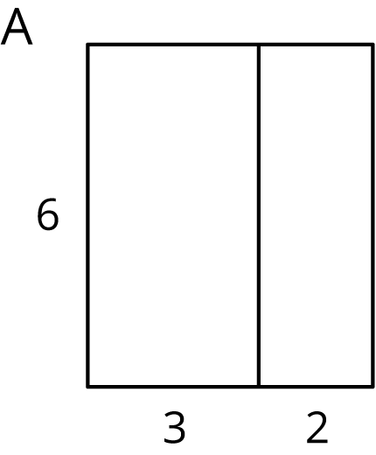
- Select all the expressions that represent the area of the shaded rectangle on the left side of figure B. Explain your reasoning.
  - $4⋅7+4⋅2$
  - $4⋅7⋅2$
  - $4⋅5$
  - $4⋅7−4⋅2$
  - $4(7−2)$
  - $4(7+2)$
  - $4⋅2−4⋅7$
- 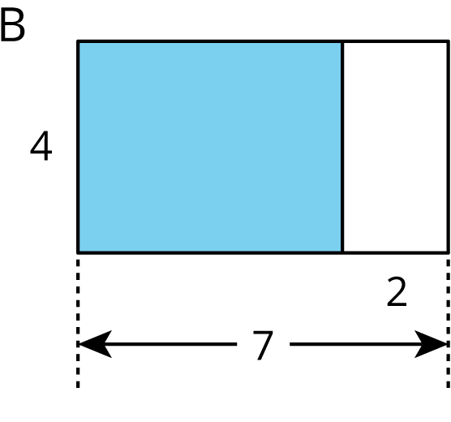

3 Distributive Practice

Student Task Statement
Complete the table. If you get stuck, skip an entry and come back to it, or consider drawing a diagram of two rectangles that share a side.
column 1 | column 2 | column 3 | column 4 | value
$5⋅98$ | $5(100−2)$ | $5⋅100−5⋅2$ | $500−10$ | 490
$33⋅12$ | $33(10+2)$
 |  | $3⋅10−3⋅4$ | $30−12$
 | $100(0.04+0.06)$
 |  | $8⋅\frac{1}{2}+8⋅\frac{1}{4}$
 |  |  | $9+12$
 |  |  | $24−16$

© CC BY Open Up Resources. Adaptations CC BY IM.

