Unit 2 Lesson 7: Using Factors and Zeros

1 More Than Factors (Warm up)

Student Task Statement
$M$ and $K$ are both polynomial functions of $x$ where $M\left(x\right)=\left(x+3\right)\left(2x−5\right)$ and $K\left(x\right)=3\left(x+3\right)\left(2x−5\right)$.
- How are the two functions alike? How are they different?
- If a graphing window of $\text{-}5≤x≤5$ and $\text{-}20≤y≤20$ shows all intercepts of a graph of $y=M\left(x\right)$, what graphing window would show all intercepts of $y=K\left(x\right)$?

2 Choosing Windows

Student Task Statement
Mai graphs the function $p$ given by $p\left(x\right)=\left(x+1\right)\left(x−2\right)\left(x+15\right)$ and sees this graph.
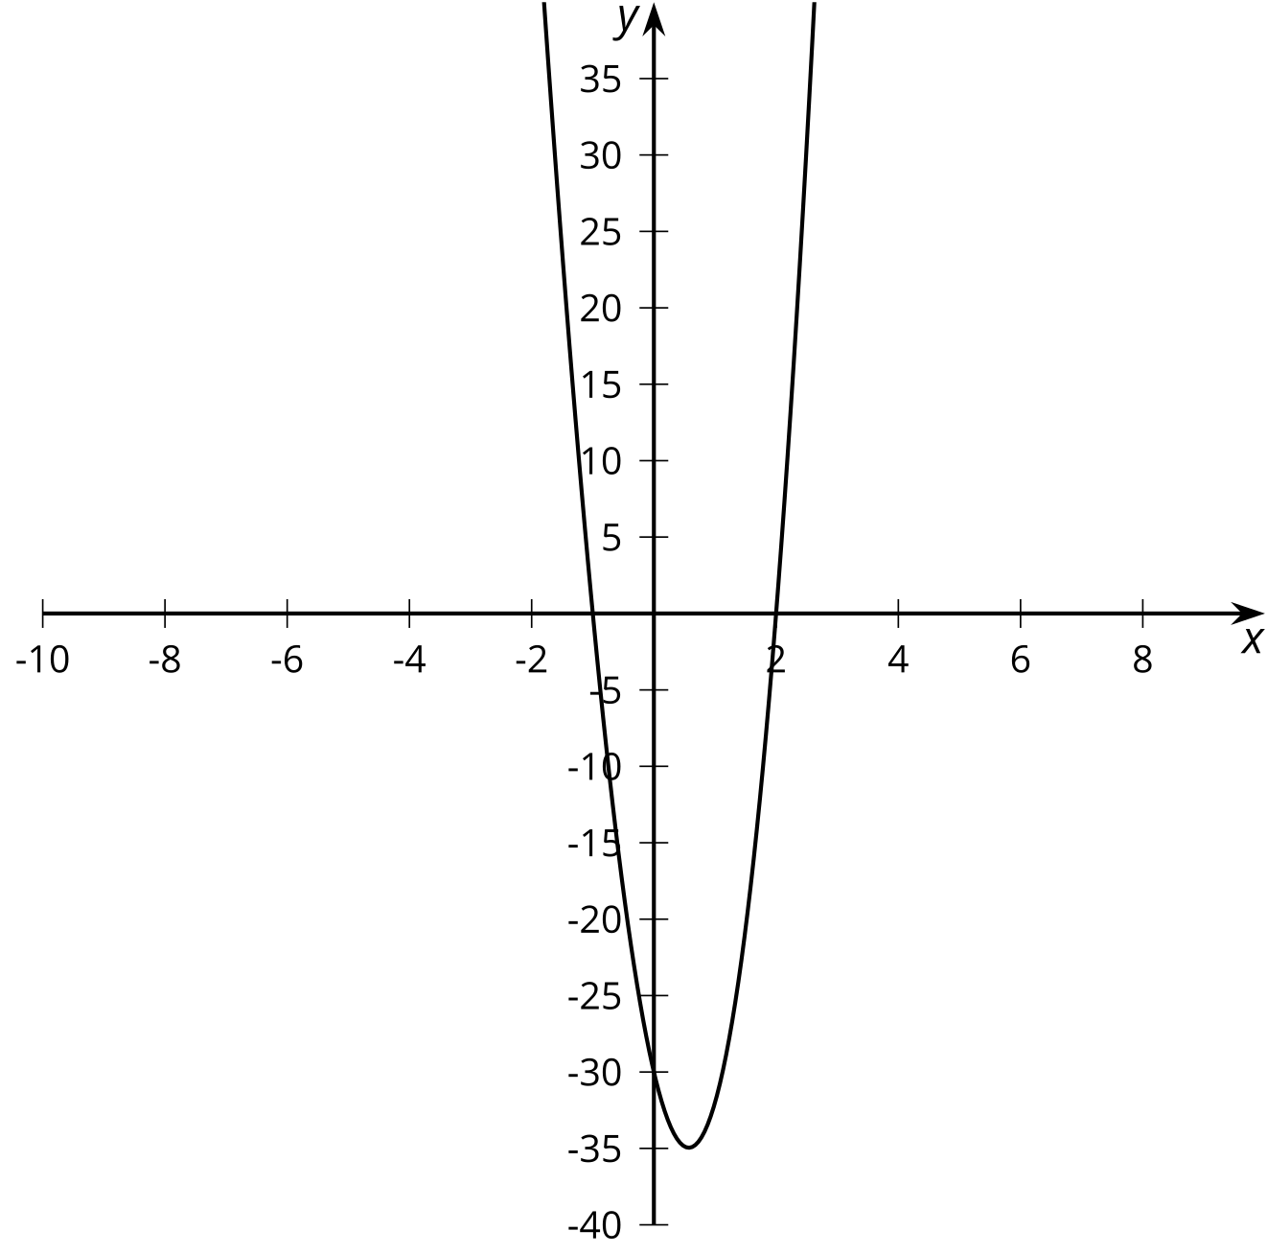
She says, “This graph looks like a parabola, so it must be a quadratic.”
- Is Mai correct? Use graphing technology to check.
- Explain how you could select a viewing window before graphing an expression like $p\left(x\right)$ that would show the main features of a graph.
- Using your explanation, what viewing window would you choose for graphing $f\left(x\right)=\left(x+1\right)\left(x−1\right)\left(x−2\right)\left(x−28\right)$?

3 What’s the Equation?

Student Task Statement
Write a possible equation for a polynomial whose graph has the following horizontal intercepts. Check your equation using graphing technology.
- $\left(4,0\right)$
- $\left(0,0\right)$ and $\left(4,0\right)$
- $\left(\text{-}2,0\right)$, $\left(0,0\right)$ and $\left(4,0\right)$
- $\left(\text{-}4,0\right),\left(0,0\right)$, and $\left(2,0\right)$
- $\left(\text{-}5,0\right)$, $\left(\frac{1}{2},0\right)$, and $\left(3,0\right)$
© CC BY 2019 by Illustrative Mathematics®

