Lesson 7 Practice Problems
- Diego wrote $f(x)=(x+2)(x−4)$ as an example of a function whose graph has $x$-intercepts at $x=\text{-}4,2$. What was his mistake?
- Write a possible equation for a polynomial whose graph has horizontal intercepts at $x=2,\text{-}\frac{1}{2},\text{-}3$.
- Which polynomial function’s graph is shown here?
- 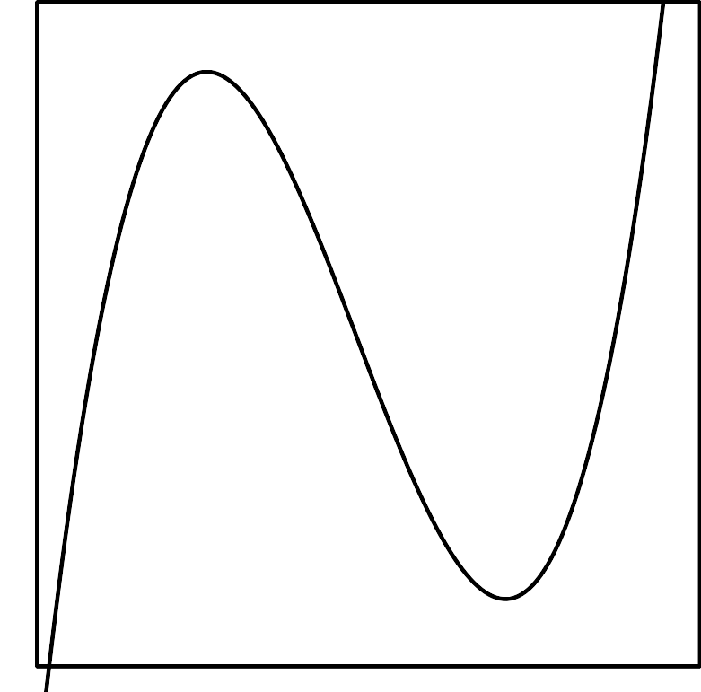
  - $f(x)=(x+1)(x+3)(x+4)$
  - $f(x)=(x+1)(x−3)(x+4)$
  - $f(x)=(x−1)(x+3)(x−4)$
  - $f(x)=(x−1)(x−3)(x−4)$
- Which expression is equivalent to $(3x+2)(3x−5)$?
  - $6x−3$
  - $9x^{2}−10$
  - $9x^{2}−3x−10$
  - $9x^{2}−9x−10$
- (From Unit 2, Lesson 4.)
- What is the value of $6(x−2)(x−3)+4(x−2)(x−5)$ when $x=\text{-}3$?
- (From Unit 2, Lesson 5.)
- Match each polynomial function with its leading coefficient.
  - $P(x)=(x+2)(2x−3)(4x+7)$
  - $P(x)=\frac{1}{2}(x−2)(2x−3)(4x+7)$
  - $P(x)=5(x−2)(2x−3)(4x+7)$
  - $P(x)=\text{-}(x−2)(2x−3)(4x+7)$
  - $P(x)=\frac{1}{4}(x+2)(2x−3)(4x+7)$
  - 40
  - 8
  - 4
  - 2
  - -8
- (From Unit 2, Lesson 6.)
© CC BY 2019 by Illustrative Mathematics®

