Unit 2 Lesson 10: Center Day 2

WU Number Talk: Subtraction Methods (Warm up)

Student Task Statement
Find the value of each expression mentally.
- $7−2$
- $8−2$
- $7−5$
- $8−6$

1 Introduce Capture Squares, Add Within 10

Student Task Statement

2 Centers: Choice Time

Student Task Statement
Choose a center.
Math Stories
Shake and Spill
Capture Squares
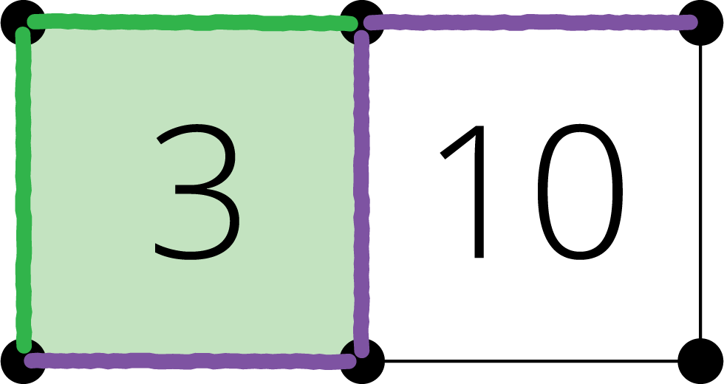
© CC BY 2021 Illustrative Mathematics®

