Lesson 9: Write Numbers to 120
- Let’s count, write, and read numbers up to 120.

9.1: Measure Animal Lengths
Animal:________________________________
Length: _______________________
Show your thinking using drawings, numbers, or words.

9.2: Write Numbers to Represent Animal Lengths
For each animal, write the number of cubes that represent its length.
- The beaver is ______________________ long.
- The dog is ______________________ long.
- The giant anteater is ______________________ long.
- The raccoon is ______________________ long.
- The red fox is ______________________ long.
- The snake is ______________________ long.
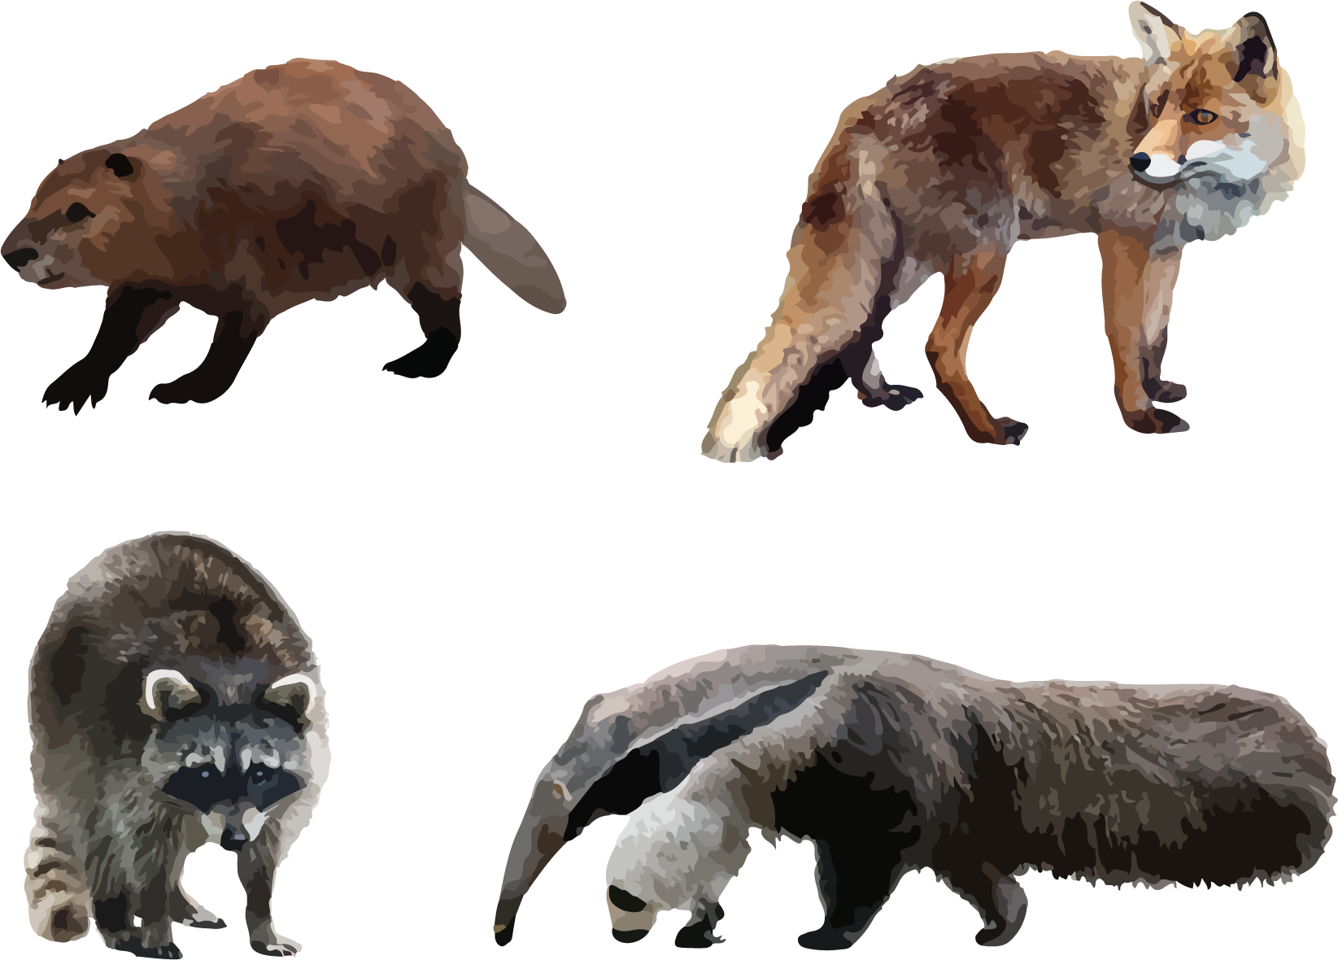
© CC BY 2021 Illustrative Mathematics®

