Unit 7 Lesson 17: Center Day 3

WU Which One Doesn’t Belong: Clocks (Warm up)

Student Task Statement
Which one doesn’t belong?
A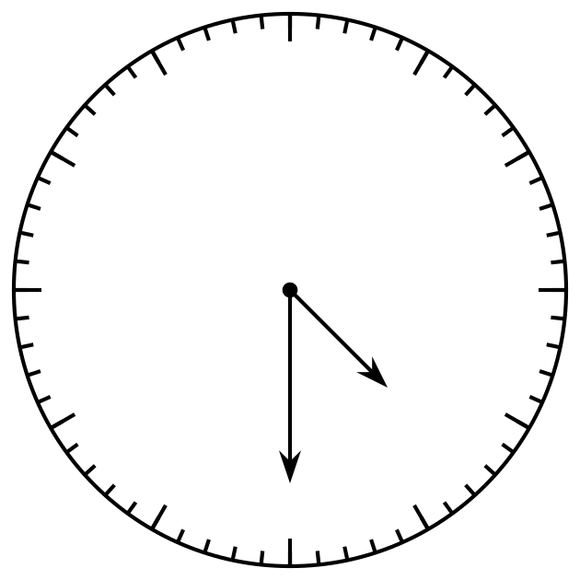
B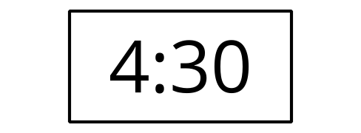
C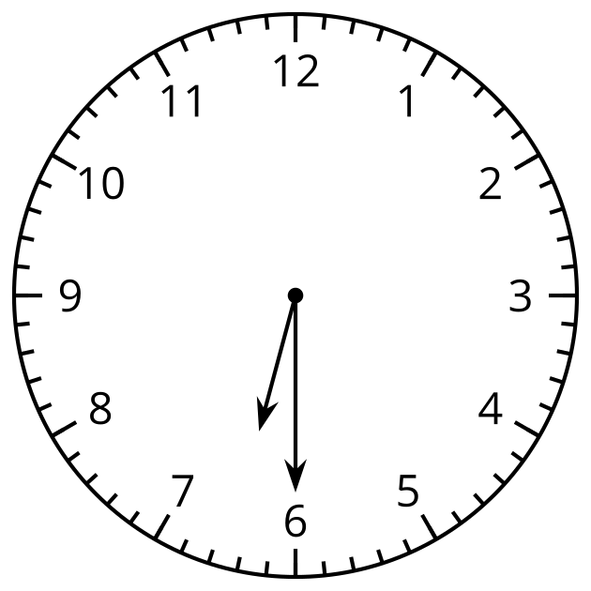
D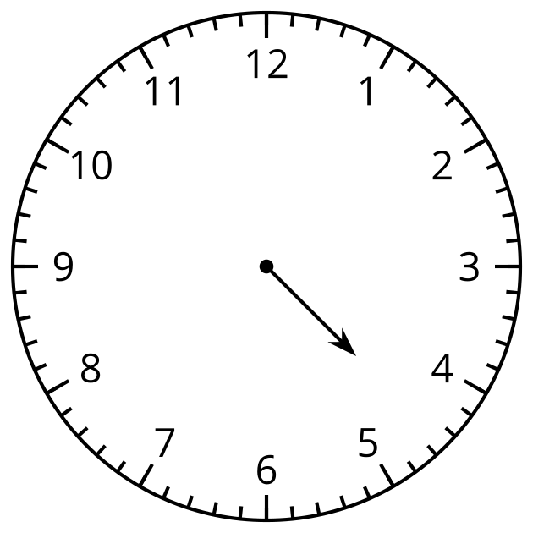

1 Introduce Which One, Grade 1 Shapes

Student Task Statement

2 Centers: Choice Time

Student Task Statement
Choose a center.
Can You Draw It?
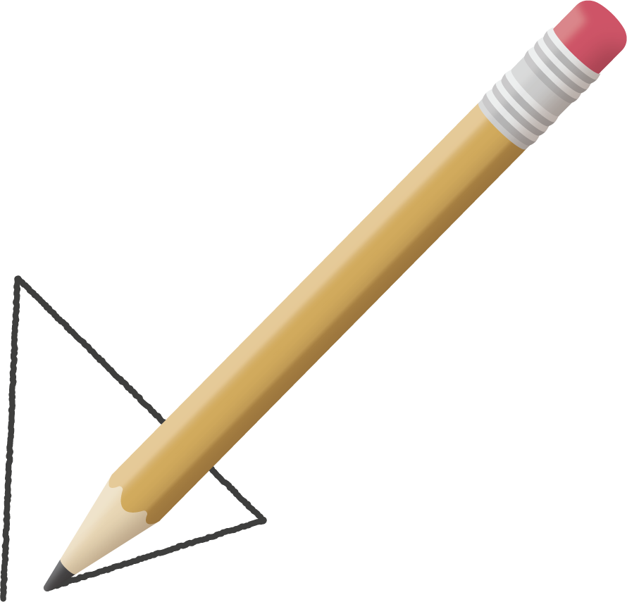
Match Mine
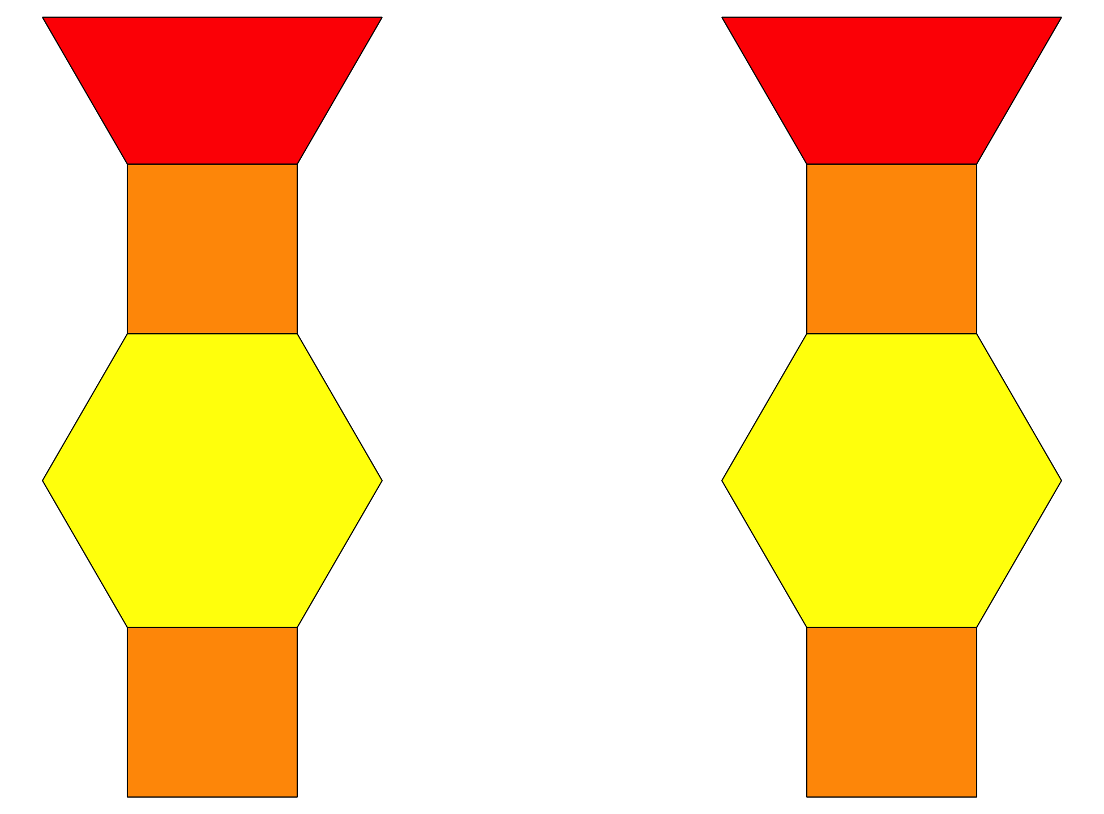
Capture Squares
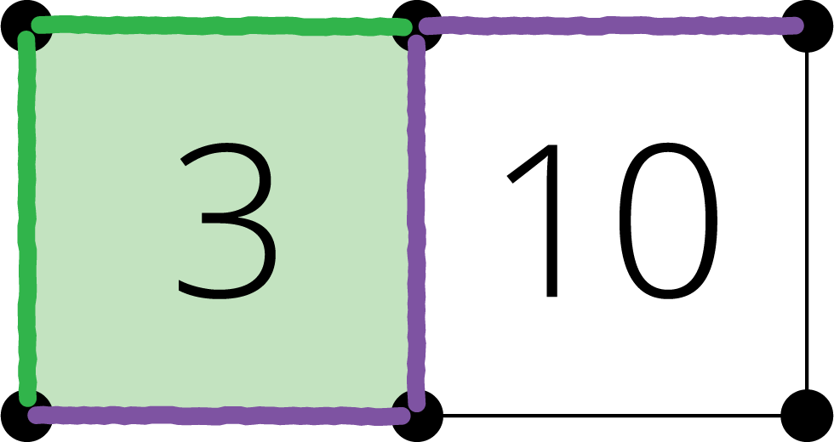
Target Numbers
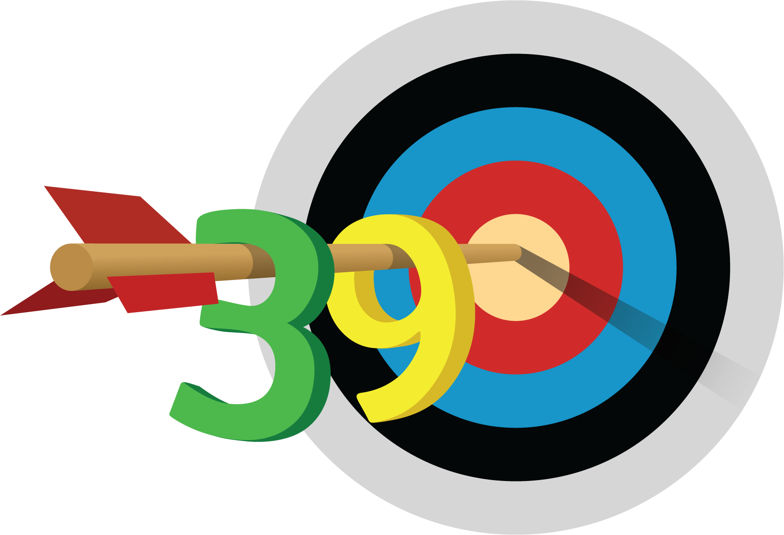
© CC BY 2021 Illustrative Mathematics®

