Unit 8 Lesson 6: Survey the Class, Survey the School

WU Notice and Wonder: Survey (Warm up)

Student Task Statement
What do you notice? What do you wonder?
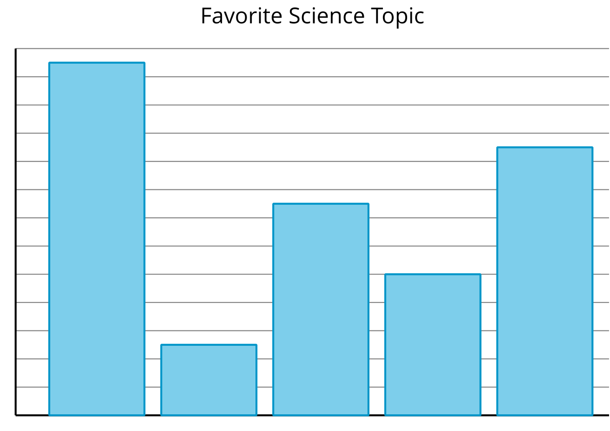

1 Create a Survey

Student Task Statement
Create a survey that you’ll use with a large group of students. It should include:
- a question
- up to 6 answer choices

2 Survey a Large Group

Student Task Statement
Your group will be surveying a lot of people. This means asking your survey question and giving the answer choices repeatedly.
To prepare for the work ahead, discuss these questions with your group:
- How will you present the survey question and answer choices? Who will present them?
- How will you record and organize the responses? Who will record them?
- How will you make sure you don't record a response from the same student multiple times?
© CC BY 2021 Illustrative Mathematics®

