Lesson 13: Center Day 2
- Let’s work on place value.

Warm-up: How Many Do You See: Place Value
How many do you see and how do you see them?
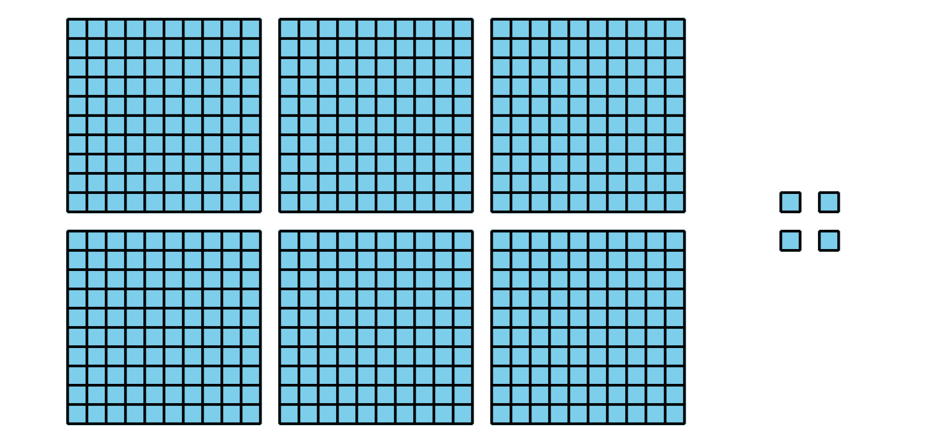
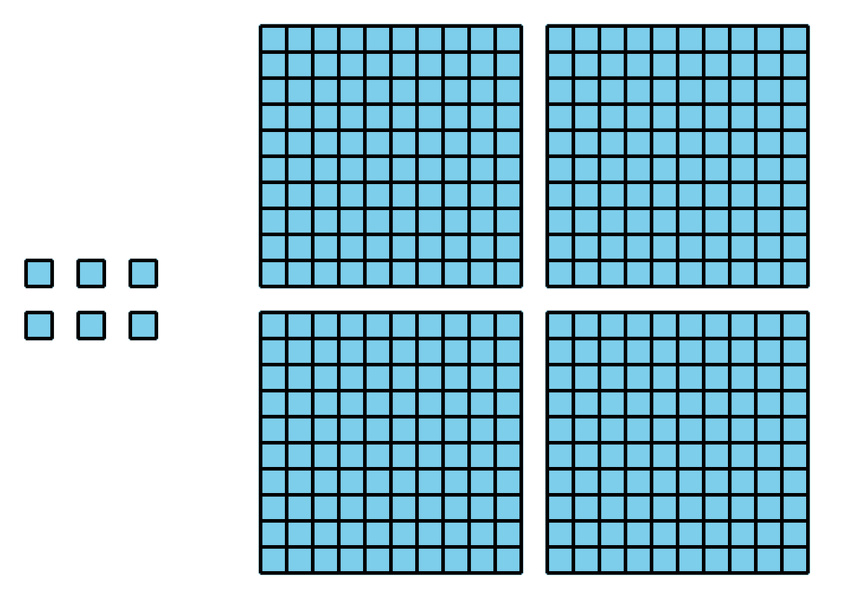
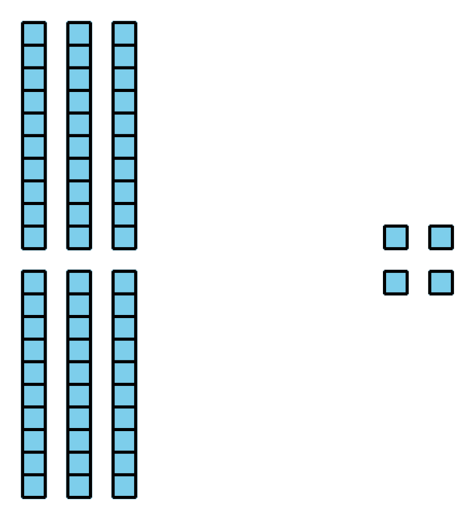

13.2: Centers: Choice Time
Choose a center.
Get Your Numbers in Order
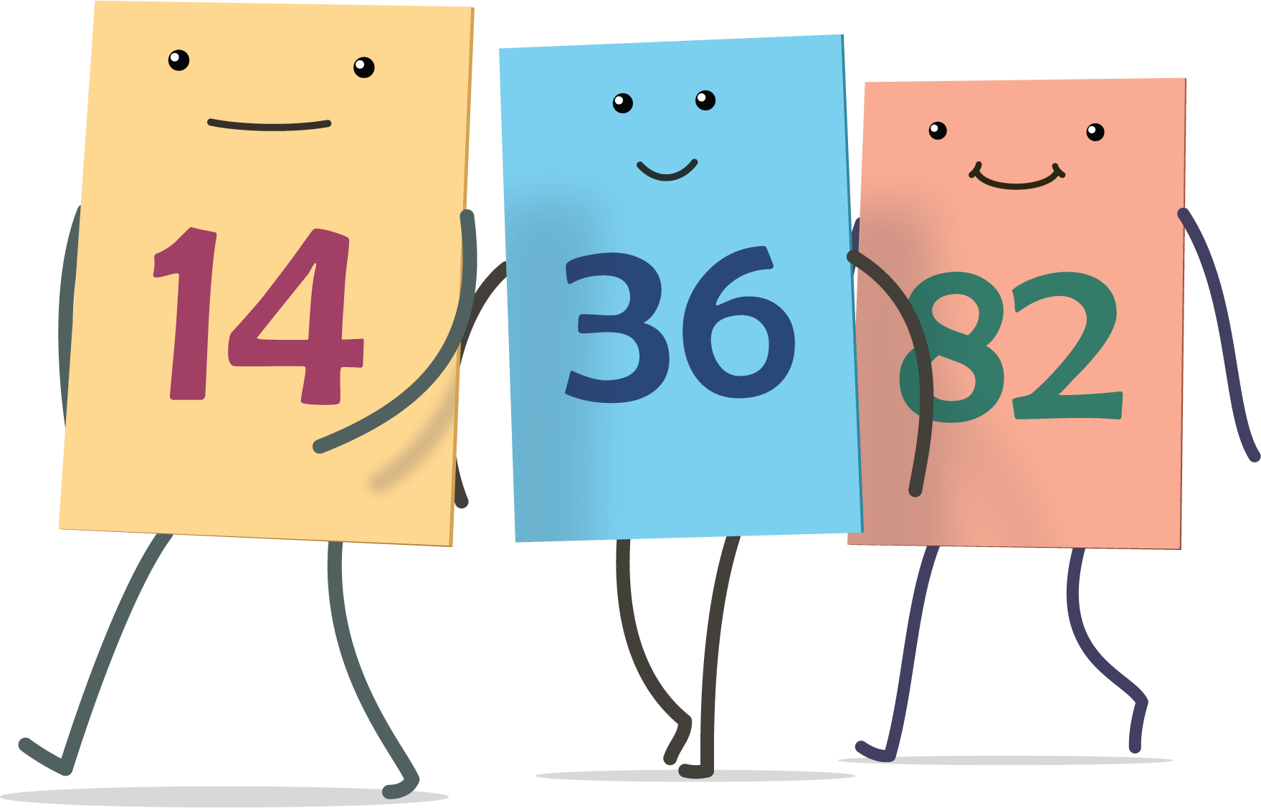
Greatest of Them All
Mystery Number
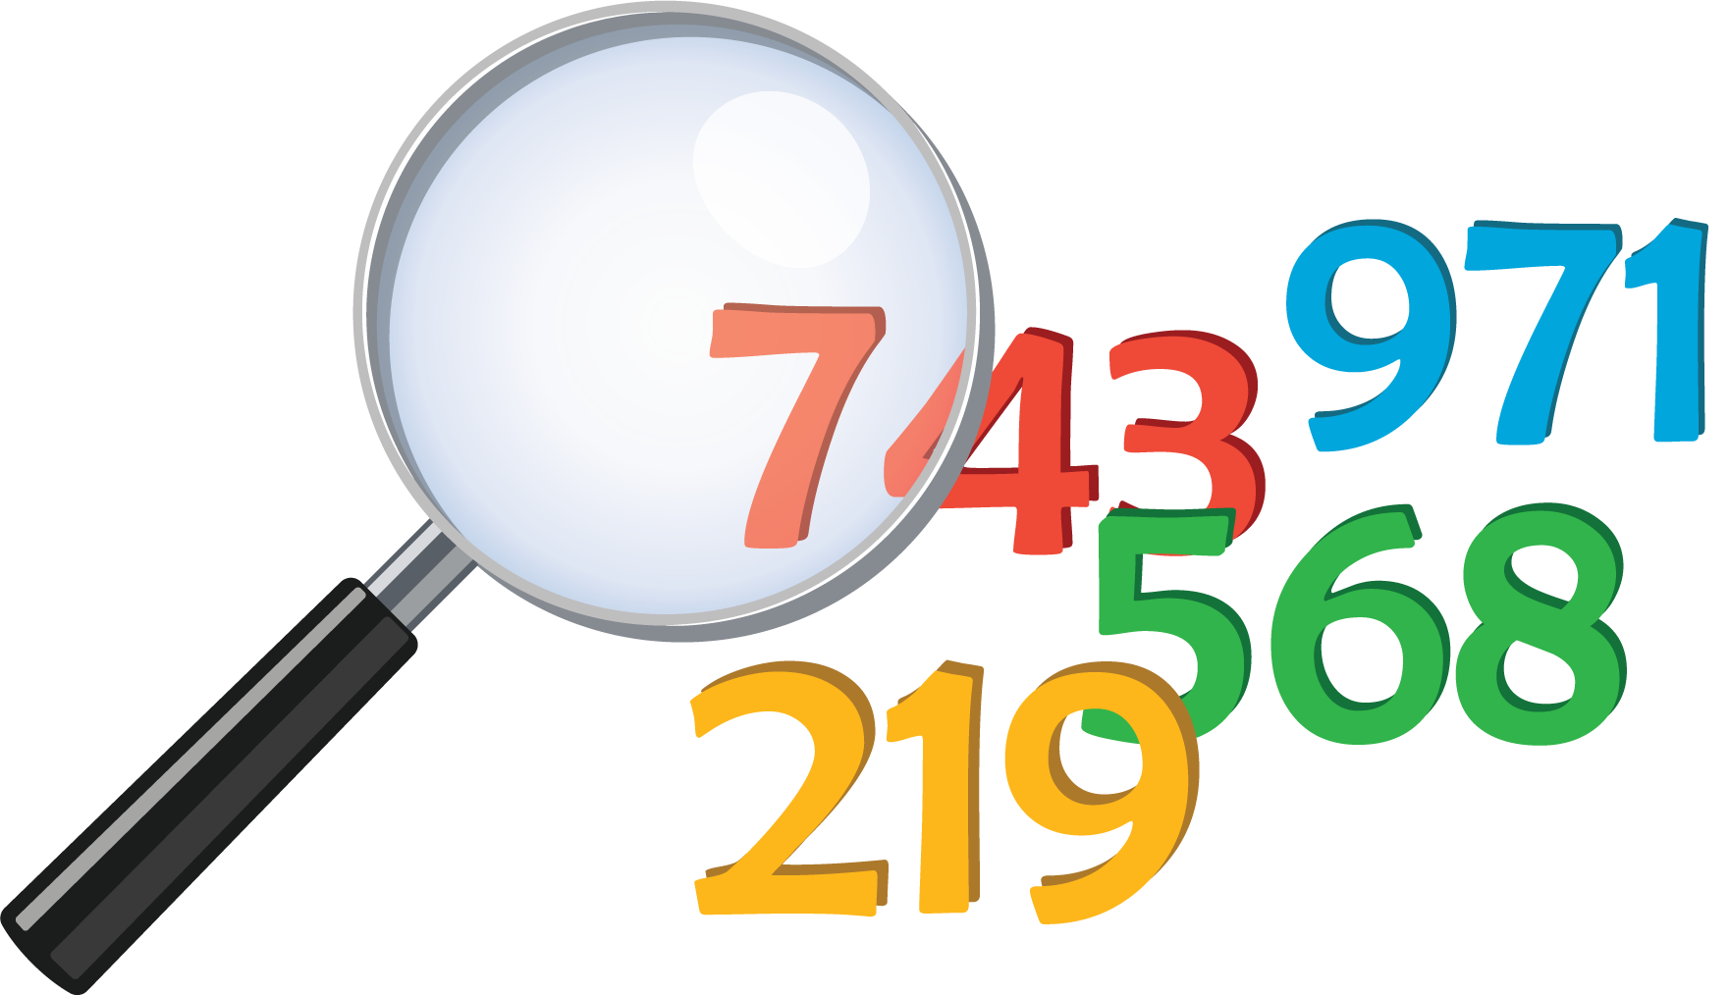
© CC BY 2021 Illustrative Mathematics®

