Unit 6 Lesson 16: Identify Quarters

WU Choral Count: Counting on by 5 (Warm up)

Student Task Statement

1 How Much is a Quarter Worth?

Images for Launch
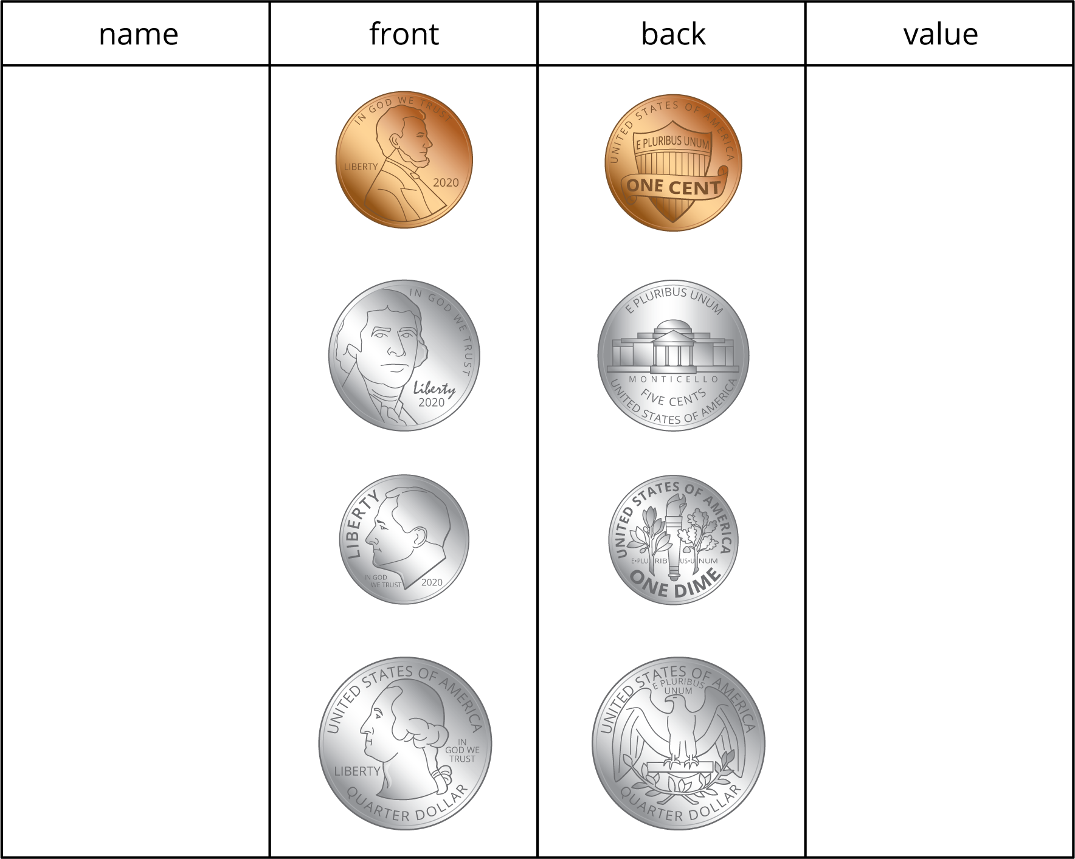

Student Task Statement
Write the names and values of the coins you know.
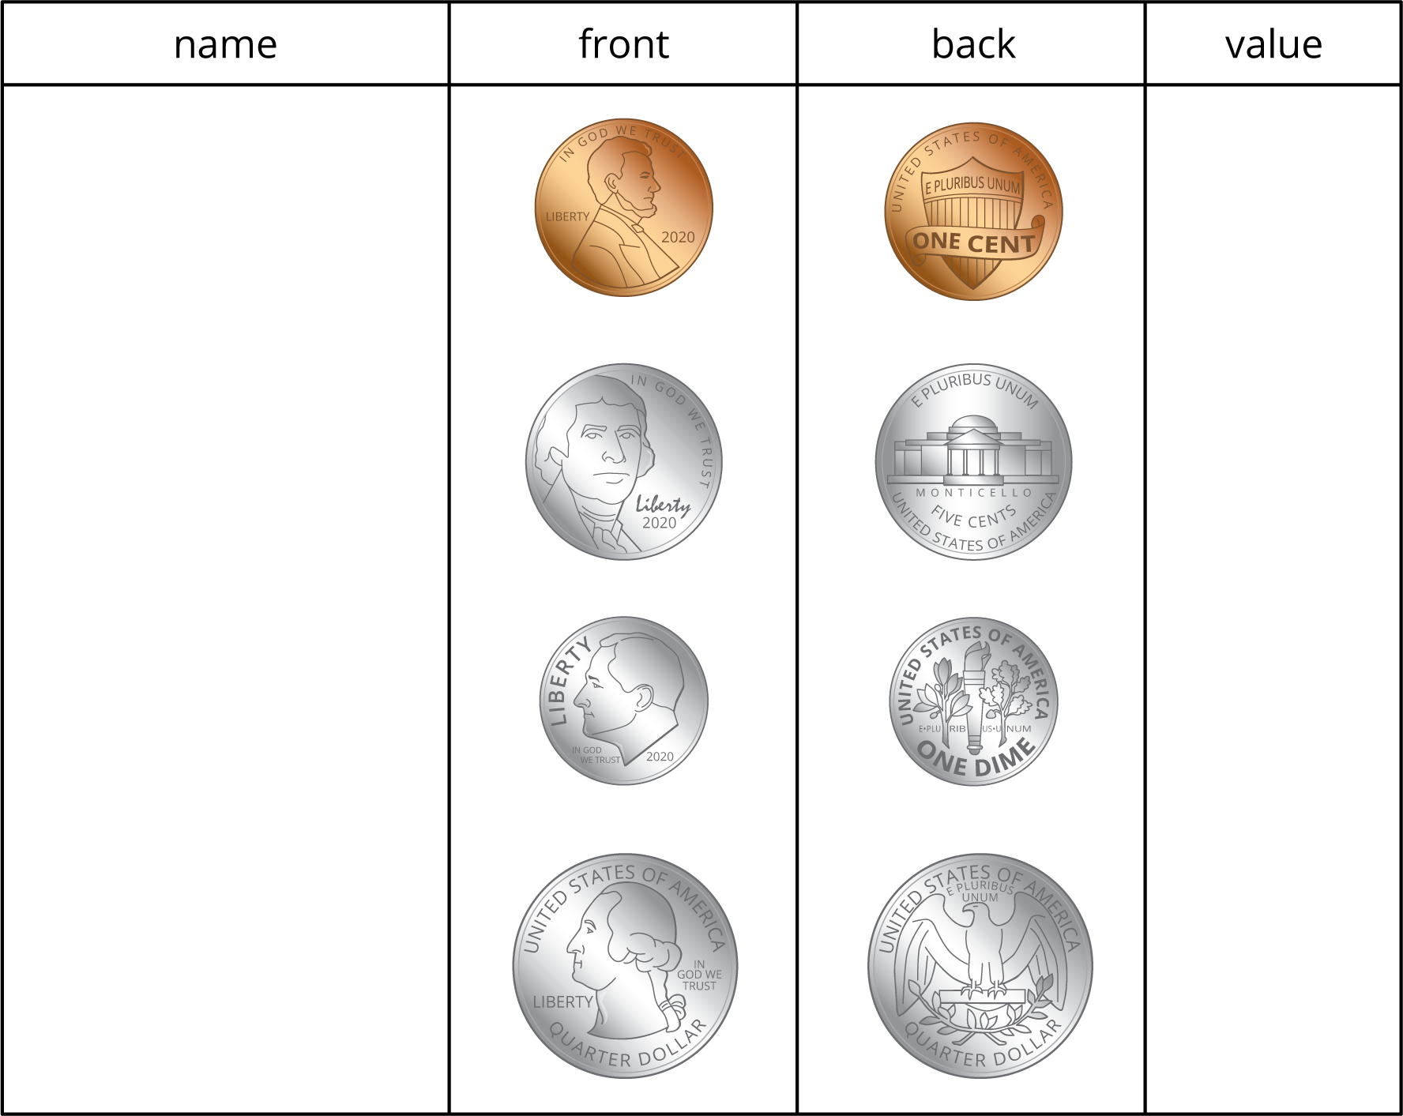
Complete the table so each row shows a value in cents and two different groups of coins that have that value.
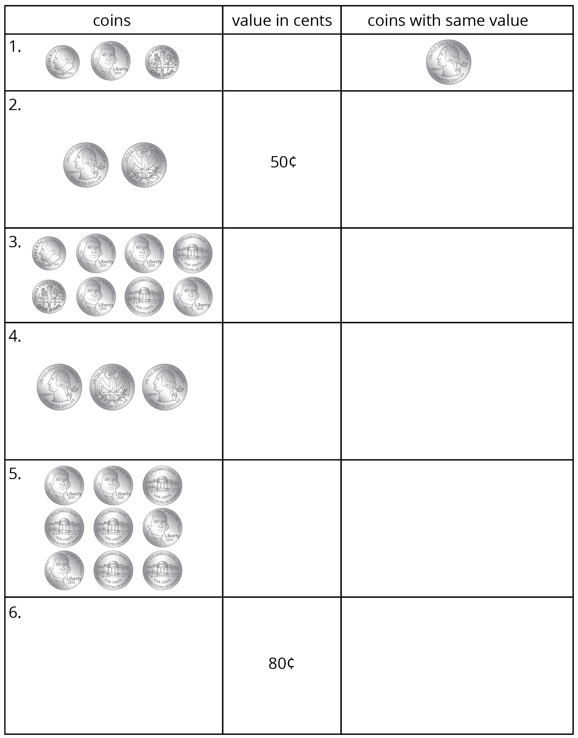

2 More Coins to Compare

Student Task Statement
- Elena's Coins
- 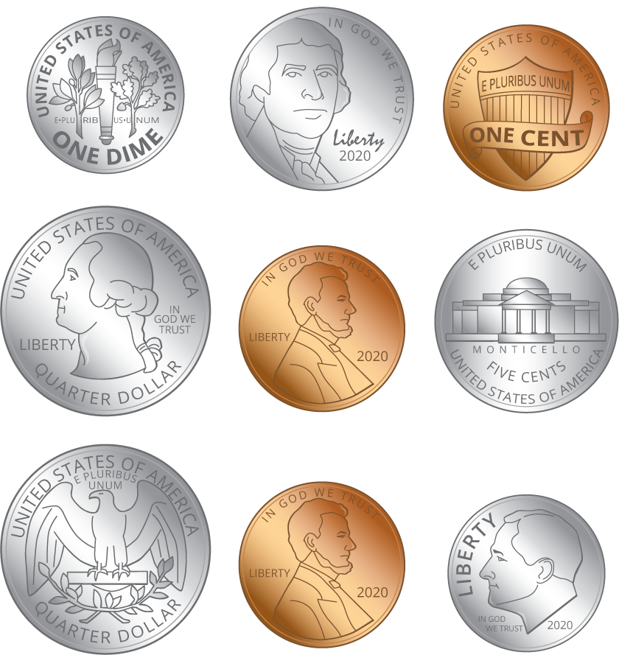
- Elena has:
- quarters
- dimes
- nickels
- pennies
- How many cents? Show your thinking.
- Tyler's Coins
- 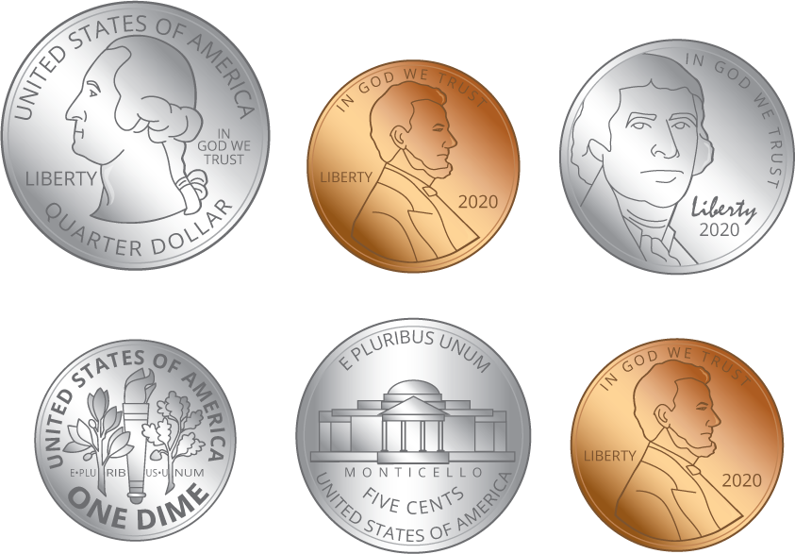
- Tyler has:
- quarters
- dimes
- nickels
- pennies
- How many cents? Show your thinking.
- Make your own set of coins with a value of 97¢.
- I used:
- quarters
- dimes
- nickels
- pennies
- Make your own set of coins with a value of 66¢. Use the fewest number of coins possible.
- I used:
- quarters
- dimes
- nickels
- pennies
© CC BY 2021 Illustrative Mathematics®

