Unit 4 Lesson 1: Describing and Graphing Situations

1 Bagel Shop (Warm up)

Student Task Statement
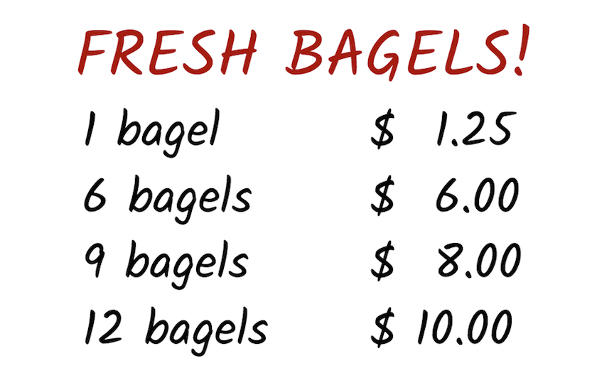
A customer at a bagel shop is buying 13 bagels. The shopkeeper says, “That would be $16.25.”
Jada, Priya, and Han, who are in the shop, all think it is a mistake.
- Jada says to her friends, “Shouldn’t the total be $13.25?”
- Priya says, “I think it should be $13.00.”
- Han says, “No, I think it should be $11.25.”
Explain how the shopkeeper, Jada, Priya, and Han could all be right.

Your teacher will give you instructions for completing the table.
number
of bagels
1
2
3
4
5
6
7
8
9
10
11
12
13

Activity Synthesis

2 Be Right Back!

Images for Launch

Student Task Statement
Three days in a row, a dog owner tied his dog’s 5-foot-long leash to a post outside a store while he ran into the store to get a drink. Each time, the owner returned within minutes.
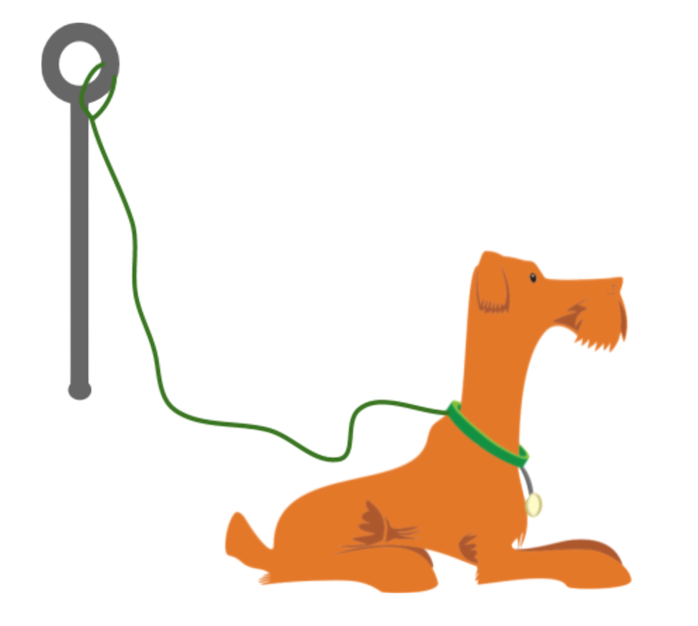
The dog’s movement each day is described here.
- Day 1: The dog walked around the entire time while waiting for its owner.
- Day 2: The dog walked around for the first minute, and then laid down until its owner returned.
- Day 3: The dog tried to follow its owner into the store but was stopped by the leash. Then, it started walking around the post in one direction. It kept walking until its leash was completely wound up around the post. The dog stayed there until its owner returned.
- Each day, the dog was 1.5 feet away from the post when the owner left.
- Each day, 60 seconds after the owner left, the dog was 4 feet from the post.
Your teacher will assign one of the days for you to analyze.
Sketch a graph that could represent the dog’s distance from the post, in feet, as a function of time, in seconds, since the owner left.
Day $\underset{_}{}$

3 Talk about a Function

Student Task Statement
Here are two pairs of quantities from a situation you’ve seen in this lesson. Each pair has a relationship that can be defined as a function.
- time, in seconds, since the dog owner left and the total number of times the dog has barked
- time, in seconds, since the owner left and the total distance, in feet, that the dog has walked while waiting
Choose one pair of quantities and express their relationship as a function.
- In that function, which variable is independent? Which one is dependent?
- Write a sentence of the form “$\underset{_}{}$ is a function of $\underset{_}{}$.”
- Sketch a possible graph of the relationship on the coordinate plane. Be sure to label and indicate a scale on each axis, and be prepared to explain your reasoning.
- 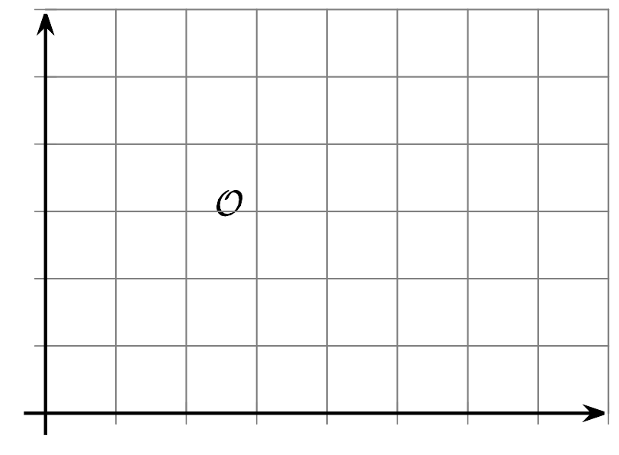
© CC BY 2019 by Illustrative Mathematics®

