Lesson 14: Shapes in Art
- Let’s find shapes in art and use shapes to make our own art.

Warm-up: Notice and Wonder: Shapes in Art
What do you notice?
What do you wonder?
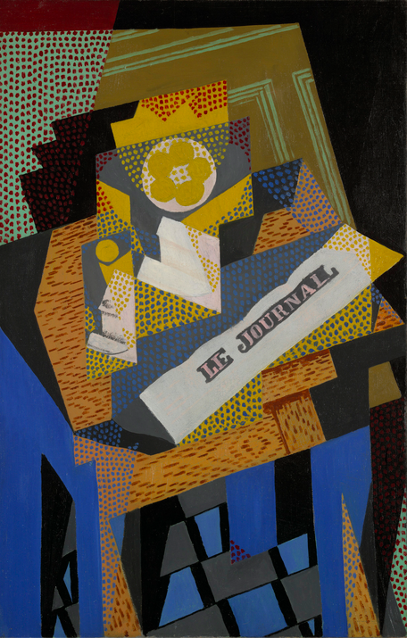

14.3: Centers: Choice Time
Choose a center.
Match Mine
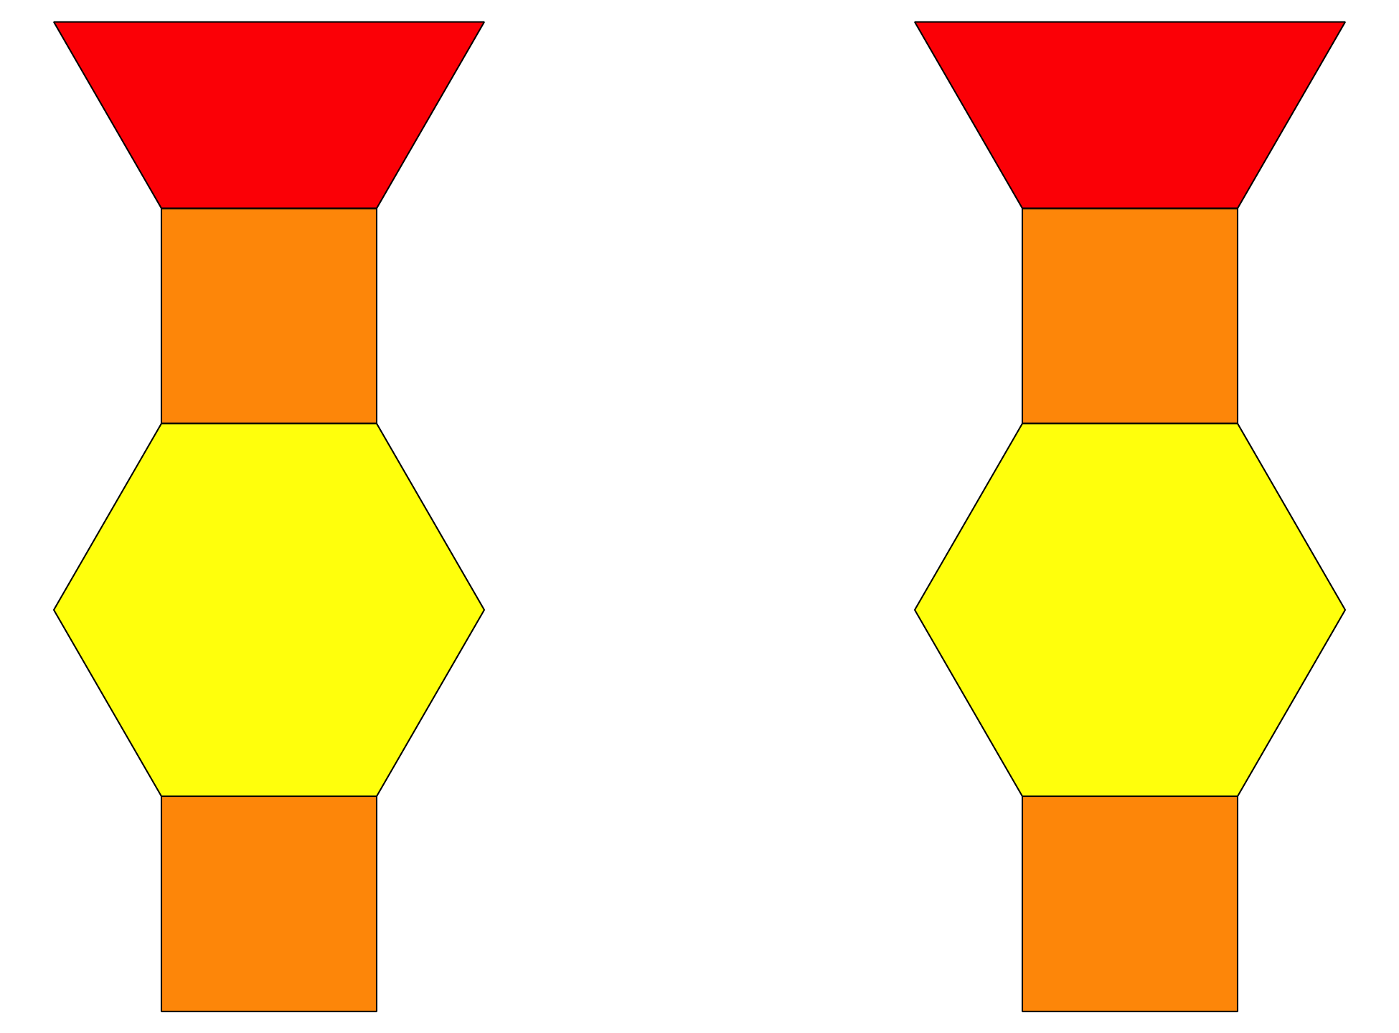
Geoblocks
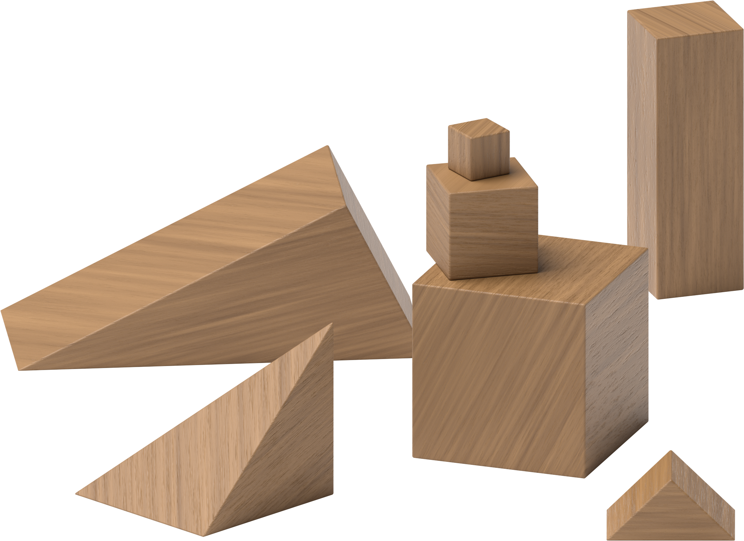
Build Shapes
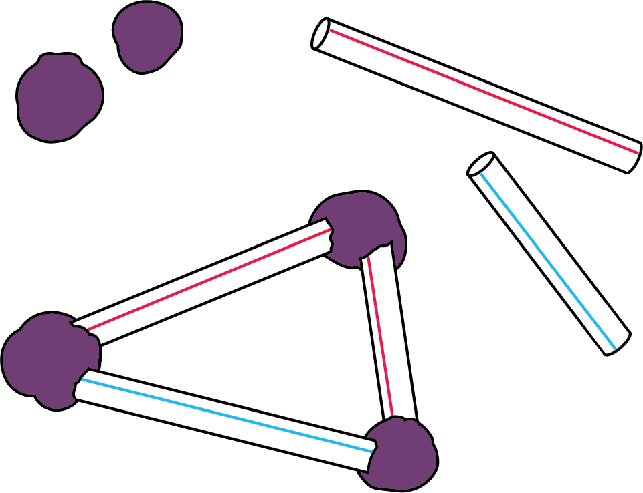
Pattern Blocks
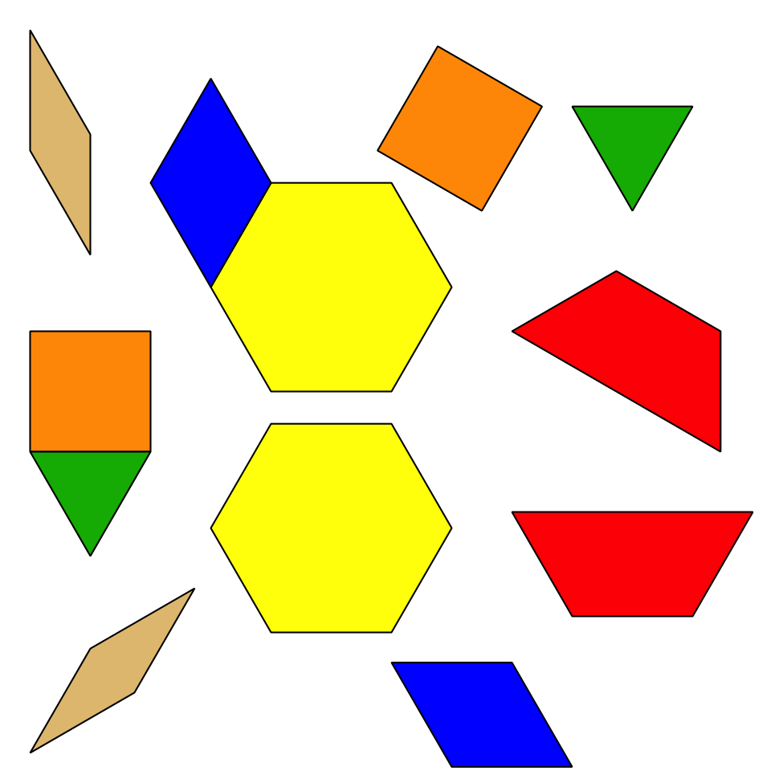
Less, Same, More
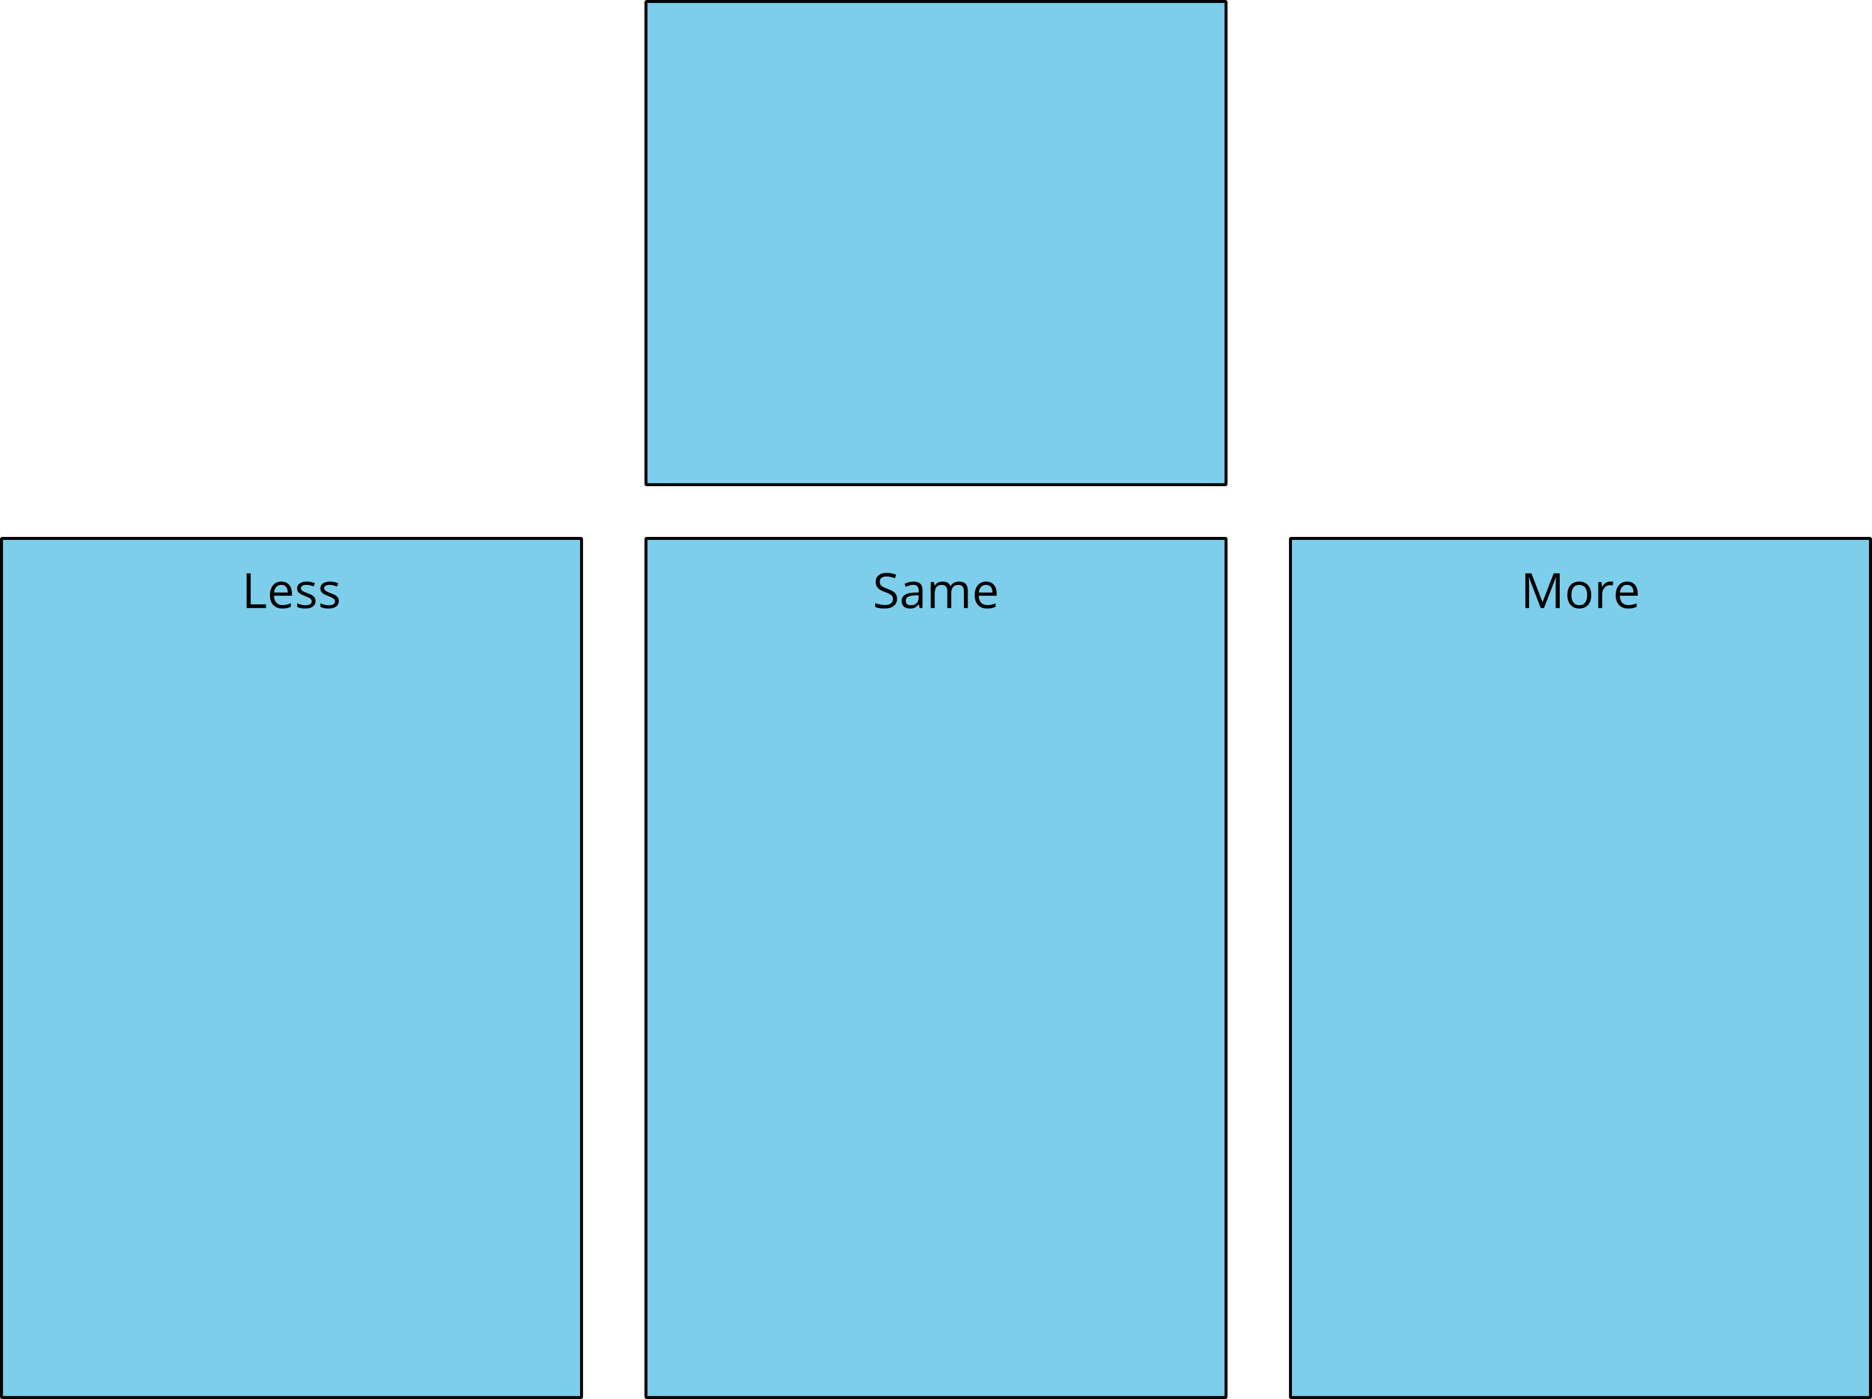

Section Summary
Section Summary
In this section we put shapes together to make larger shapes.
Sometimes we used shapes to make other shapes.
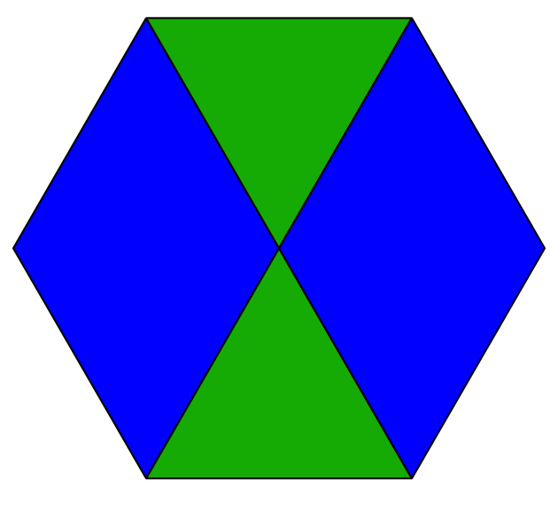
Sometimes we used shapes to make things in the world.
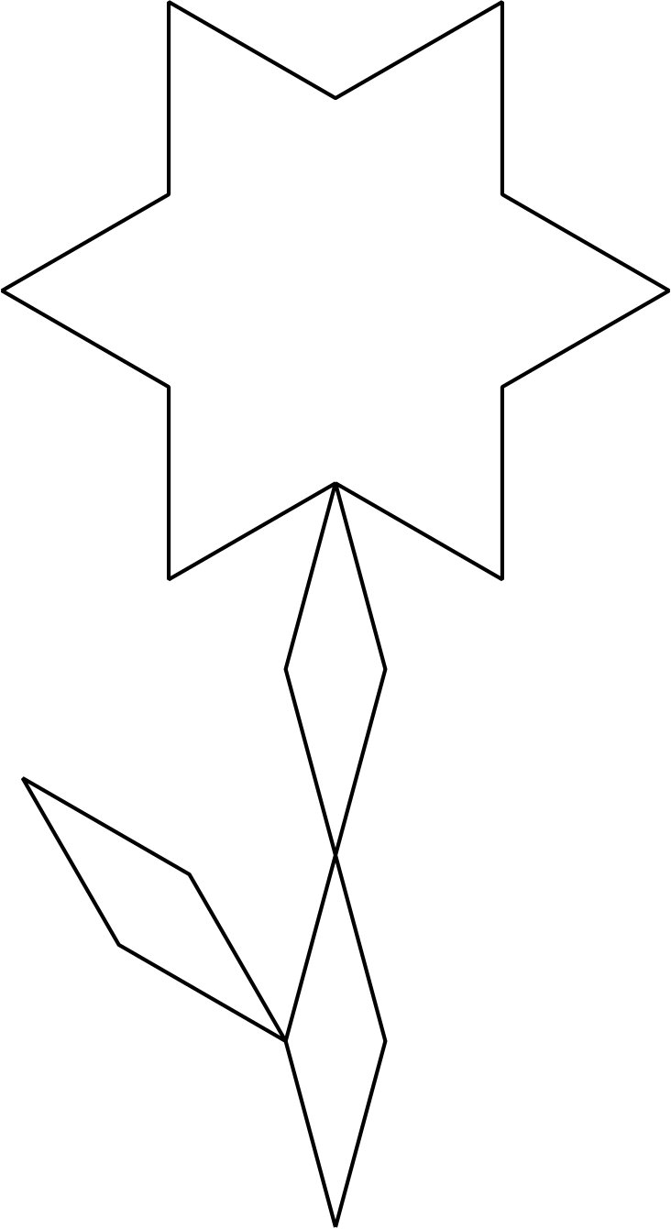
We learned that the same shape can look different when it is moved around.
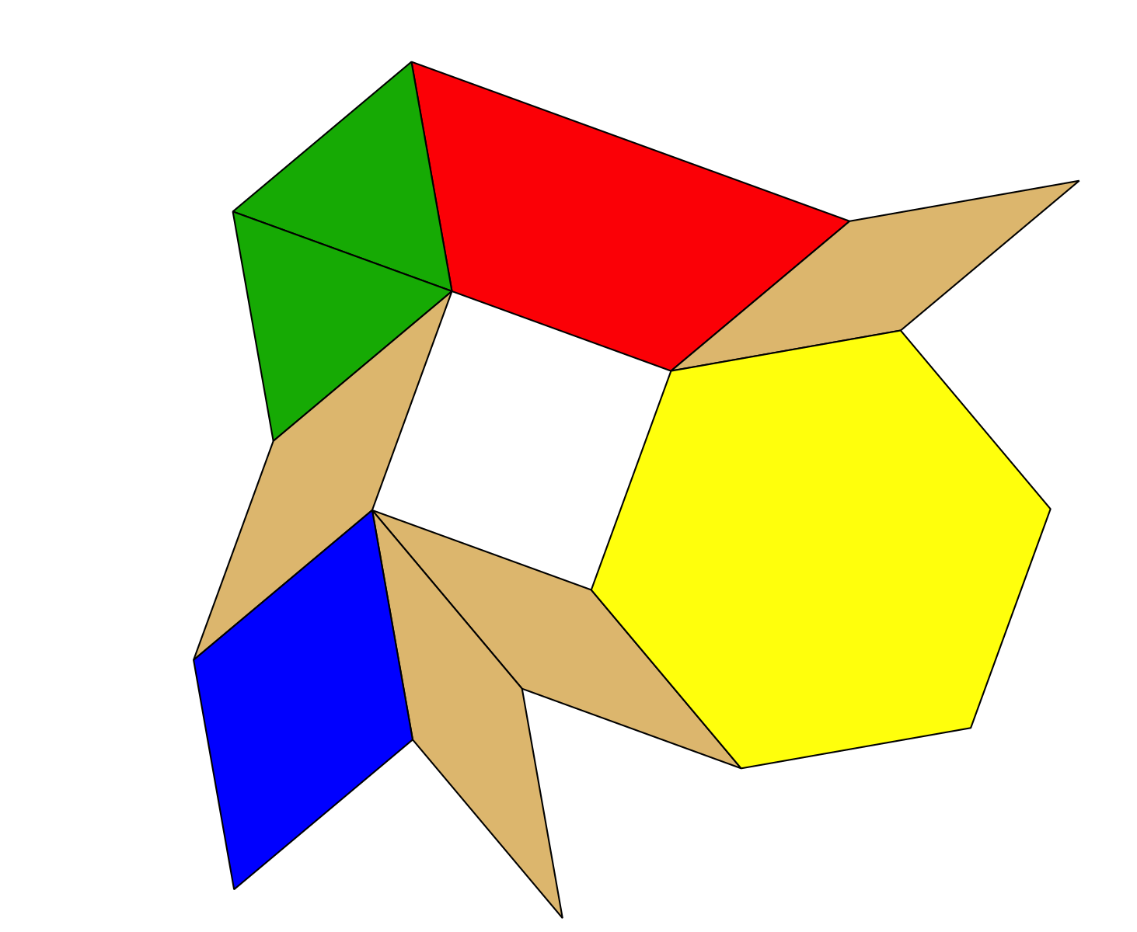
The shape that is missing is the square but it looks different because it is turned.
We also used words like above, below, beside, and next to to describe where shapes are.
The green triangle is next to the red trapezoid.
The green triangle is above the blue rhombus.
© CC BY 2021 Illustrative Mathematics®

