Lesson 18: Applications of Logarithmic Functions
- Let’s measure acidity levels and earthquake strengths.

18.1: Scrambled Logs
Without using a calculator, put the following expressions in order, from least to greatest. Be prepared to explain your reasoning.
$log11$ | $\log_{2}8$ | $\log_{5}0.2$ | $log0.01$ | $ln1$

18.2: How Acidic Is It?
The pH scale is a way to measure the acidity of a liquid solution. It is based on the concentration of positive hydrogen ions in the liquid. A smaller pH indicates more hydrogen ions and higher acidity. A larger pH indicates less hydrogen ions and lower acidity.
Here is a table showing the hydrogen ion concentration (in moles per liter) and the pH of some different liquids:
liquids | hydrogen ion concentration  (moles per liter) | pH
water | ${10}^{\text{-}7}$ | 7
coffee | ${10}^{\text{-}5}$
root beer | ${10}^{\text{-}4}$
orange juice | ${10}^{\text{-}3}$
seawater
vinegar
- Which of the drinks listed, water, coffee, root beer, or orange juice, is the most acidic? Which is the least acidic? Explain how you know.

  - Seawater has a pH of 8. Is it more acidic or less acidic than water? Record the hydrogen ion concentration of seawater in the table.
  - Vinegar has a pH of 2.4. Is it more acidic or less acidic than orange juice? Record the hydrogen ion concentration of vinegar in the table.
- A logarithm is used to translate hydrogen ion concentrations to pH values. With a partner, discuss how the hydrogen ion concentrations might be related to the pH. Use words or expressions to describe the relationship you notice.

18.3: pH Ratings
This table shows the relationship between hydrogen ion concentrations and pH ratings (acidity) for different substances.
substance | hydrogen ion concentration  (moles per liter) | pH
mild detergent | 0.0000000001 | 10
toothpaste | 0.000000001 | 9
baking soda | 0.00000001 | 8
blood | 0.0000001 | 7
milk | 0.000001 | 6
banana | 0.00001 | 5
tomato | 0.0001 | 4
apple | 0.001 | 3
lemon | 0.01 | 2
- Write an equation to represent the pH rating, $p$, in terms of the hydrogen ion concentration $h$, in moles per liter.
- Test your equation by using the hydrogen ion concentration of a substance from the table as the input. Does it produce the right pH rating as the output? If not, revise your equation and test it again.
- Magnesium hydroxide (also called “milk of magnesia”) is a medication used to treat stomach indigestion. It has a hydrogen concentration $5.6×{10}^{\text{-}11}$ mole per liter. Estimate a pH rating for magnesium hydroxide. Explain or show your reasoning.
- As shown in the table, apple has a pH of 3 and milk has a pH of 6. How many times more acidic is the apple than milk?

Are you ready for more?
The graph shows points representing the hydrogen ion concentration, in moles per liter, and pH ratings of the different substances you saw earlier.
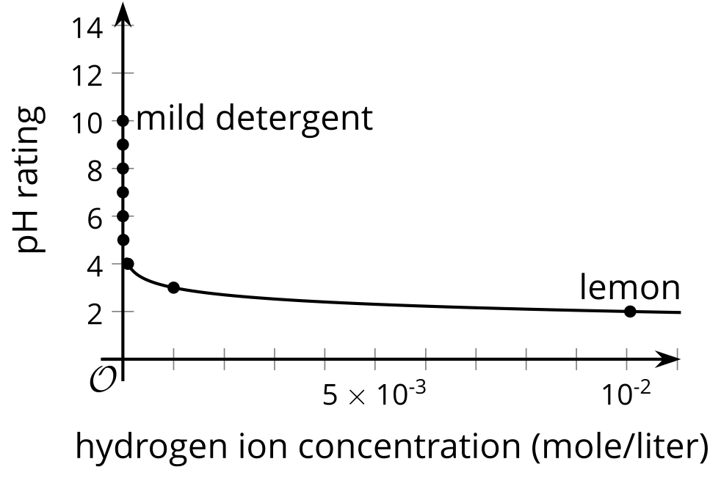
- Which point represents baking soda? Which represents banana? How can you tell?
- Vinegar has a pH of 2.4. Where on the graph would a point that represents vinegar be plotted?
- Why do you think the graph appears the way it does, with a group of points stacked up along the vertical axis?
- How is it like and unlike other graphs of logarithmic functions you have seen so far?

18.4: Measuring Earthquake Strength
Here is a table showing the Richter ratings for displacements recorded by a seismograph 100 km from the epicenter of an earthquake.
seismograph displacement (meters) | ${10}^{\text{-}6}$ | ${10}^{\text{-}5}$ | ${10}^{\text{-}4}$ | ${10}^{\text{-}3}$ | ${10}^{\text{-}2}$ | ${10}^{\text{-}1}$ | ${10}^{0}$ | ${10}^{1}$
Richter rating | 1 | 2 | 3 | 4 | 5 | 6 | 7 | 8
- Compare an earthquake rated with a magnitude of 5 on the Richter scale and that rated with a 6. How do their displacements compare? What about an earthquake with a magnitude rated with a 2 and that rated with a 3?
- Discuss with a partner how the displacement might be related to the Richter scale. Express that relationship in words or with an expression.
- An earthquake shook the northwest part of Indonesia in 2004, causing massive damage and casualties. If a seismograph was located 100 km from the epicenter, it would have recorded a displacement of 125 m! Use your answer to the previous question to estimate the Richter rating for the earthquake.

Lesson 18 Summary
Logarithms are helpful in a variety of real-world contexts. Let’s look at an example in chemistry.
The acidity of a substance is measured by the concentration of positive hydrogen ions, $H$, in moles per liter. If the concentration is ${10}^{x}$, then the acidity rating, or pH rating, is $\text{-}x$. For example, grapefruit juice has a hydrogen ion concentration of about ${10}^{\text{-3}}$ mole per liter, so its acidity rating is about 3. The concentration of hydrogen ions in lemon juice is ${10}^{\text{-2}}$ mole per liter, so its acidity or pH rating is 2.
We can see that the pH rating is -1 times the exponent in the expression representing the hydrogen ion concentration. Because the exponent in a power of 10 can be expressed in terms of the base 10 logarithm, the pH rating can be expressed as $\text{-}1\log_{10}H$ or simply $\text{-}\log_{10}H$.
When the exponent in a power of 10 increases by 1, say from ${10}^{\text{-3}}$ to ${10}^{\text{-2}}$, the quantity changes by a factor of 10. This means that lemon juice has 10 times the hydrogen ion concentration of grapefruit juice. Water, which has a pH rating of 7, has ${10}^{\text{-7}}$ mole of hydrogen ions per liter. This means that water has $\frac{1}{10,000}$ of the hydrogen ion concentration of grapefruit juice.
Another example of logarithm use is the Richter scale, which measures the strength of an earthquake in terms of the displacement of the needle on a seismograph. A displacement of 1 micrometer, one millionth of a meter, measures 1 on the Richter scale. Each time the displacement increases by a factor of 10, the Richter scale measure increases by 1. So a displacement of 10 micrometers measures 2 on the Ricther scale, and a displacement of 1,000 micrometers (1 mm) measures 4 on the Richter scale.
If the seismograph displacement is $d$ meters, the Richter rating of the earthquake can be expressed as $7+\log_{10}d$. We can check that when $d=1×{10}^{\text{-}6}$ (a displacement of 1 micrometer), the Richter rating is 1. And when the displacement increases by a factor of 10, the exponent of $d$ increases by 1, so the Richter rating of the earthquake increases by 1.
© CC BY 2019 by Illustrative Mathematics®

