Unit 5 Lesson 10: Combining Functions

1 Notice and Wonder: Are Book Sales Improving? (Warm up)

Student Task Statement
What do you notice? What do you wonder?
$t$ (years since 2010) | number of books sold  in the US (millions) | population of  the US (millions)
0 | 2,530 | 309.35
1 | 2,400 | 311.64
2 | 2,730 | 313.99
3 | 2,720 | 316.23
4 | 2,700 | 318.62
5 | 2,710 | 321.04
6 | 2,700 | 323.41

2 How Many Books Can One Person Have?

Student Task Statement
The table shows the values of two functions, $P$ and $B$, where $P\left(t\right)$ is the population of the US, in millions, $t$ years after 2010, and $B\left(t\right)$ is the number of books sold per year, in millions, $t$ years after 2010.
$t$ (years since 2010) | $B\left(t\right)$ (millions) | $P\left(t\right)$ (millions) | $R\left(t\right)$
0 | 2,530 | 309.35
1 | 2,400 | 311.64
2 | 2,730 | 313.99
3 | 2,720 | 316.23
4 | 2,700 | 318.62
5 | 2,710 | 321.04
6 | 2,700 | 323.41
- Plot the values of $B$ as a function of $t$. What does the plot tell you about book sales?
- 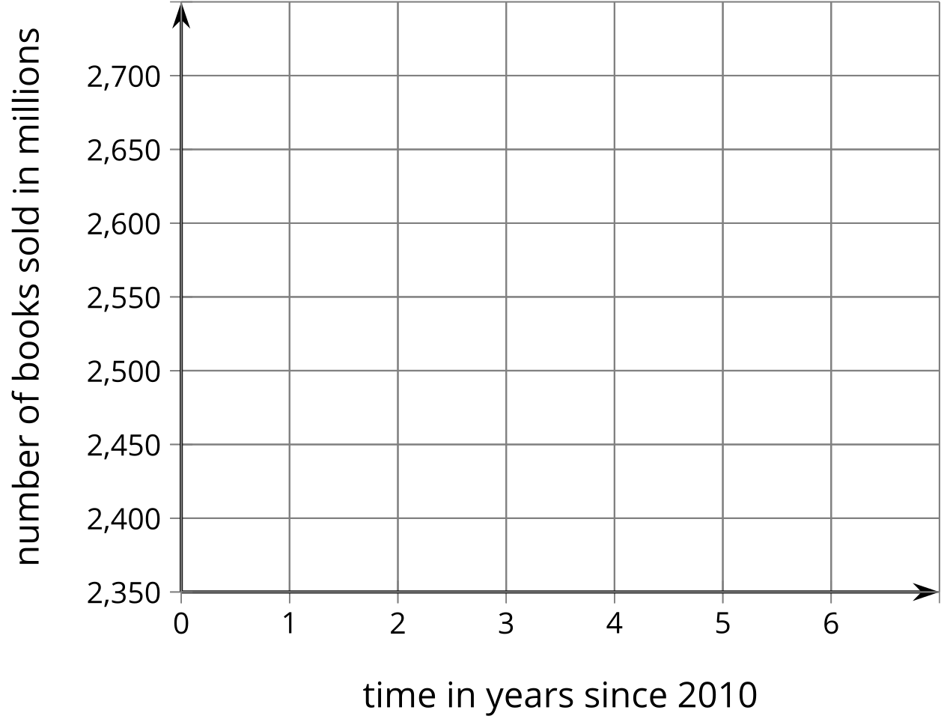
- How many books were sold per person in 2010 and 2016? What do these values tell you about book sales?
- Define a new function $R$ by $R\left(t\right)=\frac{B\left(t\right)}{P\left(t\right)}$. Complete the table and then graph the values of $R\left(t\right)$. What do the values of $R$ tell you?

3 Adding Functions

Student Task Statement
- Here are the graphs of two functions, $E$ and $L$. Define a new function $S$ by adding $E$ and $L$, so $S\left(x\right)=E\left(x\right)+L\left(x\right)$. On the same axes, sketch what you think the graph of $S$ looks like.
- 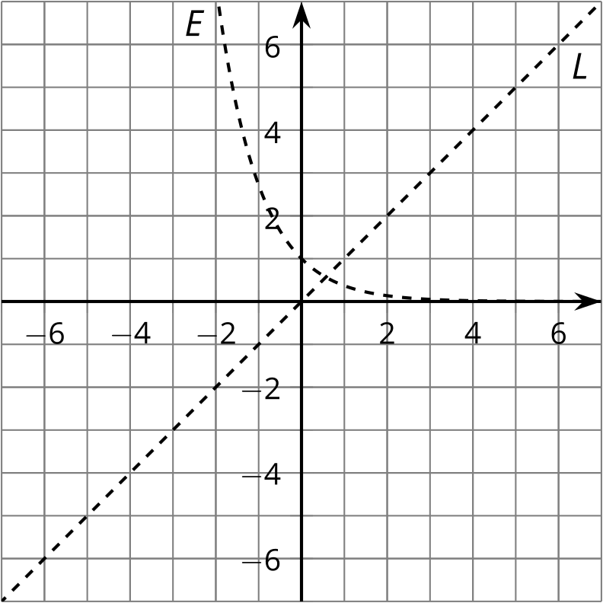
- Sketch the graph of the sum of $E$ and each of the following functions.
- 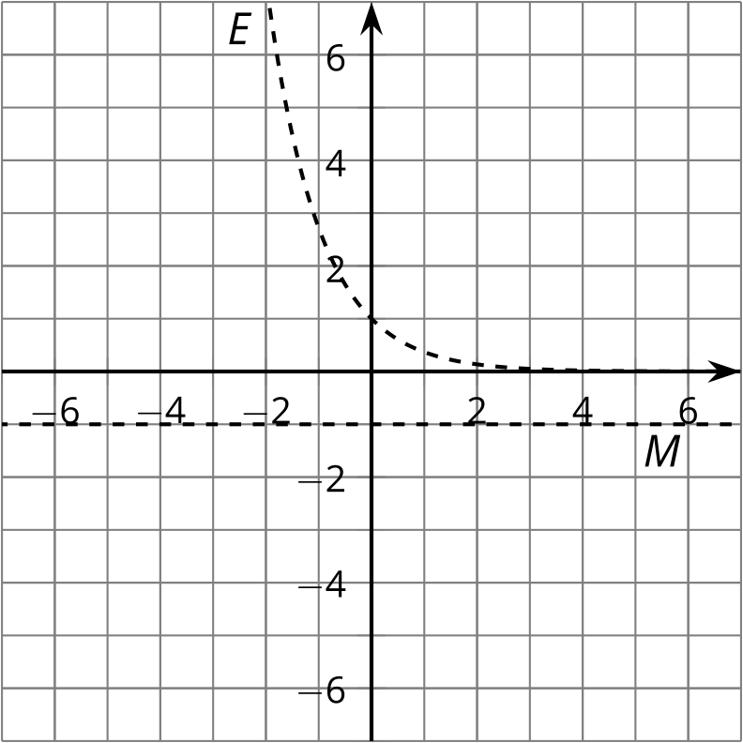
- 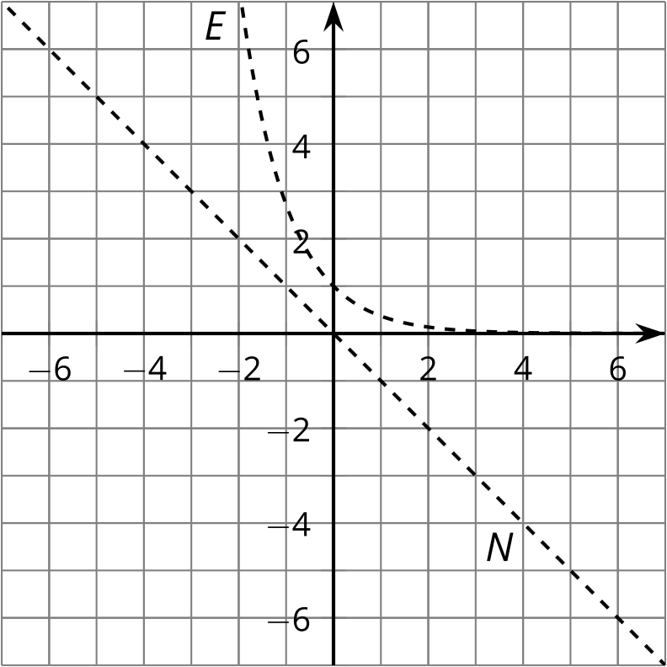
- 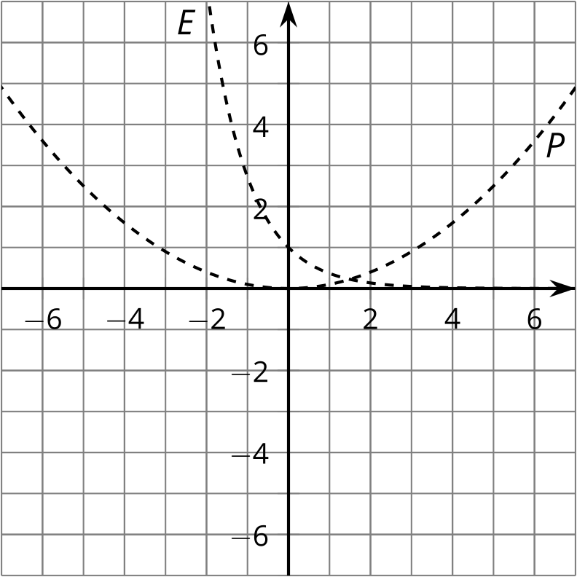
- 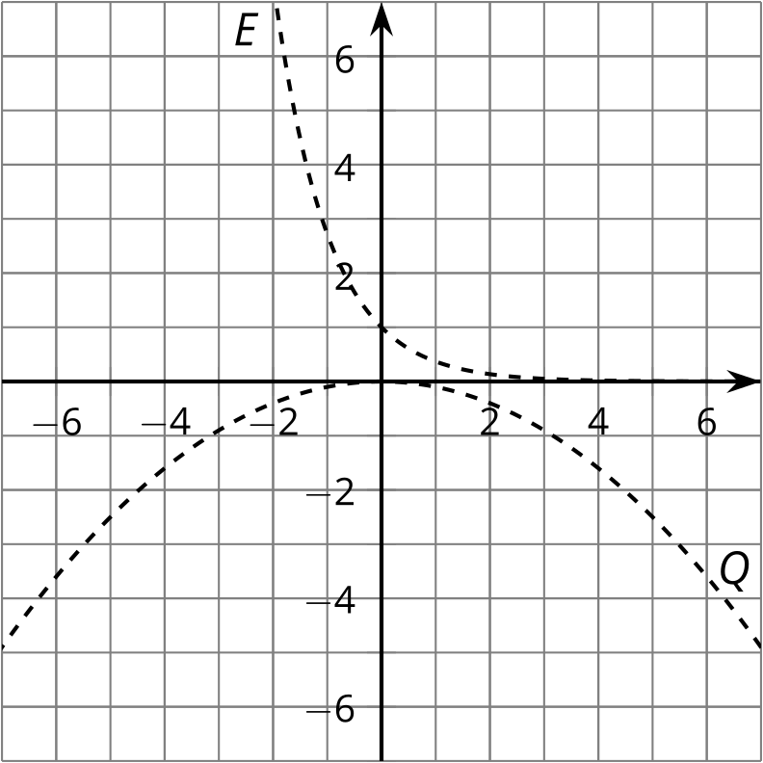
© CC BY 2019 by Illustrative Mathematics®

