Lesson 8 Practice Problems
- Select all the true equations.
  - $cos\left(15\right)=sin\left(15\right)$
  - $cos\left(75\right)=sin\left(15\right)$
  - $cos\left(75\right)=cos\left(15\right)$
  - $cos\left(15\right)=sin\left(75\right)$
  - $tan\left(15\right)=tan\left(75\right)$
- Write 2 expressions that can be used to find the value of $x$.
- 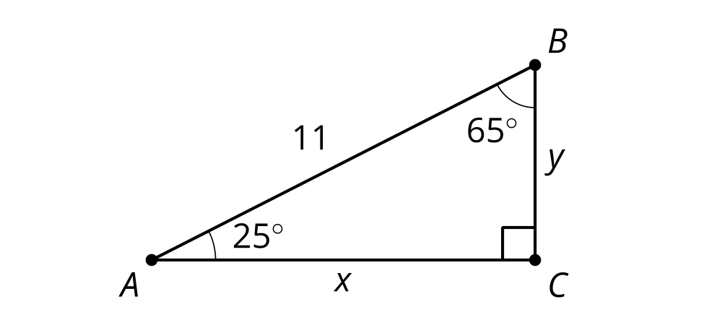
- Andre and Mai are discussing how to solve for side $AB$. Andre thinks he can use the equation $tan\left(12\right)=\frac{x}{6}$ to solve for $AB$. Mai thinks she can use the equation $tan\left(78\right)=\frac{6}{x}$ to solve for $AB$. Do you agree with either of them? Show or explain your reasoning.
- 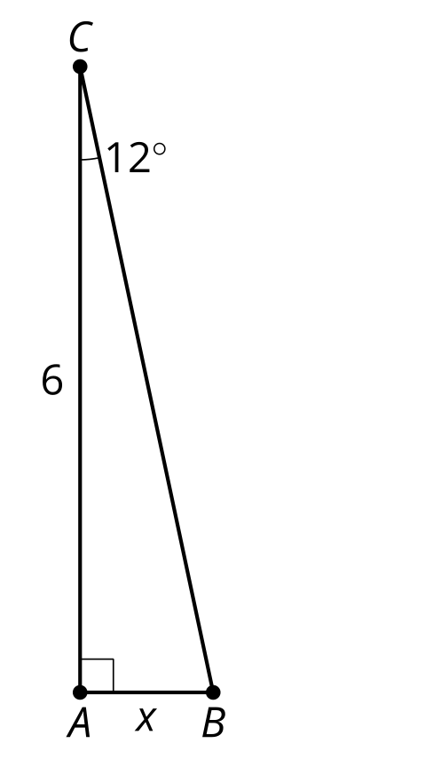
- Technology required. Jada is visiting New York City to see the Empire State building. She is 100 feet away when she spots it. To see the top, she has to look up at an angle of 86.1 degrees. How tall is the Empire State building?
- (From Unit 4, Lesson 7.)
- Technology required. Find the missing measurements in triangle $ABC$.
- 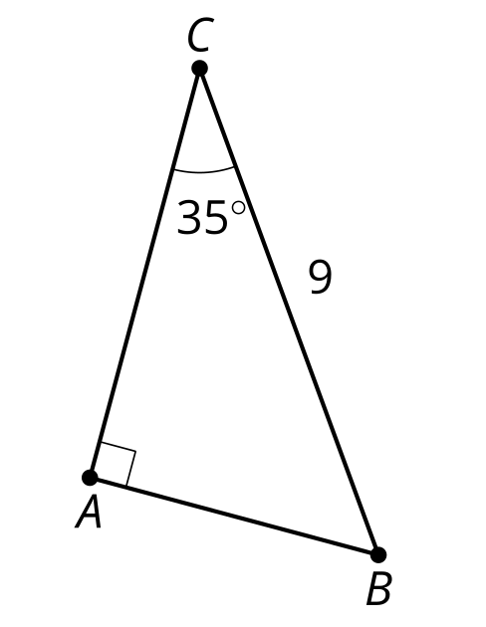
- (From Unit 4, Lesson 7.)
- Right triangle $ABC$ is shown.
- Write 2 expressions which are equal to the length of side $BC$.
- 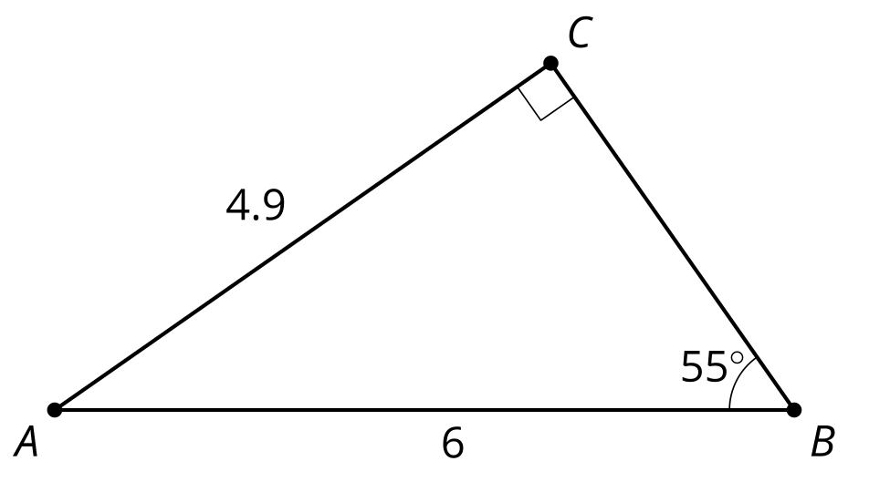
- (From Unit 4, Lesson 6.)
- A triangle has sides with lengths 7, 24, and 25.
  - Verify this is a Pythagorean triple.
  - Approximate the acute angles in this triangle.
- (From Unit 4, Lesson 5.)
- Priya is playing hand ball and wants the ball to bounce off wall $CB$ and land at $D$. The court is 20 feet wide and 34 feet deep. Where on the wall should she aim if she's standing at point $A$?
- 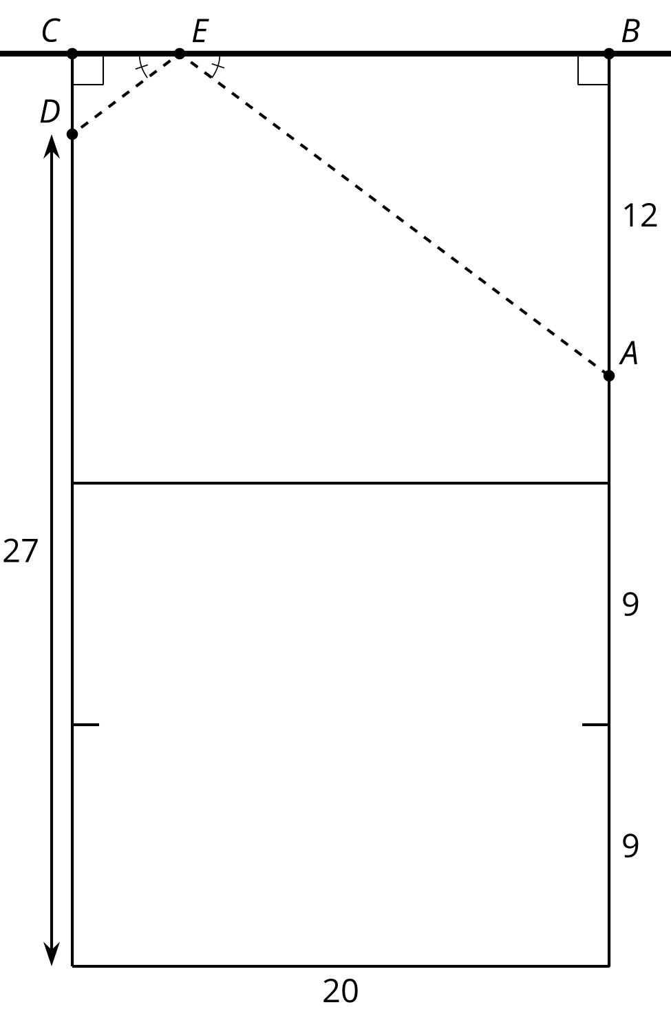
- (From Unit 3, Lesson 16.)
© CC BY 2019 by Illustrative Mathematics®

