Lesson 11: All Kinds of Prisms
- Let’s find the volume of all different kinds of prisms.

Warm-up: Which One Doesn’t Belong: Many Prisms
Which one doesn’t belong?
A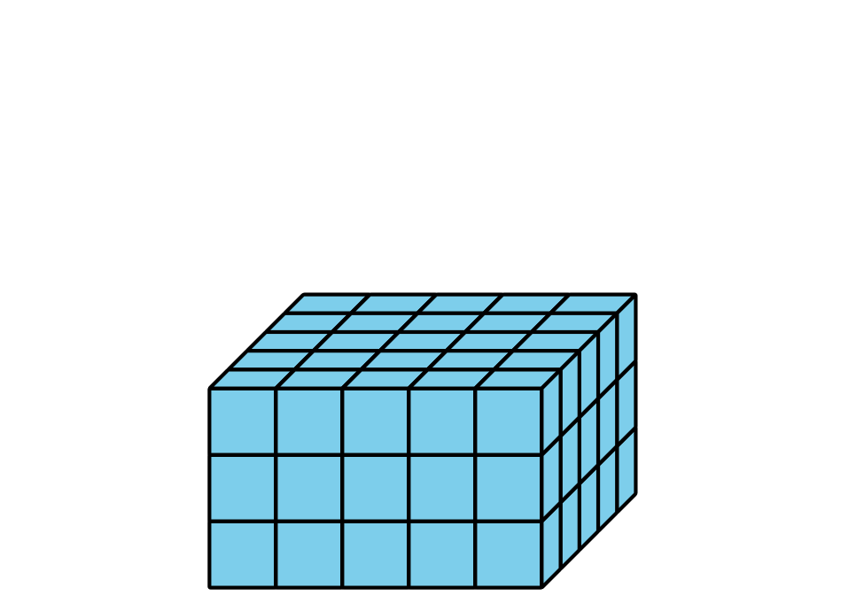
B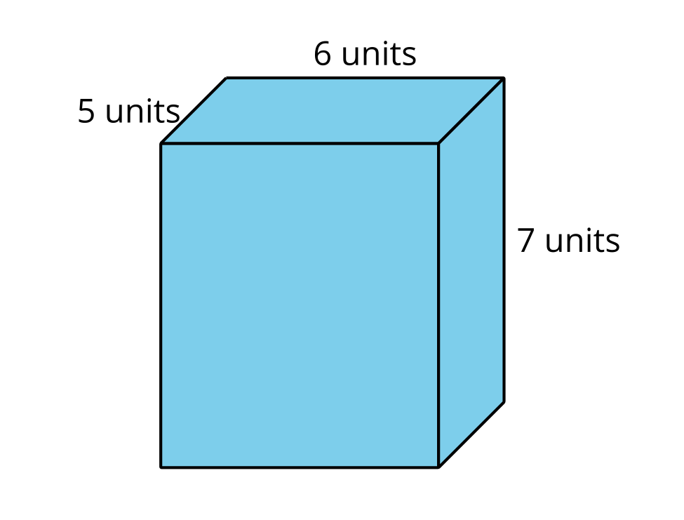
C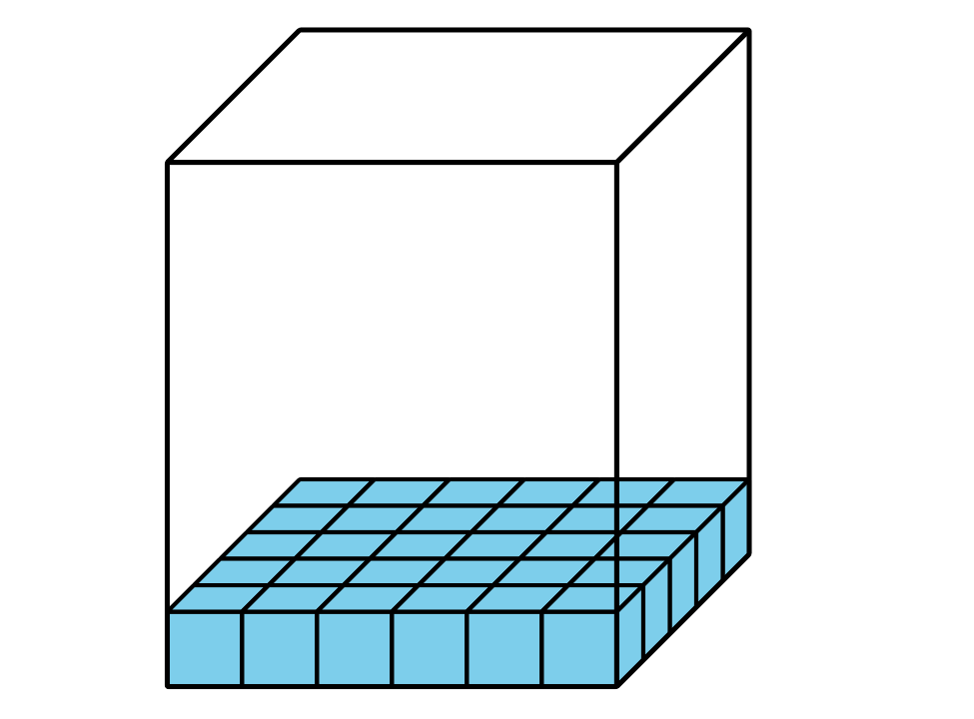
D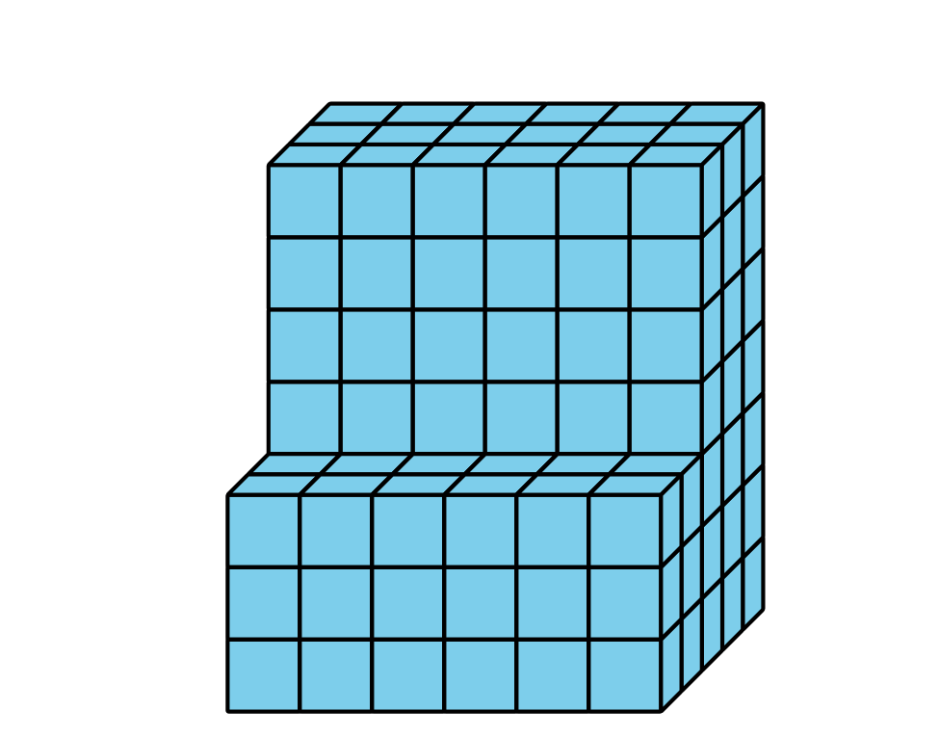

11.1: Prism Palooza
For each problem, explain or show your reasoning.
- Han is filling a box with cubes. Below is a diagram of the box. How many cubes can fit in the box if Han completely packs it, without gaps between cubes?
- 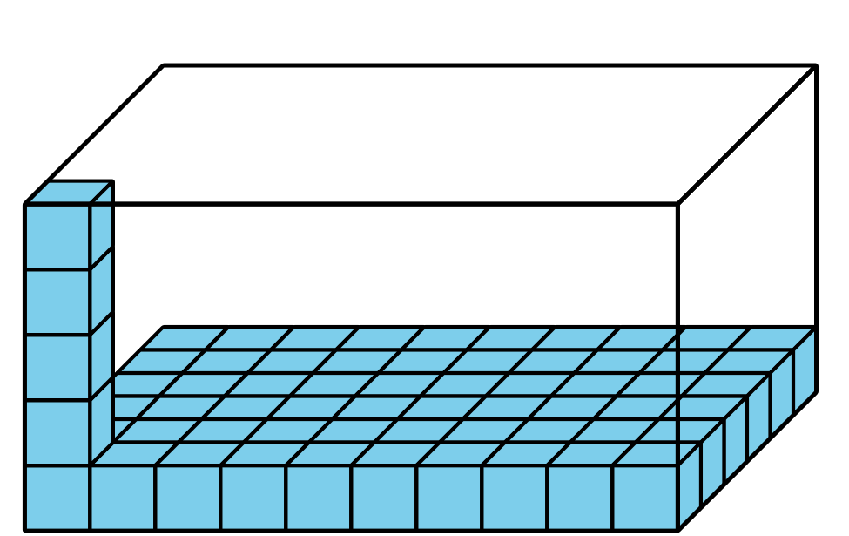
- Clare bought a storage container for her art supplies. The storage container was 4 feet wide, 9 feet long, and 5 feet high. What is the volume of her container?
- Mai’s new bedroom has a walk-in closet with a floor that measures 30 square feet. Her closet ceiling is 9 feet from the floor. What is the volume of her closet?

11.2: Problem Solving with Figures
The elementary school is going to build a raised bed garden like the one in the picture, but they will use a different design. Here is a diagram that shows the side lengths of the garden the school will build.
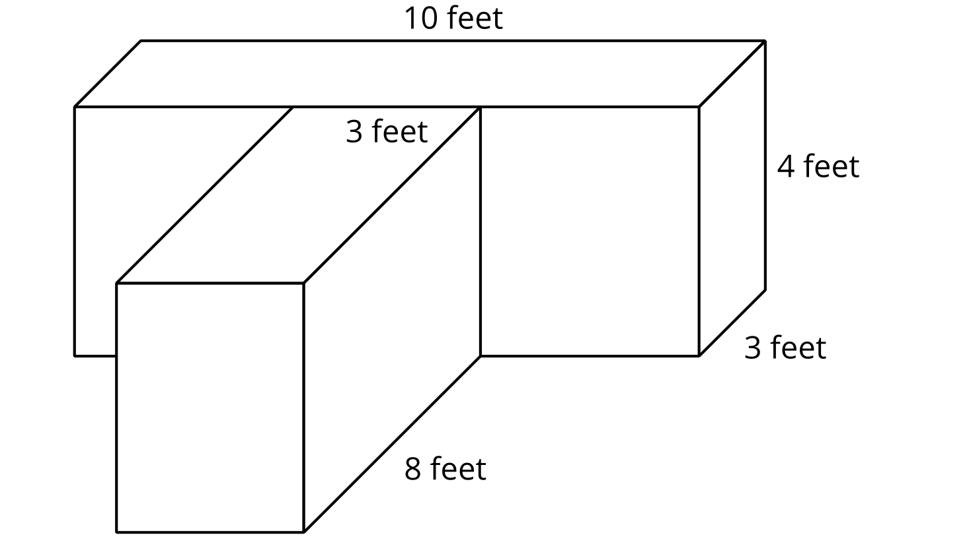
- What is the volume of the garden? Explain or show your reasoning.
- Write an expression to represent the volume of the garden.
- 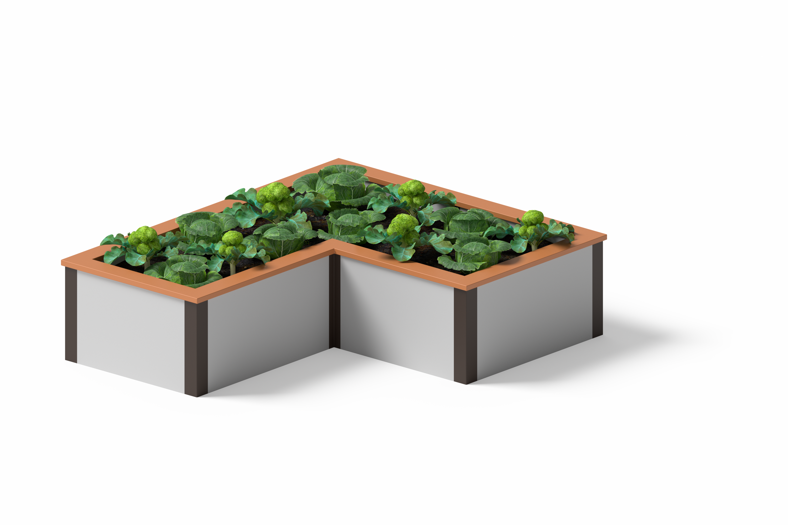
- Noah wants to design a garden with the same volume but different side lengths. What could the side lengths of his garden be?
- Which garden design do you like better? Explain or show your reasoning.

Section Summary
Section Summary
Some figures are made from two rectangular prisms. We can decompose these figures and find the volume of each prism. Then, we add the volumes of the two prisms to find the total volume of the figure.
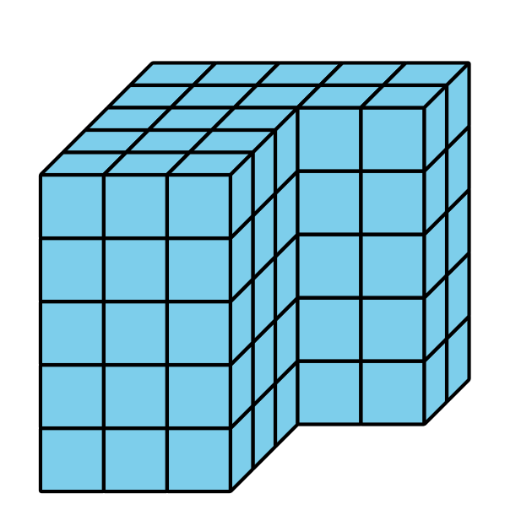
There is often more than one way to decompose figures made from 2 rectangular prisms. These expressions can be used to find the volume of the figure:
$\left(3×3×5\right)+\left(5×2×5\right)$
$\left(3×5×5\right)+\left(2×2×5\right)$
© CC BY 2021 Illustrative Mathematics®

