Lesson 10: Fractional Side Lengths Less Than 1

Standards Alignments
Addressing | 5.NF.B.3, 5.NF.B.4.a, 5.NF.B.4.b
Building Towards | 5.NF.B.4

Teacher-facing Learning Goals
- Find the area of a rectangle with one non-unit fractional side length.
- Represent the area of a rectangle with a multiplication expression.

Student-facing Learning Goals
- Let’s find the area of rectangles with a fractional side length.

Lesson Purpose
The purpose of this lesson is for students to find the area of rectangles with one non-unit fractional side length and one whole number side length.
In the previous lesson, students extended their understanding of multiplication to find the area of rectangles with a side length that is a unit fraction. In this lesson, students will find the area of rectangles with a whole number side length and a non-unit fraction side length. Students will apply what they learned in earlier lessons to area representations and recognize that a side length of $\frac{a}{b}$ is equivalent to a side length of $a×\frac{1}{b}$. This allows them to find areas by counting the number of pieces covering the area and then multiplying this by the unit fractional area of each piece. For example, in the image below, there are 8 shaded pieces and each piece has an area of $\frac{1}{3}$ square unit.
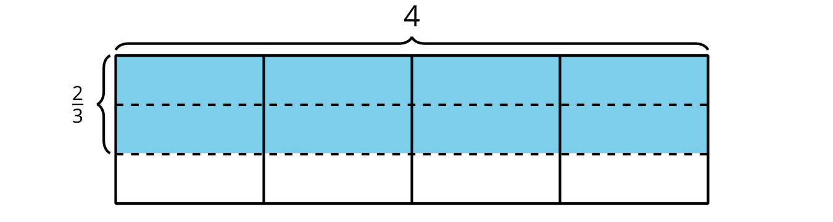

Access for:

Students with Disabilities
- Representation (Activity 1)

English Learners
- MLR2 (Activity 2)

Instructional Routines
5 Practices (Activity 1), Estimation Exploration (Warm-up)

Lesson Timeline
Warm-up | 10 min
Activity 1 | 20 min
Activity 2 | 15 min
Lesson Synthesis | 10 min
Cool-down | 5 min

Teacher Reflection Question
In the next lesson, students will find the area of a rectangle where one of the side lengths is a fraction greater than 1. Try finding the area of a rectangle that is $\frac{5}{4}$ by 6. How do the understandings in today’s lesson support how you found the area of that rectangle?

Cool-down
(to be completed at the end of the lesson) 5min
A Fractional Side Length

Standards Alignments
Addressing | 5.NF.B.4.b

Student-facing Task Statement
- Write a multiplication expression to represent the area of the shaded region.
- 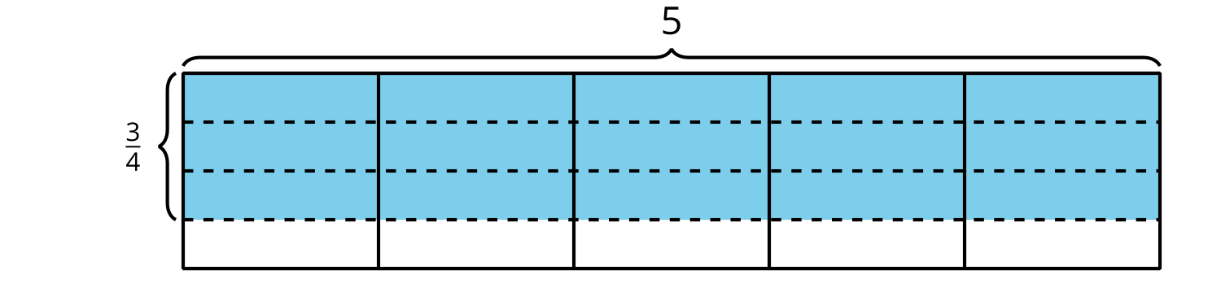
- Find the area of the shaded region.

Student Responses
- $\frac{3}{4}×5$ or $5×\frac{3}{4}$
- $\frac{15}{4}$ or $3\frac{3}{4}$ square units

