Lesson 22 Practice Problems
- Identify all values of $x$ that make the equation true.
  - $\frac{2x+1}{x}=\frac{1}{x−2}$
  - $\frac{1}{x+2}=\frac{2}{x−1}$
  - $\frac{x+3}{1−x}=\frac{x+1}{x+2}$
  - $\frac{x+2}{x+8}=\frac{1}{x+2}$
- Kiran is solving $\frac{2x−3}{x−1}=\frac{2}{x(x−1)}$ for $x$, and he uses these steps:
- $\begin{matrix}\frac{2x−3}{x−1} & =\frac{2}{x(x−1)} \\ (x−1)\left(\frac{2x−3}{x−1}\right) & =x(x−1)\left(\frac{2}{x(x−1)}\right) \\ 2x−3 & =2 \\ 2x & =5 \\ x & =2.5\end{matrix}$
- He checks his answer and finds that it isn't a solution to the original equation, so he writes “no solutions.” Unfortunately, Kiran made a mistake while solving. Find his error and calculate the actual solution(s).
- Identify all values of $x$ that make the equation true.
  - $x=\frac{25}{x}$
  - $x+2=\frac{6x−3}{x}$
  - $\frac{x}{x^{2}}=\frac{3}{x}$
  - $\frac{6x^{2}+18x}{2x^{3}}=\frac{5}{x}$
- Is this the graph of $g(x)=\text{-}x^{4}(x+3)$ or $h(x)=x^{4}(x+3)$? Explain how you know.
- 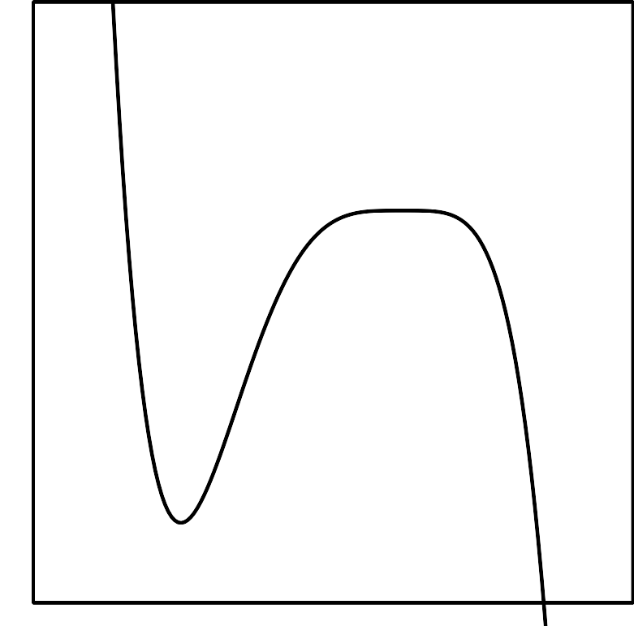
- (From Unit 2, Lesson 10.)
- Rewrite the rational function $g(x)=\frac{x−9}{x}$ in the form $g(x)=c+\frac{r}{x}$, where $c$ and $r$ are constants.
- (From Unit 2, Lesson 18.)
- Elena has a boat that would go 9 miles per hour in still water. She travels downstream for a certain distance and then back upstream to where she started. Elena notices that it takes her 4 hours to travel upstream and 2 hours to travel downstream. The river’s speed is $r$ miles per hour. Write an expression that will help her solve for $r$.
- (From Unit 2, Lesson 21.)
© CC BY 2019 by Illustrative Mathematics®

