Unit 6 Lesson 14: Center Day 3

WU Number Talk: Adding Up to 4 Two-digit Numbers (Warm up)

Student Task Statement
Find the value of each expression mentally.
- $10+15+20+10$
- $5+30+20$
- $15+20+30$
- $25+15+5+15$

1 Introduce Picture Books, Find Shapes

Student Task Statement

2 Centers: Choice Time

Student Task Statement
Choose a center.
Capture Squares
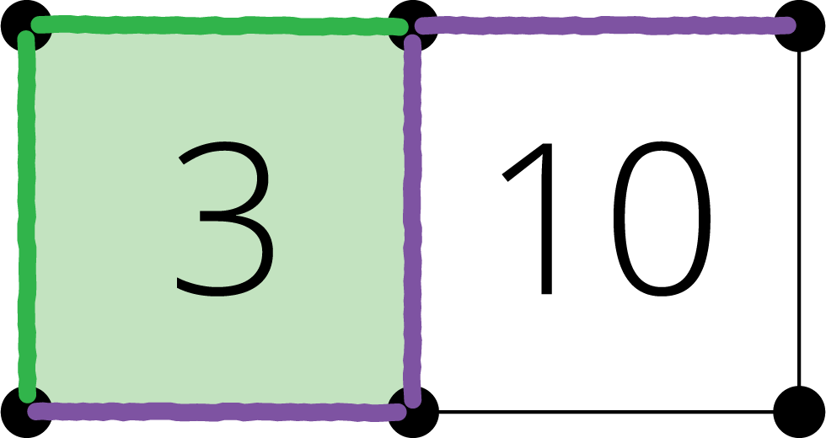
Number Puzzles
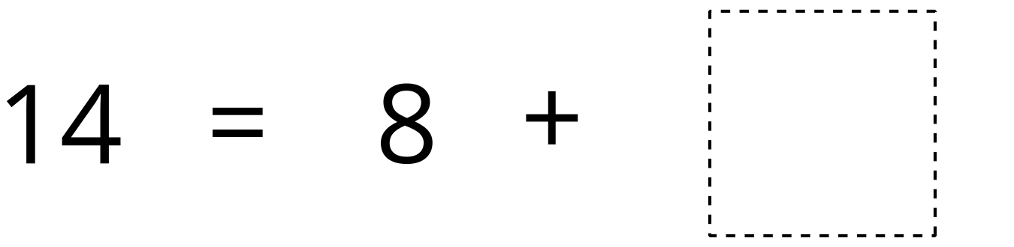
Picture Books
© CC BY 2021 Illustrative Mathematics®

