Lesson 15: Ways to Solve Problems and Show Solutions
- Let’s solve problems about spending a day at the fair and think about how to best show our solutions.

Warm-up: Number Talk: Divide by 8
Find the value of each expression mentally.
- $80÷8$
- $72÷8$
- $96÷8$
- $96÷4$

15.1: A Day at the Fair
You spent a day at the fair. Solve four problems about your day and create a poster to show your reasoning and solutions.
- You arrived at the fair!
- Entry to the fair is $9 a person. You went there with 6 other people. How much did it cost your group to enter the fair?
- How did you start your day? (Choose one.)
- 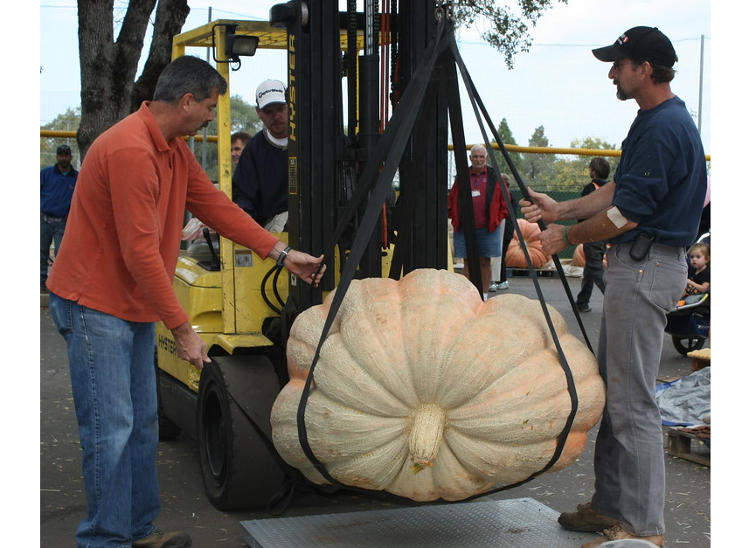
- You arrived at the giant pumpkin weigh-off at 11:12 a.m. and left at 12:25 p.m. How long were you there?
- You spent 48 minutes at the carnival and left at 12:10 p.m. What time did you get to the carnival?
- 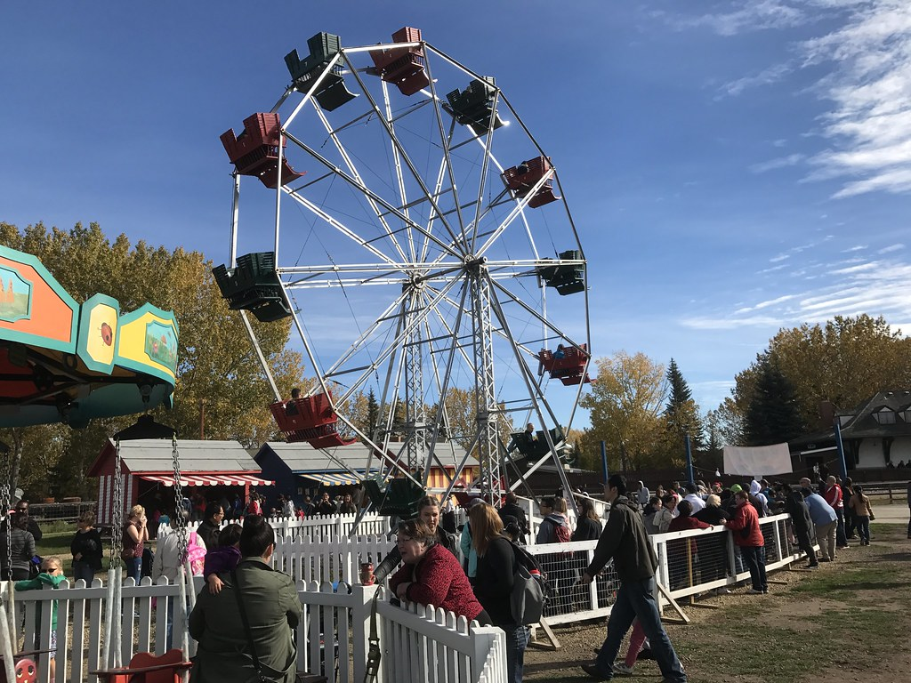
- What was next? (Choose one.)
- 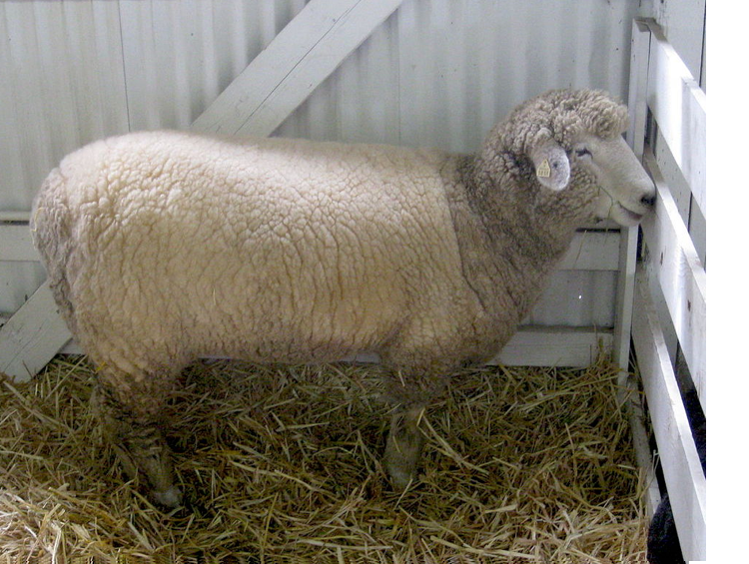
- You visited a barn with 7 sheep. The sheep drink 91 liters of water a day, each sheep drinking about the same amount. How much does each sheep drink a day?
- You visited a life-size sculpture of a cow made of butter. The butter cow weighs 273 kilograms, which is 277 kilograms less than the actual cow. How much does the actual cow weigh?
- 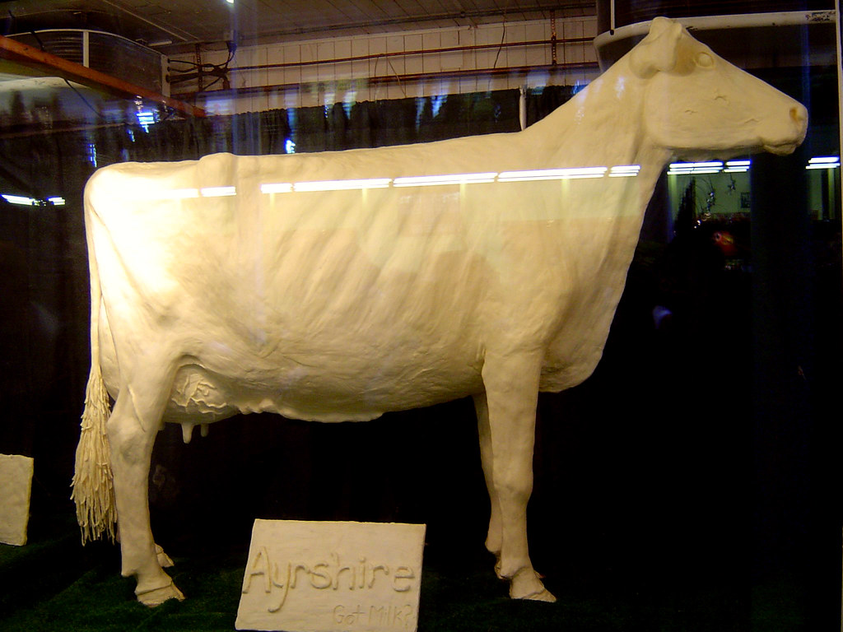
- Before you went home . . .
- 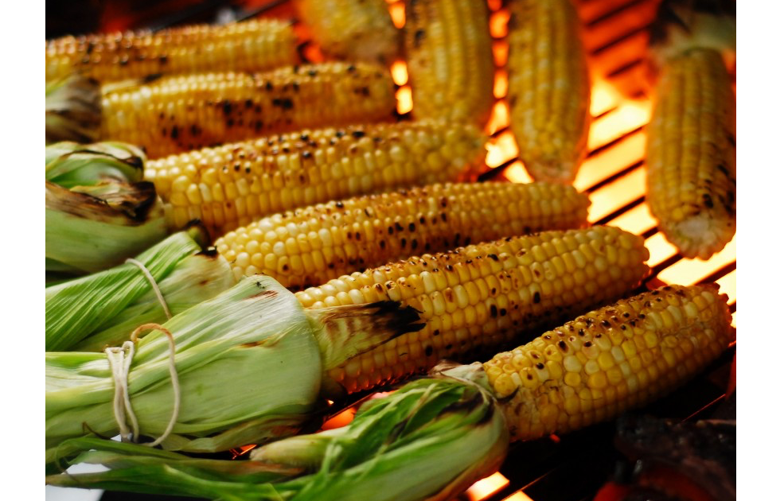
- You stopped for some grilled corn on the cob. On the grill, there were 54 ears of corn arranged in 9 equal rows. How many ears of corn were in each row?

15.2: A Day at the Fair Gallery Walk
As you visit the posters with your partner:
- Look for a problem that was solved using a strategy that is different from yours. What made it different? Describe the strategy.
- Look for ways that your classmates made their thinking and the math work clear to you. Describe at least three things they did or showed on the posters.

Section Summary
Section Summary
In this section, we solved all kinds of problems about time, weight, and liquid volume. We did so using addition, subtraction, multiplication, and division, as well as different reasoning strategies.
Clare spent 48 minutes at the carnival. She left the carnival at 12:10 p.m. What time did she get to the carnival?
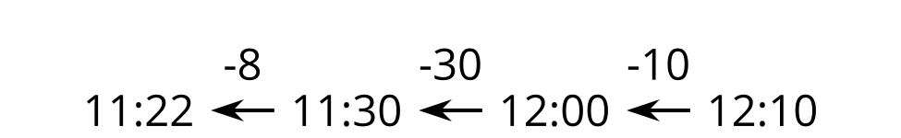
A cow made of butter weighs 273 kilograms. That is 277 kilograms less that the actual cow. How much does the actual cow weigh?
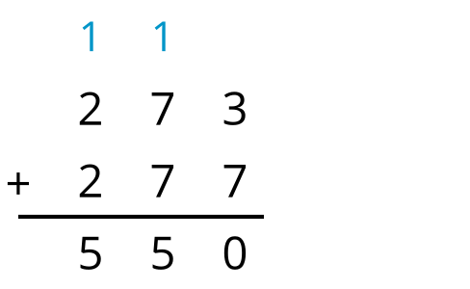
A grower used 84 liters to water their pumpkin seedlings. Each seedling gets 12 liters. How many seedlings were there?
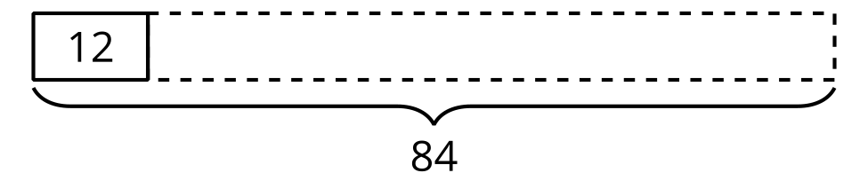
© CC BY 2021 Illustrative Mathematics®

