Lesson 1: Estimation Explorations with Fractions

Standards Alignments
Addressing | 3.NF.A.1, 3.NF.A.2

Teacher-facing Learning Goals
- Estimate fractions represented in diagrams and on number lines.

Student-facing Learning Goals
- Let’s explore estimations with fractions.

Lesson Purpose
The purpose of this lesson is for students to practice reasoning about fraction representations through estimation.
In previous lessons, students learned how to represent fractions with area diagrams, fraction strips, and number lines. In this lesson, students revisit each of these representations in an estimation context. Students have an opportunity to think about how to partition each representation to decide what fraction is shown (MP7). Additionally, if time allows and it seems of benefit to student understanding, there is an option after each activity to find the exact value of the fraction in the task statement.
If students need additional support with the concepts in this lesson, refer back to Unit 5, Section A in the curriculum materials.

Access for:

Students with Disabilities
- Engagement (Activity 2)

English Learners
- MLR2 (Activity 1)

Instructional Routines
Which One Doesn’t Belong? (Warm-up)

Lesson Timeline
Warm-up | 10 min
Activity 1 | 15 min
Activity 2 | 10 min
Activity 3 | 10 min
Lesson Synthesis | 10 min
Cool-down | 5 min

Teacher Reflection Question
Which fraction representations did students seem most comfortable with today? Which representations do you want to be sure to work more with before the year is over?

Cool-down
(to be completed at the end of the lesson) 5min
Fraction Representations

Standards Alignments
Addressing | 3.NF.A.1, 3.NF.A.2

Student-facing Task Statement
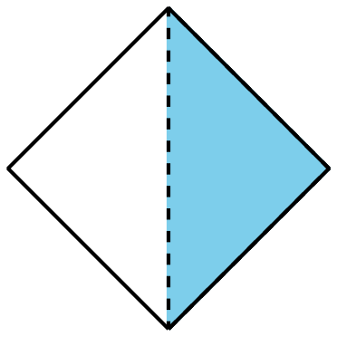
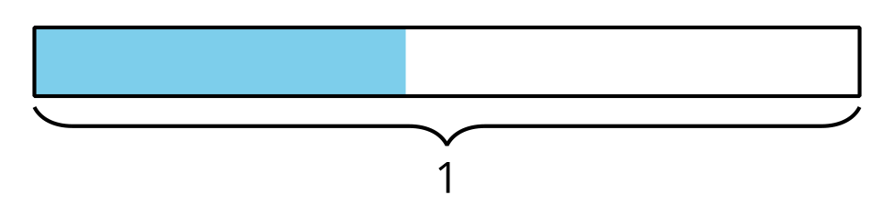
Could the shaded part of the shape, the point on the number line, and the shaded part of the diagram all represent the same fraction?
Explain your reasoning.

Student Responses
No. Sample response: The shaded part of the shape is $\frac{1}{2}$. The point on the number line is greater than $\frac{1}{2}$ but is less than 1. The shaded part of the diagram is less than $\frac{1}{2}$.

