Lesson 12: Types of Angles
- Let’s look at different types of angles.

Warm-up: Number Talk: Fractions of 120 and 360
Find the value of each expression mentally.
- $12×\frac{1}{12}$
- $120×\frac{1}{12}$
- $360×\frac{1}{12}$
- $360×\frac{3}{12}$

12.1: Sorting Angles
In an earlier lesson, you and your partner drew some angles on cards.
Put the cards together and sort the angles into two groups. Be prepared to explain why you sort them the way you do.

12.2: What is It, Really?
- Mai and Jada are looking at this drawing. Jada says it is just a line. Mai says it is an angle.
- With whom do you agree? Explain your reasoning.
- Tyler and Andre were measuring an angle in a letter Y.
- Andre said the angle he measured is obtuse. Tyler said the angle is acute.
- Explain why they could both be right.

12.3: Small Angles, Large Angles
- Identify each angle as acute, right, obtuse, or straight.
- 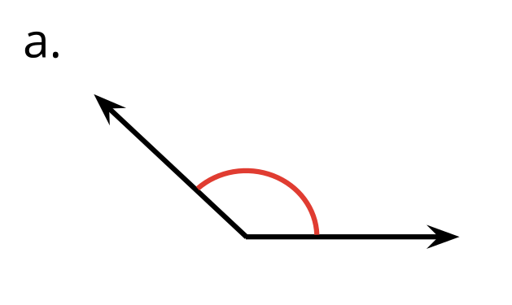
- 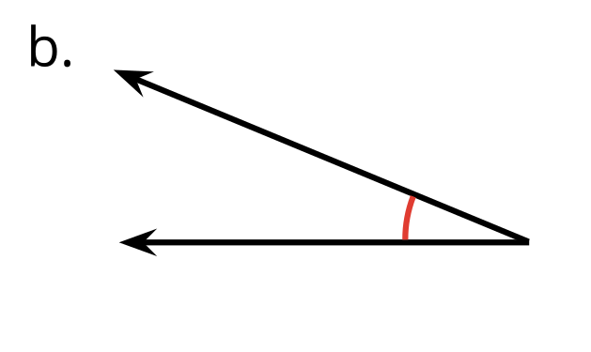
- 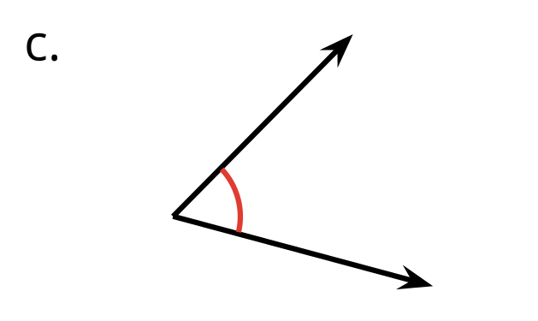
- 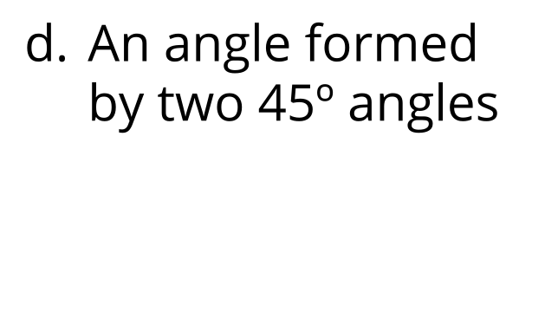
- 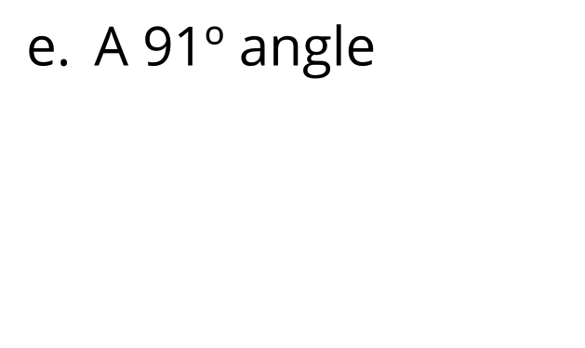
- 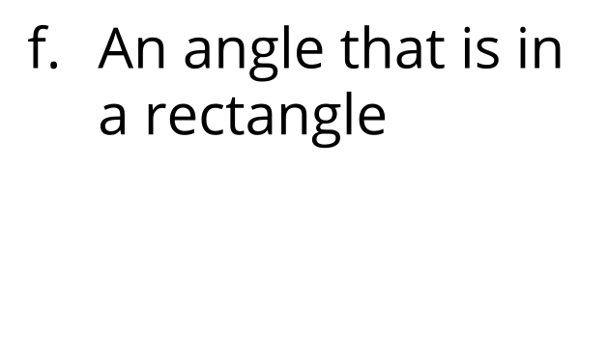
- 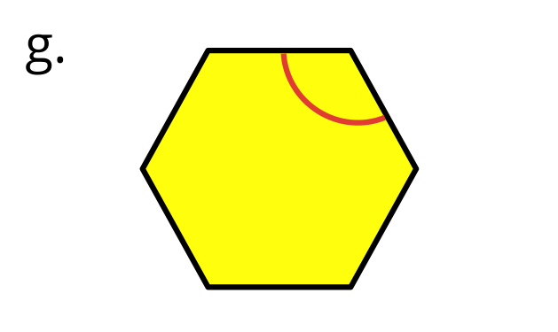
- 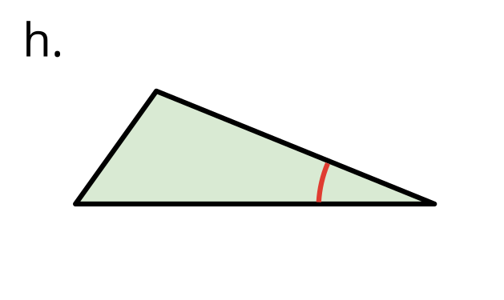
- 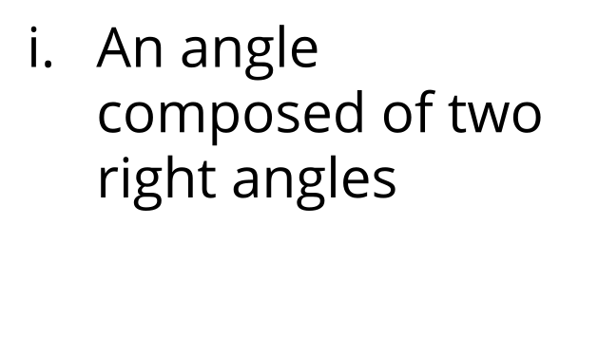
- 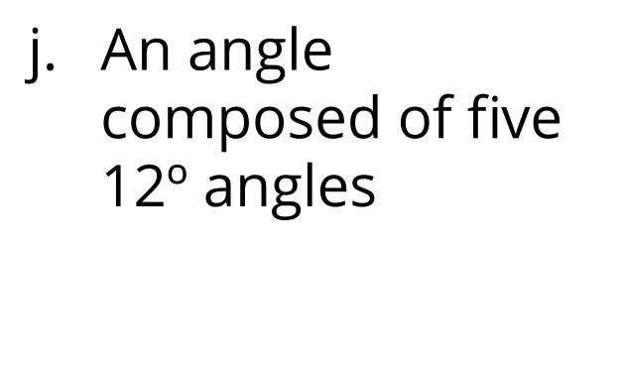
- Here is a drawing of the structure of a roof.
- 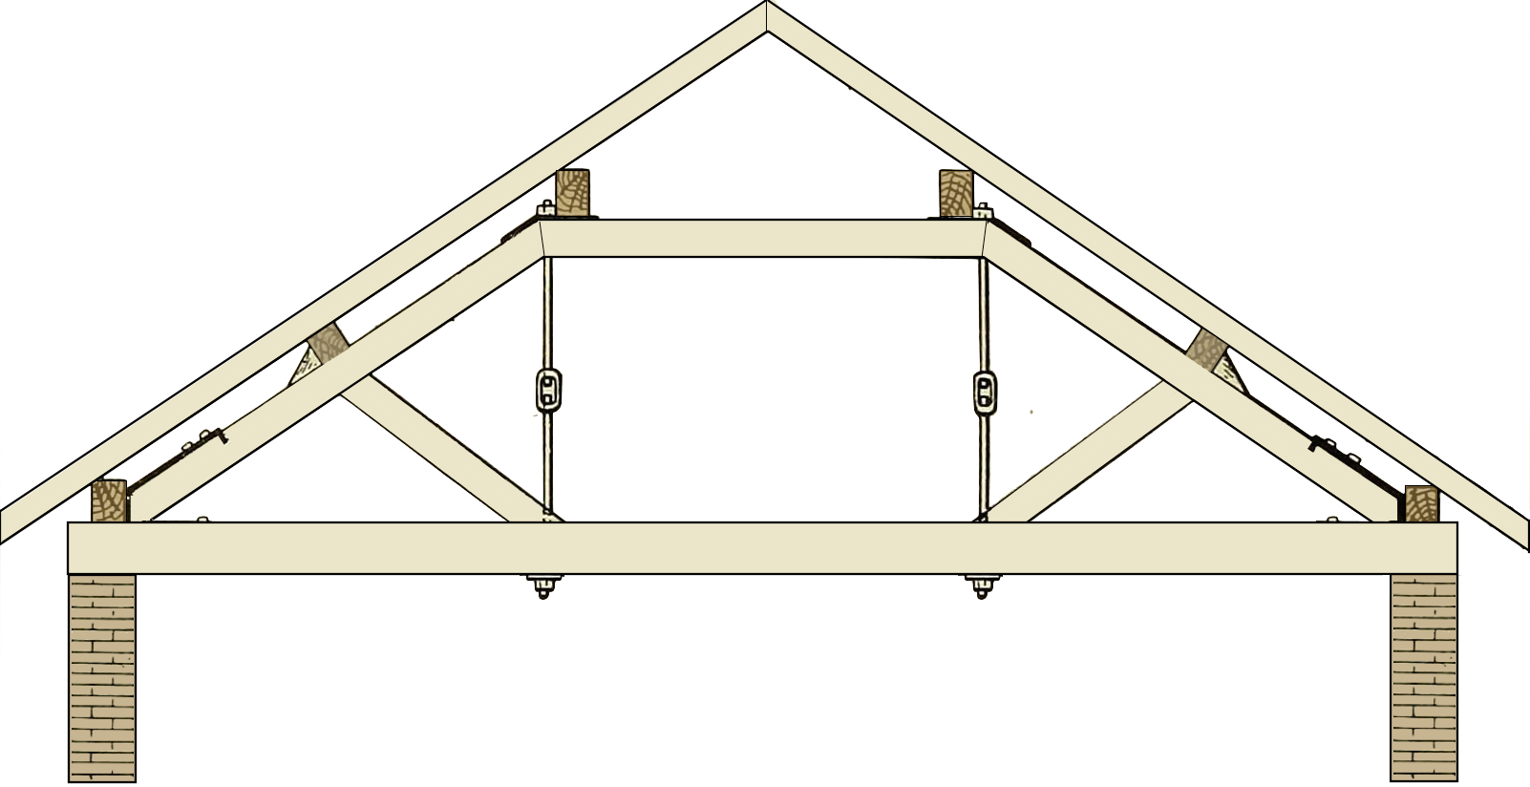
- Find as many acute and obtuse angles as you can in the drawing.
- Use an “A” to label acute angles, a square (◻) for right angles, and an “O” for obtuse angles.

- 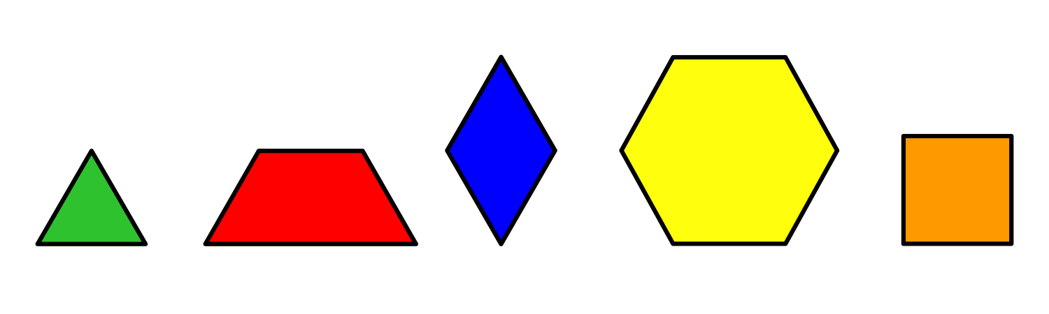
  - Diego is holding a pattern block that has 2 acute angles and 2 obtuse angles. Which pattern block could it be?
  - He then picks up a pattern block with no obtuse angles. Which pattern block could he be picking up? Explain your reasoning.
© CC BY 2021 Illustrative Mathematics®

