Lesson 11: Which One Doesn’t Belong?
- Let’s complete and create Which One Doesn’t Belong sets.

Warm-up: Which One Doesn’t Belong: Strings of Numbers
Which one doesn’t belong?
- 0, 4, 8, 12, 16
- 3, 6, 9, 12, 15
- 5, 105, 205, 305, 405
- 6, 60, 600, 6,000, 60,000

11.1: Add One That Doesn’t Belong
Here are two incomplete Which One Doesn’t Belong sets, each with one item missing. For each set:
- Find at least one reason that all items belong in the set.
- Find at least one reason that each item doesn’t belong.
- Add an item to complete each set. Make sure there is at least one reason it belongs and one reason it doesn’t belong.
- Set 1
- 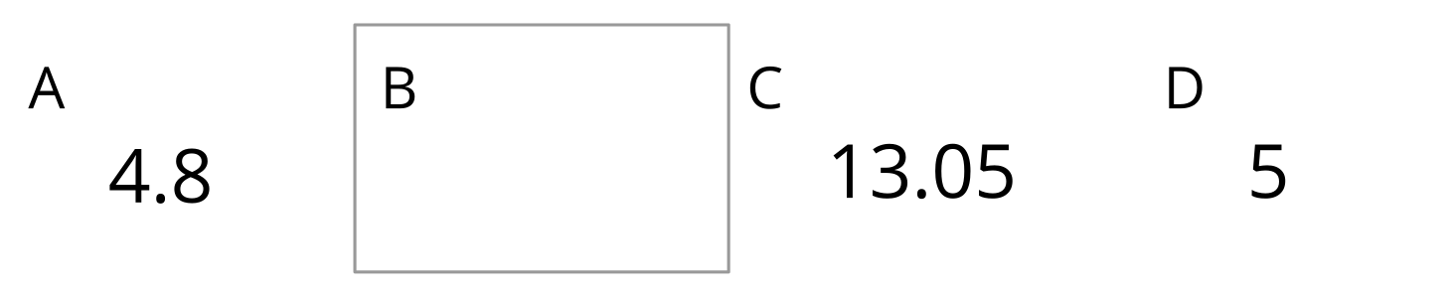
  - A, C, and D all belong because . . .
  - A doesn't belong because . . .
  - C doesn't belong because . . .
  - D doesn't belong because . . .
  - Add a new item B. It belongs because . . .
  - It doesn't belong because . . .
- Set 2
- 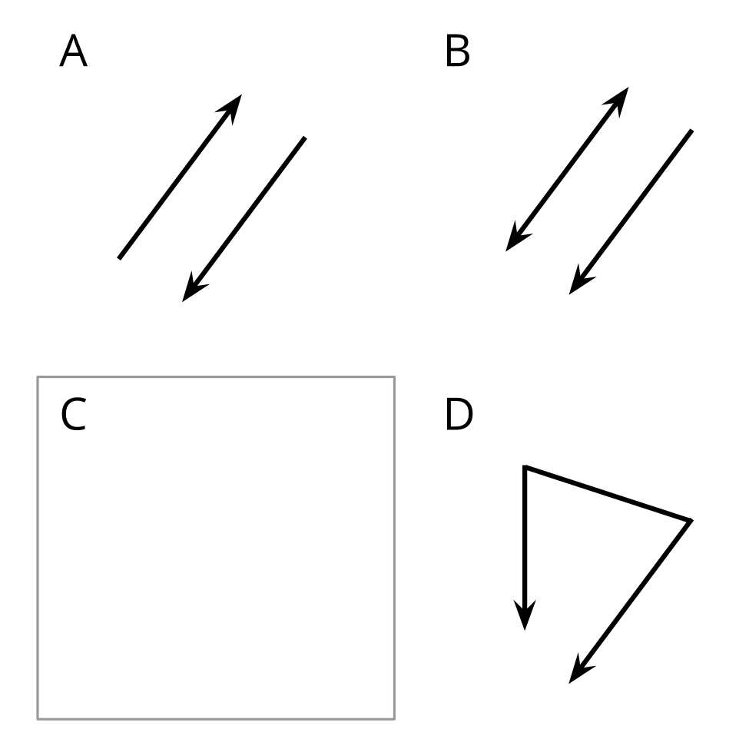
  - A, B, and D all belong because . . .
  - A doesn't belong because . . .
  - B doesn't belong because . . .
  - D doesn't belong because . . .
  - Add a new item C. It belongs because . . .
  - It doesn't belong because . . .

11.2: Add Two That Don’t Belong
Here is an incomplete Which One Doesn’t Belong set. It has two missing items.
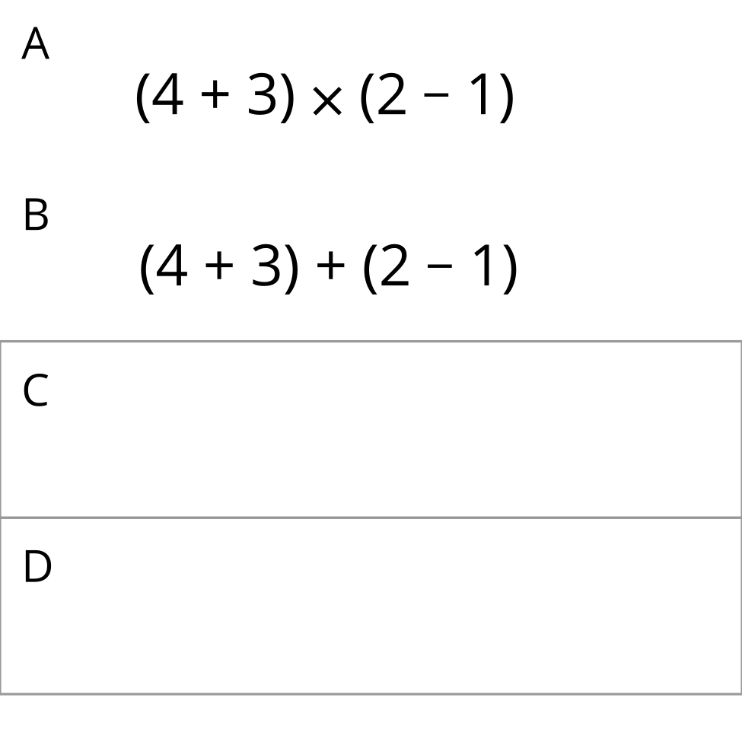
- Find at least one reason that the first two items, A and B, belong in the set.
- Add two items to complete the set. Make sure there is at least one reason that each new item belongs and at least one reason it doesn’t belong.
  - C and D both belong because . . .
  - C doesn't belong because . . .
  - D doesn't belong because . . .
- After you’ve completed the set, check items A and B. Does each one still have a reason not to belong? If not, adjust your new items so that A and B are each still unique in some way.

11.3: Add Three That Don’t Belong
Here is an incomplete Which One Doesn’t Belong set. It has three missing items.
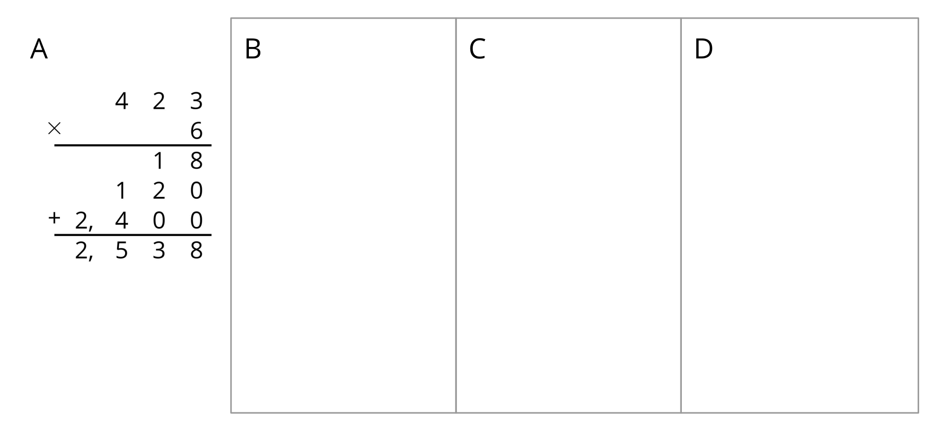
Add three items to complete the set. Make sure there is at least one reason that all items belong and at least one reason each item doesn’t belong.
- They all belong in the set because . . .
- A doesn't belong because . . .
- B doesn't belong because . . .
- C doesn't belong because . . .
- D doesn't belong because . . .
© CC BY 2021 Illustrative Mathematics®

