Unit 7 Lesson 5 Cumulative Practice Problems
- Segments $AB$, $DC$, and $EC$ intersect at point $C$. Angle $DCE$ measures ${148}^{∘}$. Find the value of $x$.
- 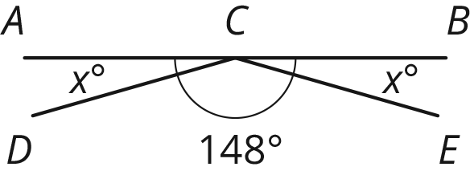
- Line $ℓ$ is perpendicular to line $m$. Find the value of $x$ and $w$.
- 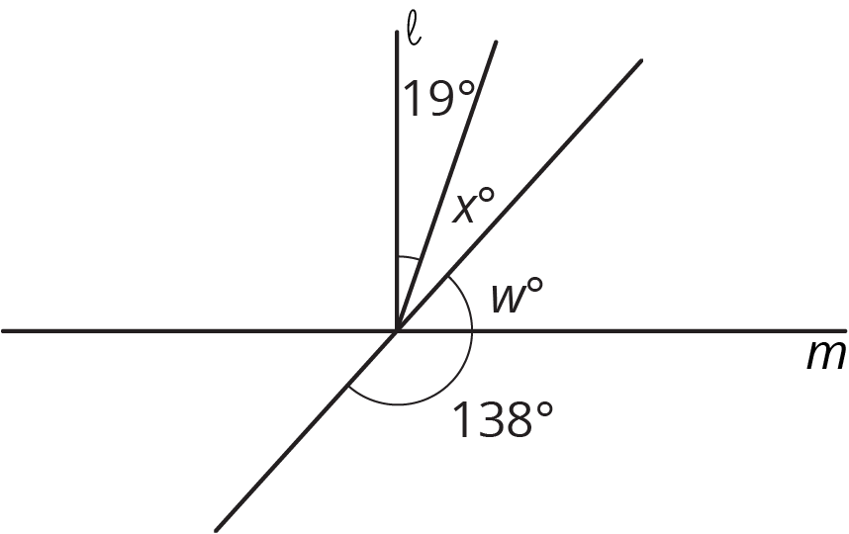
- If you knew that two angles were complementary and were given the measure of one of those angles, would you be able to find the measure of the other angle? Explain your reasoning.
- For each inequality, decide whether the solution is represented by $x<4.5$ or $x>4.5$.
  - $\text{-}24>\text{-}6(x−0.5)$
  - $\text{-}8x+6>\text{-}30$
  - $\text{-}2(x+3.2)<\text{-}15.4$
- (From Unit 6, Lesson 15.)
- A runner ran $\frac{2}{3}$ of a 5 kilometer race in 21 minutes. They ran the entire race at a constant speed.
  - How long did it take to run the entire race?
  - How many minutes did it take to run 1 kilometer?
- (From Unit 4, Lesson 2.)
- Jada, Elena, and Lin walked a total of 37 miles last week. Jada walked 4 more miles than Elena, and Lin walked 2 more miles than Jada. The diagram represents this situation:
- 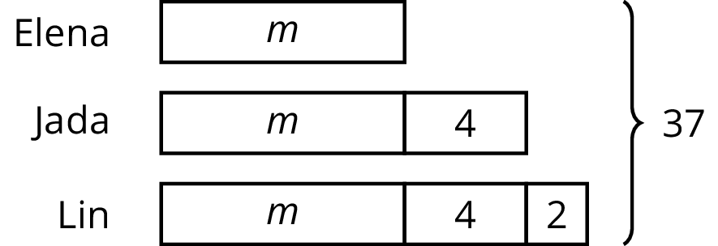

- Find the number of miles that they each walked. Explain or show your reasoning.
- (From Unit 6, Lesson 12.)
- Select all the expressions that are equivalent to $\text{-}36x+54y−90$.
  - $\text{-}9(4x−6y−10)$
  - $\text{-}18(2x−3y+5)$
  - $\text{-}6(6x+9y−15)$
  - $18(\text{-}2x+3y−5)$
  - $\text{-}2(18x−27y+45)$
  - $2(\text{-}18x+54y−90)$
- (From Unit 6, Lesson 19.)
© CC BY Open Up Resources. Adaptations CC BY IM.

