Lesson 15: Animal Shape Stamp Art
- Let’s make animals out of shapes.

Warm-up: Notice and Wonder: Animals at the Watering Hole
What do you notice?
What do you wonder?
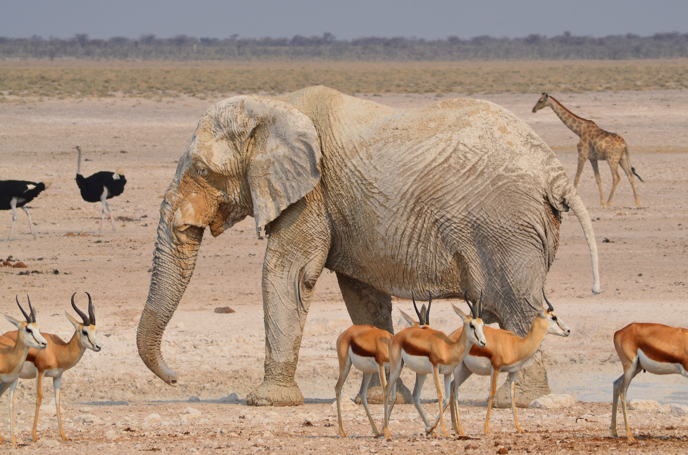

15.1: Animal Print Making
Use the shape stamps to create an animal.
© CC BY 2021 Illustrative Mathematics®

