Lesson 12: Lots and Lots of Garbage
- Let’s investigate what happens to garbage.

Warm-up: Notice and Wonder: Garbage Truck
What do you notice? What do you wonder?
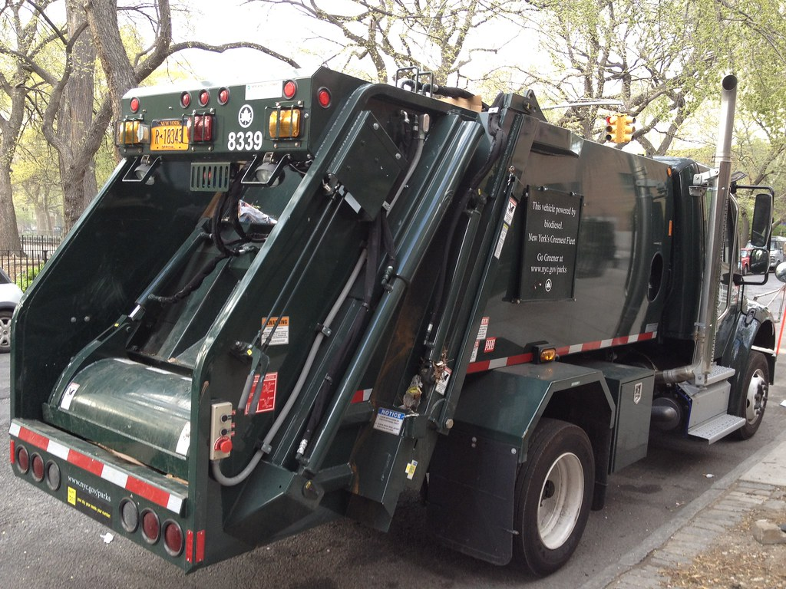

12.1: 60 Containers
- Find at least 5 different ways to arrange 60 containers. Represent each arrangement with an expression.
- 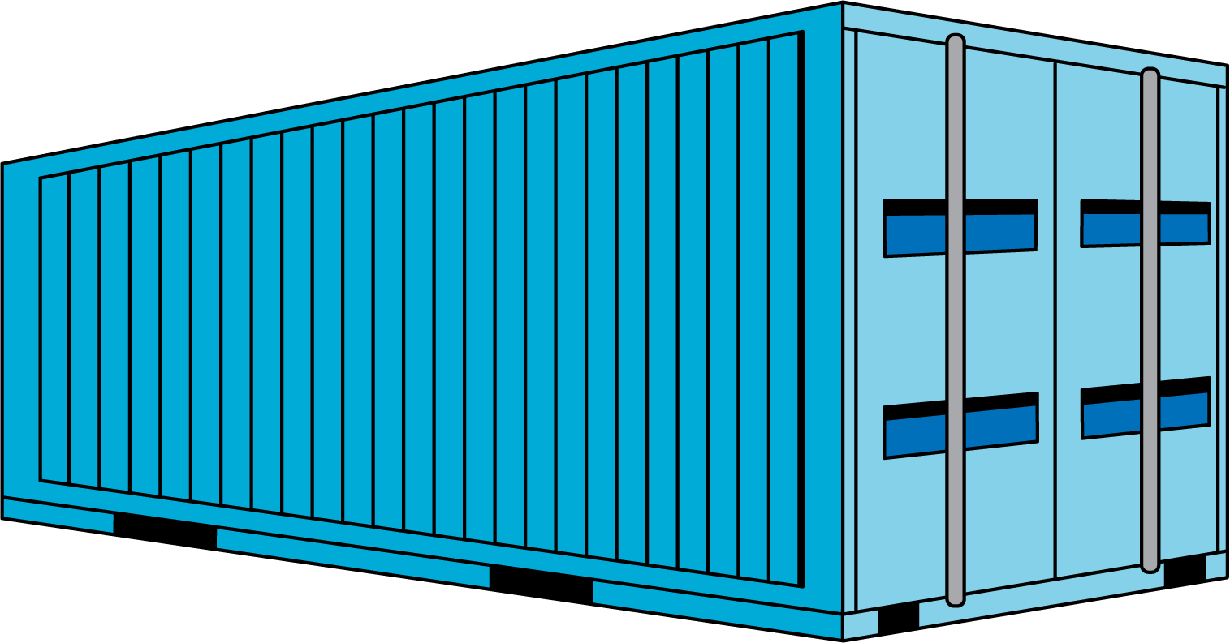
- Create a visual display to show which is the best arrangement for shipping the 3,300 tons of garbage.

12.2: How Many Containers on the Ship?
- How many containers are on the cargo ship?
- Record an estimate that is:
- too low | - about right | - too high
- How many containers are on the cargo ship?
- Record an estimate that is:
- too low | - about right | - too high
- What assumptions were you making when you came up with your estimates?
© CC BY 2021 Illustrative Mathematics®

