Lesson 11: Fractional Side Lengths Greater Than 1

Standards Alignments
Addressing | 5.NF.B.3, 5.NF.B.4.b

Teacher-facing Learning Goals
- Find the area of a rectangle with one fractional side length greater than 1 in a way that makes sense to them.
- Represent the area of a rectangle with a multiplication expression.

Student-facing Learning Goals
- Let’s find the area of more rectangles.

Lesson Purpose
The purpose of this lesson is for students to find the area of a rectangle where one of the side lengths is a fraction greater than 1.
In previous lessons, students multiplied fractions by whole numbers and found the area of rectangles with one fractional side length when the fraction was less than 1. They used visual representations to support their reasoning. For example, students use this picture to explain why $\frac{2}{3}×4=\left(2×4\right)×\frac{1}{3}$.
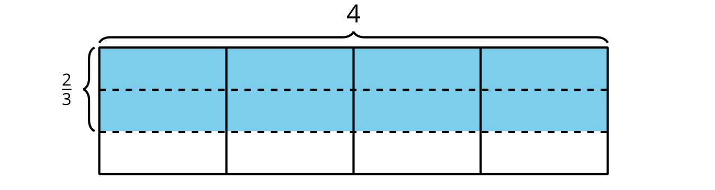
In this lesson, students apply these strategies to find the area of a rectangle with a fractional side length greater than 1.
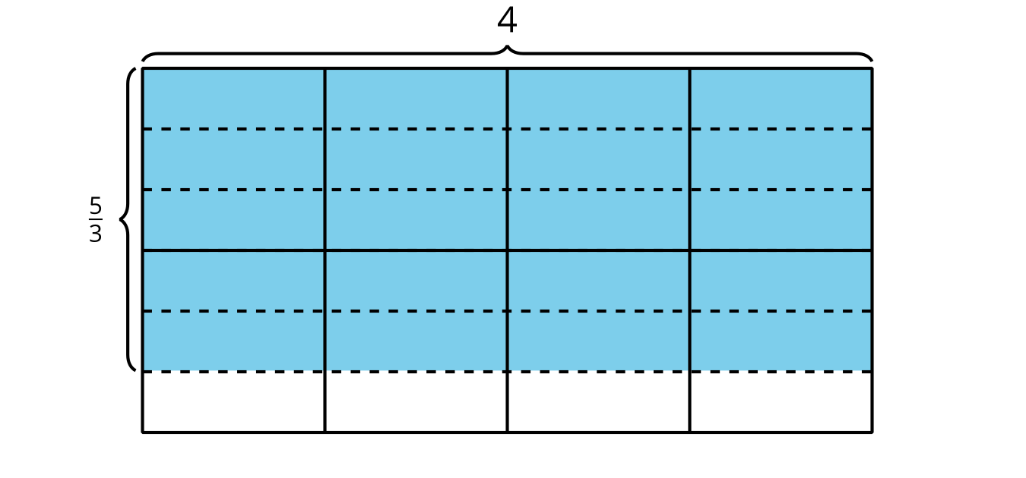
Using an area diagram like this, the same reasoning shows that $\frac{5}{3}×4=\left(5×4\right)×\frac{1}{3}$.

Access for:

Students with Disabilities
- Engagement (Activity 2)

English Learners
- MLR8 (Activity 1)

Instructional Routines
5 Practices (Activity 1), True or False (Warm-up)

Lesson Timeline
Warm-up | 10 min
Activity 1 | 20 min
Activity 2 | 15 min
Lesson Synthesis | 10 min
Cool-down | 5 min

Teacher Reflection Question
- Why is it important for students to be able to write and interpret different expressions to represent and find the area of rectangles with fractional side lengths?

Cool-down
(to be completed at the end of the lesson) 5min
Find the Area

Standards Alignments
Addressing | 5.NF.B.4.b

Student-facing Task Statement
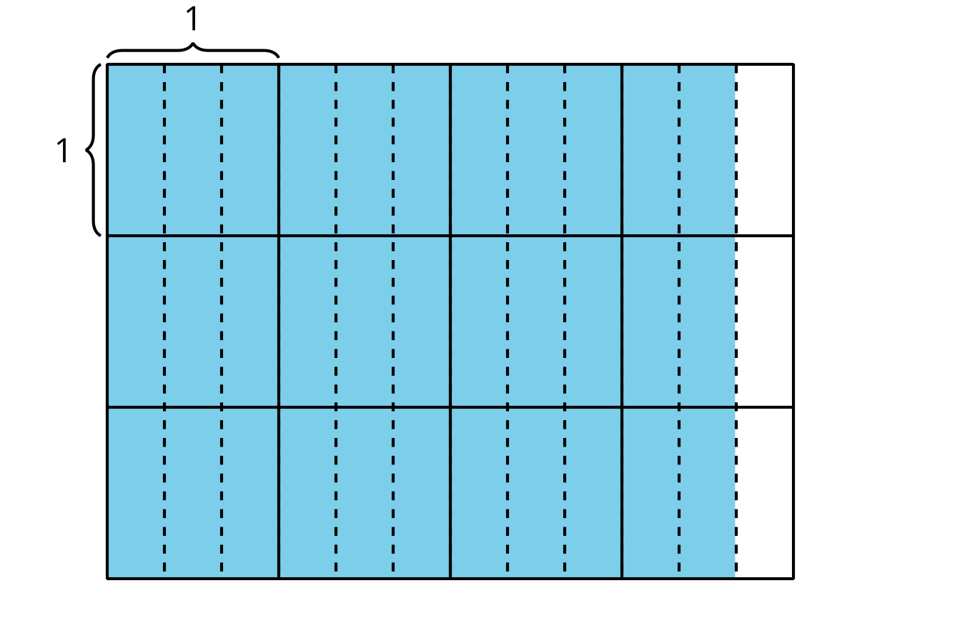
- Write a multiplication expression to represent the area of the shaded region.
- What is the area of the shaded region?

Student Responses
- $3×\frac{11}{3}$ or $\frac{11}{3}×3$ or $\frac{11×3}{3}$ or $\frac{3×11}{3}$
- 11 square units or equivalent

