Lesson 23 Practice Problems
- Select all the identities:​​​​
  - $(x+2)^{3}=x^{3}+8$
  - $(x^{6}+x)=(x−1)(x^{5}+x^{4}+x^{3}+x^{2}+x)$
  - $(x^{2}−1)(x^{4}+x^{2}+1)=x^{6}−1$
  - $(x+1)^{4}=x^{4}+x^{3}+x^{2}+x+1$
  - $(x+1)(x^{4}−x^{3}+x^{2}−x+1)=x^{5}+1$
  - $(x^{3}−1)(x^{3}+1)=x^{6}−1$
- Is $2(x+1)^{2}=(2x+2)^{2}$ an identity? Explain or show your reasoning.
- Mai is solving the rational equation $5=\frac{2+7x}{x}$ for $x$. What move do you think Mai would make first to solve for $x$? Explain your reasoning.
- For $x$-values of 0 and -2, $(x^{5}+32)=(x+2)^{5}$. Does this mean the equation is an identity? Explain your reasoning.
- Clare finds an expression for $S(r)$ that gives the surface area in square inches of any cylindrical can with a specific fixed volume, in terms of its radius $r$ in centimeters. This is the graph Clare gets if she allows $r$ to take on any value between -1.2 and 3.
  - What would be a more appropriate domain for Clare to use instead?
  - What is the approximate minimum surface area for her can?
- 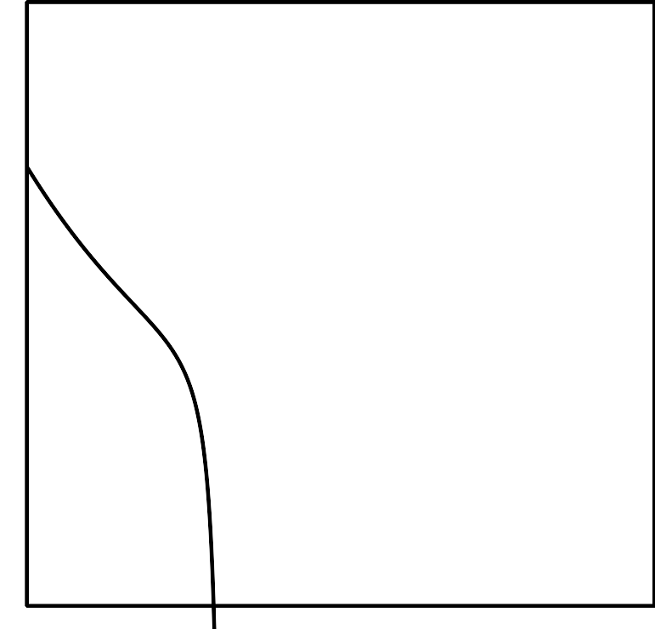
- (From Unit 2, Lesson 16.)
- Which values of $x$ make $\frac{3x+1}{x}=\frac{1}{x−3}$ true?
- (From Unit 2, Lesson 22.)
© CC BY 2019 by Illustrative Mathematics®

