Lesson 12: Order Numbers
- Let’s put numbers in order.

Warm-up: Number Talk: Subtract Tens
Find the value of each expression mentally.
- $80−50$
- $87−50$
- $76−40$
- $66−30$

12.1: Who is Out of Order?
Kiran and Andre put a list of numbers in order from least to greatest.
Kiran
207, 217, 272, 269, 290
Andre
207, 217, 269, 272, 290
Andre disagreed with Kiran, so he used a number line to justify his answer.
Who do you agree with? Why?
Be prepared to explain your thinking. Use what you know about place value or the number line to justify your reasoning.

12.2: Order Numbers
- Estimate the location of 839, 765, 788, 815, and 719 on the number line. Mark each number with a point. Label the point with the number it represents.
- Order the numbers from least to greatest.
- _______, _______, _______, _______, _______
- Estimate the location of 199, 245, 173, 218, and 137 on the number line. Mark each number with a point. Label the point with the number it represents.
- Order the numbers from greatest to least.
- _______, _______, _______, _______, _______
- Order the numbers from least to greatest.
- 545, 454, 405, 504, and 445
- _______, _______, _______, _______, _______
- Explain or show your thinking. Use the number line if it helps.
- Was it more helpful for you to put the numbers in order first or put them on the number line first? Explain.
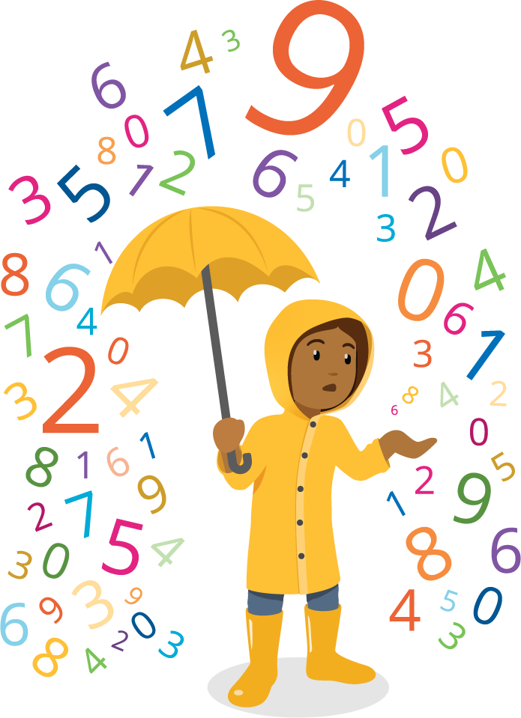

Section Summary
Section Summary
In this section, we learned how to compare three-digit numbers. We used number lines, base-ten diagrams, and the value of the digits in base-ten numerals to help us compare and explain our thinking.
Diagrams are helpful when comparing numbers because you can see and compare hundreds to hundreds, tens to tens, and ones to ones. We learned that you can do this with the digits too.
The number line shows the numbers in order, so we can see which number is the largest based on its location.
We also wrote expressions using the $>$, $<$, and $=$ symbols.
$432>424$
432 is greater than 424
$424<432$
424 is less than 432
© CC BY 2021 Illustrative Mathematics®

