Unit 6 Lesson 15: Identify Pennies, Nickels, and Dimes

WU What Do You Know About Money? (Warm up)

Student Task Statement
What do you know about money?

1 Show Me the Money

Images for Launch
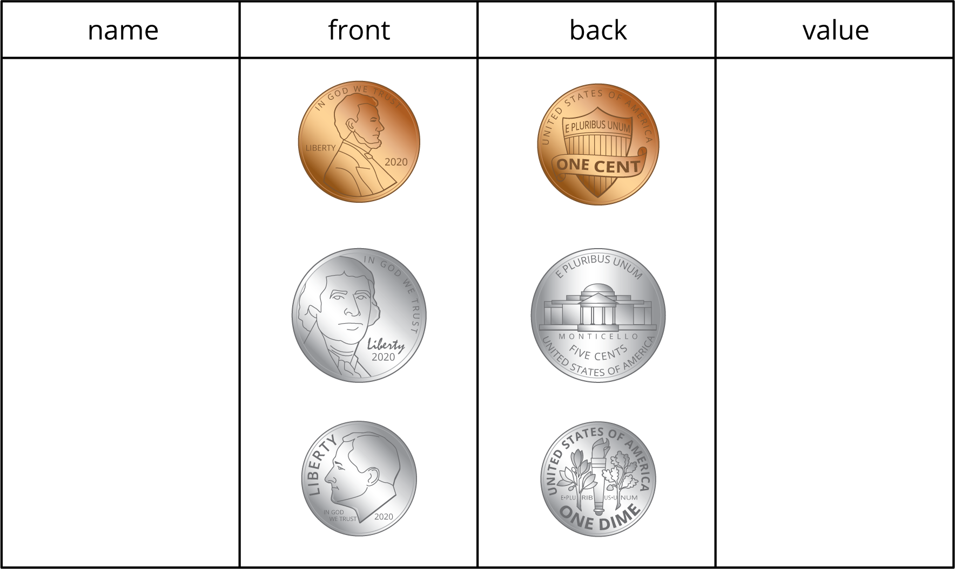

Student Task Statement
Name the coins in each group and find the value in cents. Show your thinking using numbers, words, drawings, or equations.
- Andre’s coins:
- 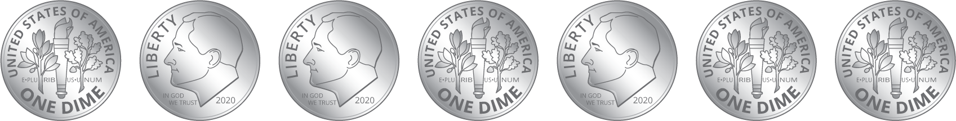
  - Circle the name of the coins in this collection:
  - dimes
  - nickels
  - pennies
  - What is the value of the coins?
- Clare’s coins:
- 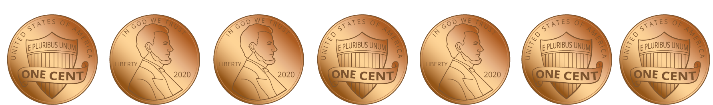
  - Circle the name of the coins in this collection:
  - dimes
  - nickels
  - pennies
  - What is the value of the coins?
- Han’s coins:
- 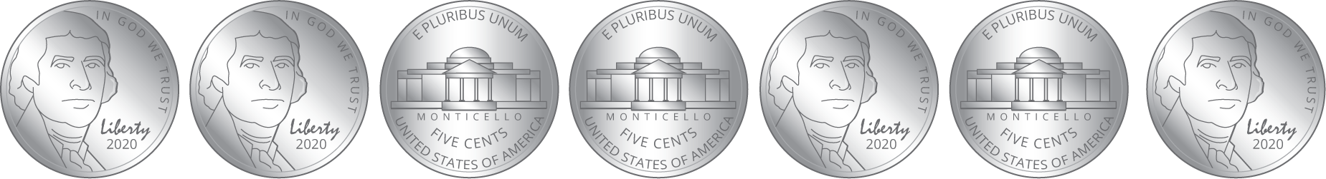
  - Circle the name of the coins in this collection:
  - dimes
  - nickels
  - pennies
  - What is the value of the coins?
- Show 2 different ways to make 10¢ using numbers, words, or drawings.

2 Compare Coins

Student Task Statement
Name the coins in each group and find the value in cents. Show your thinking using numbers, words, drawings, or equations.
- Mai’s coins:
- 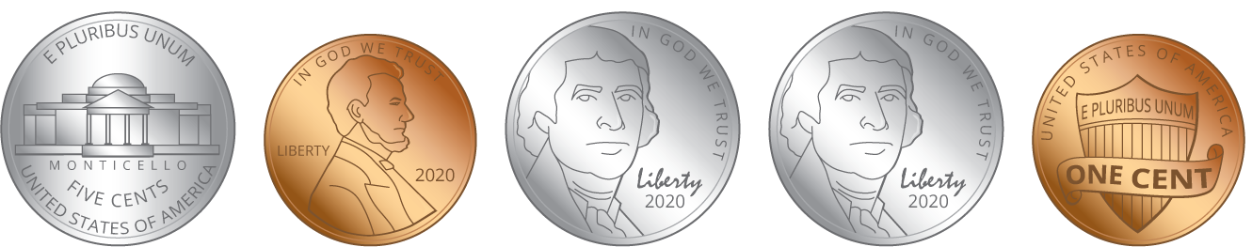
  - Circle the names of the coins in this collection:
  - dimes
  - nickels
  - pennies
  - What is the value of the coins?
- Andre’s coins:
- 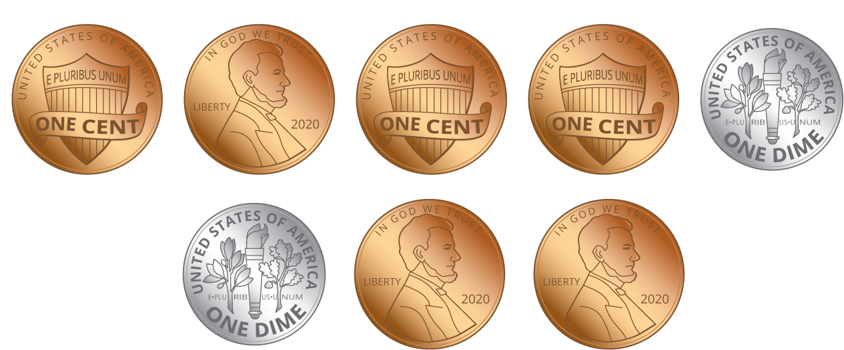
  - Circle the names of the coins in this collection:
  - dimes
  - nickels
  - pennies
  - What is the value of the coins?
- Clare’s coins:
- 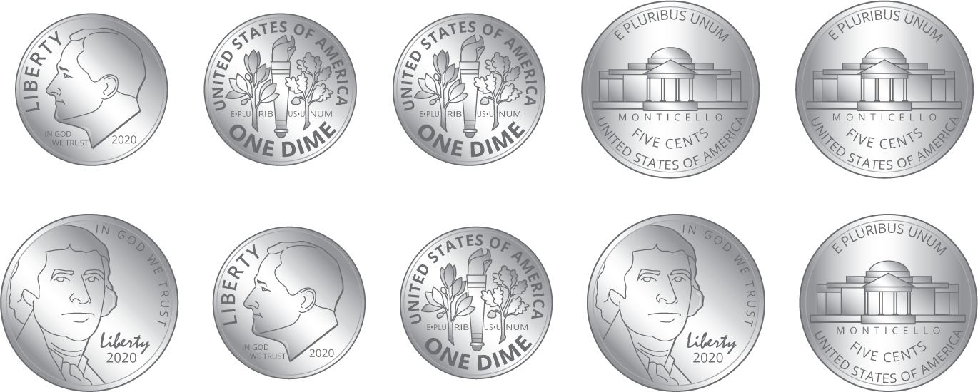
  - Circle the names of the coins in this collection:
  - dimes
  - nickels
  - pennies
  - What is the value of the coins?
- Priya’s coins:
- 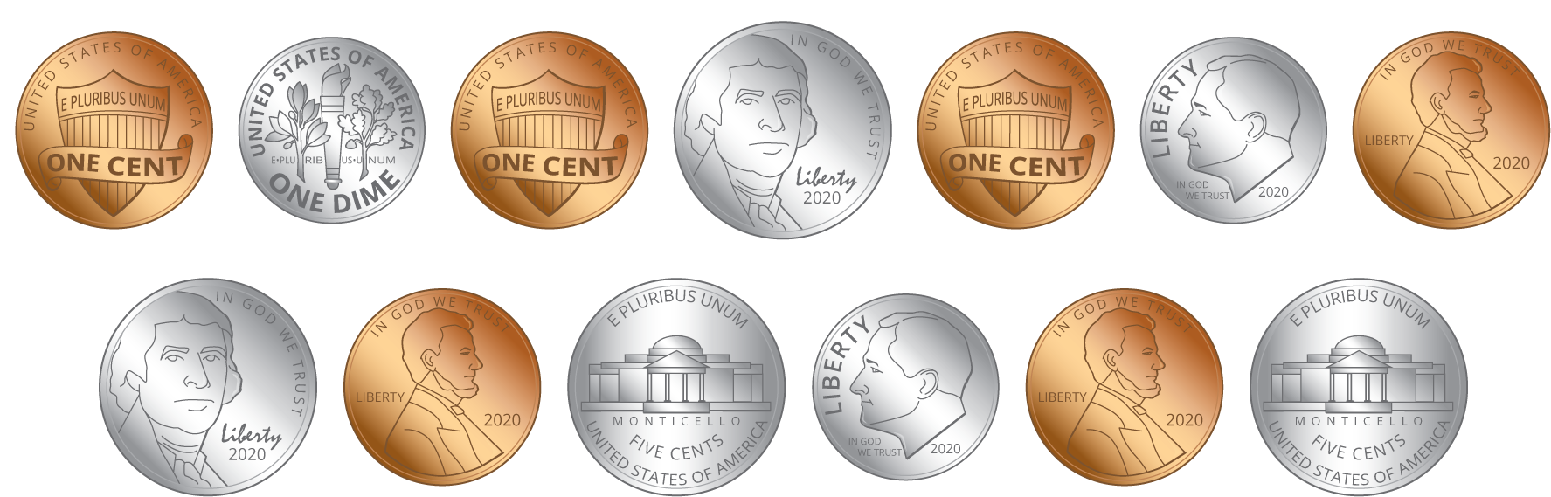
  - Circle the names of the coins in this collection:
  - dimes
  - nickels
  - pennies
  - What is the value of the coins?
- Compare your coin names and how you found the values with your partner.
- Whose group of coins has the least value?
- Who has the most coins? Does this group of coins have the greatest value? Explain.

Images for Activity Synthesis
© CC BY 2021 Illustrative Mathematics®

