Lesson 13: Find Angle Measurements
- Let’s compose and decompose angles to find their measurements.

Warm-up: Notice and Wonder: Corner Pieces
What do you notice? What do you wonder?
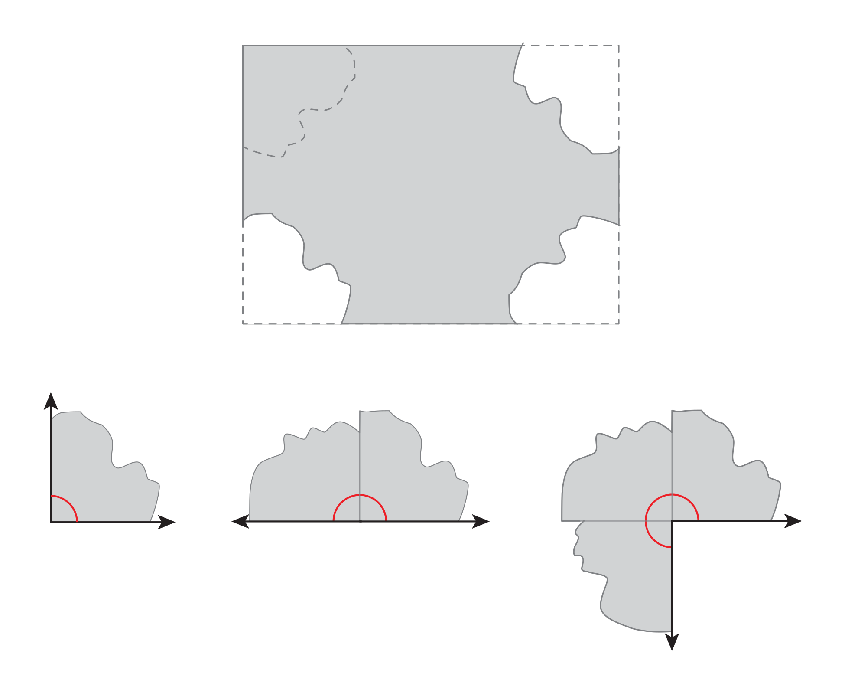

13.1: How Big Are These Angles?
Your teacher will give you materials that can help you find angle measurements.
- Use the materials and what you know about a right angle to find the size of angles $p$, $q$, $r$, and $s$. Be prepared to explain or show your reasoning.
- 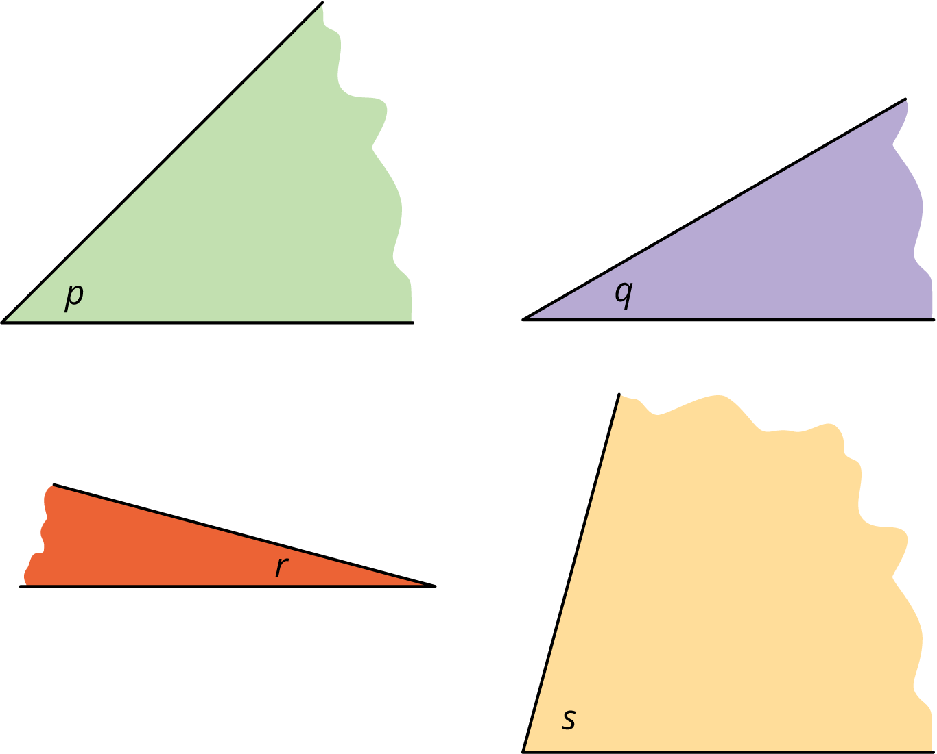
- Next, use the measurements of angles $p$, $q$, $r$, and $s$ to find the measurements of the following angles.
- 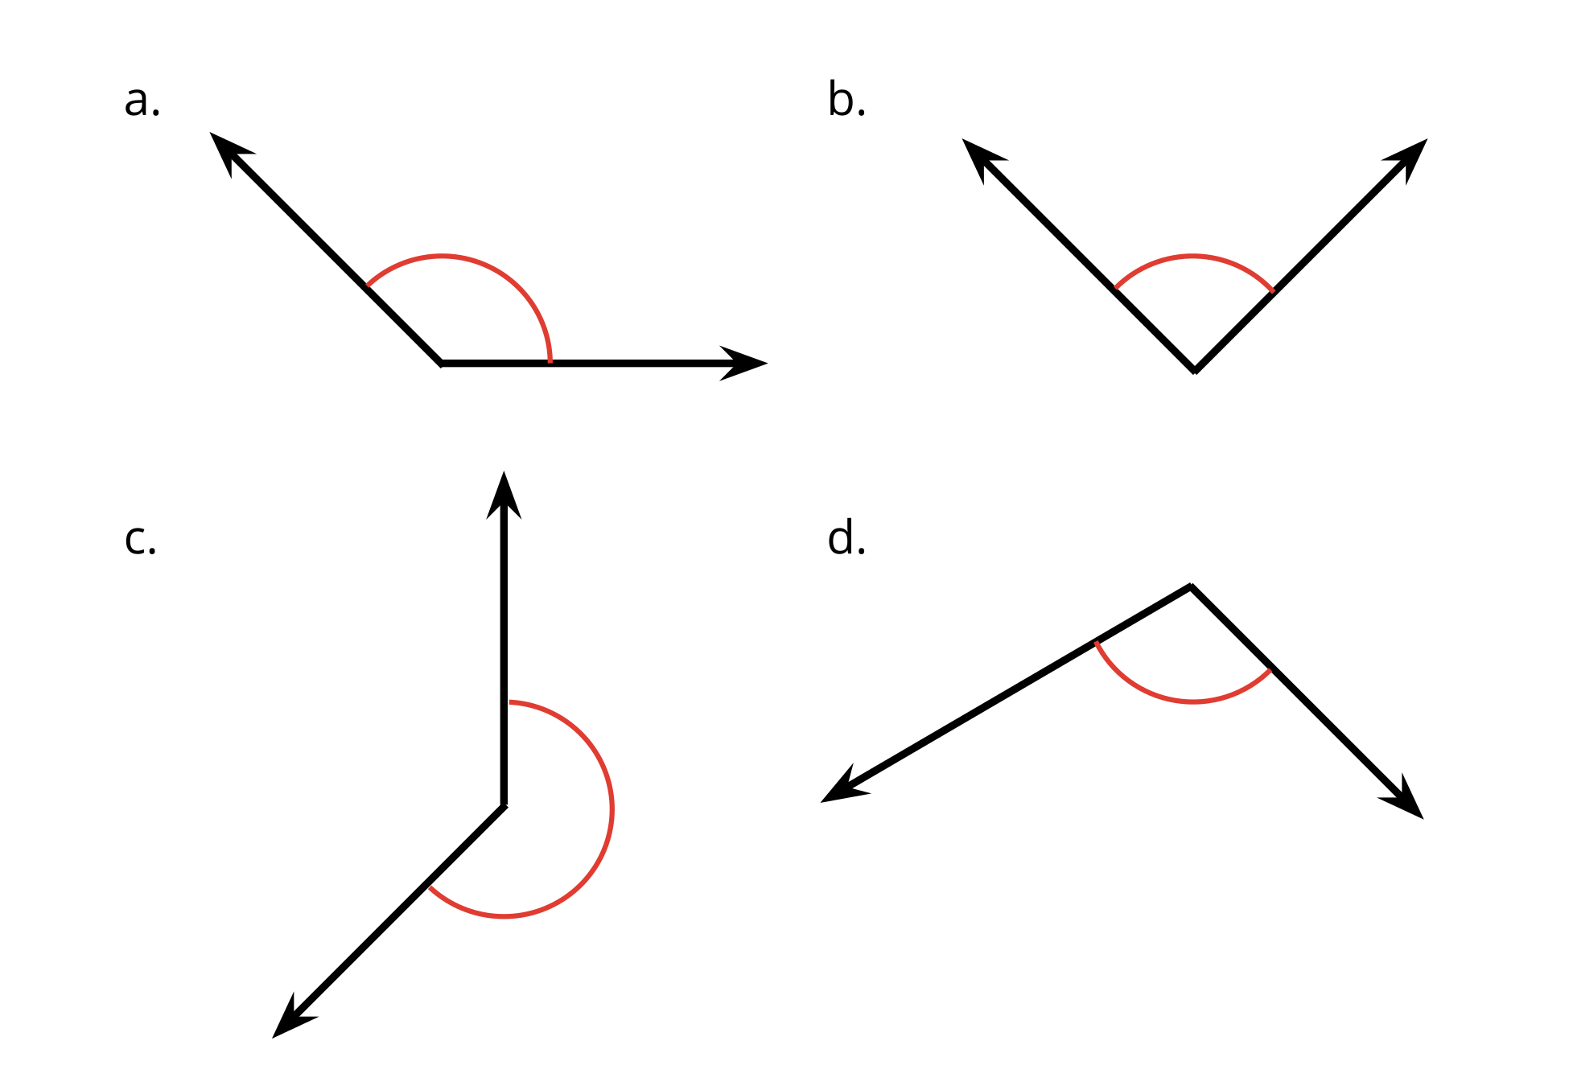

13.2: Angles in a Kite
Your teacher will give you a square sheet of paper. Follow the steps to fold the paper into a kite. Fold as precisely as possible.
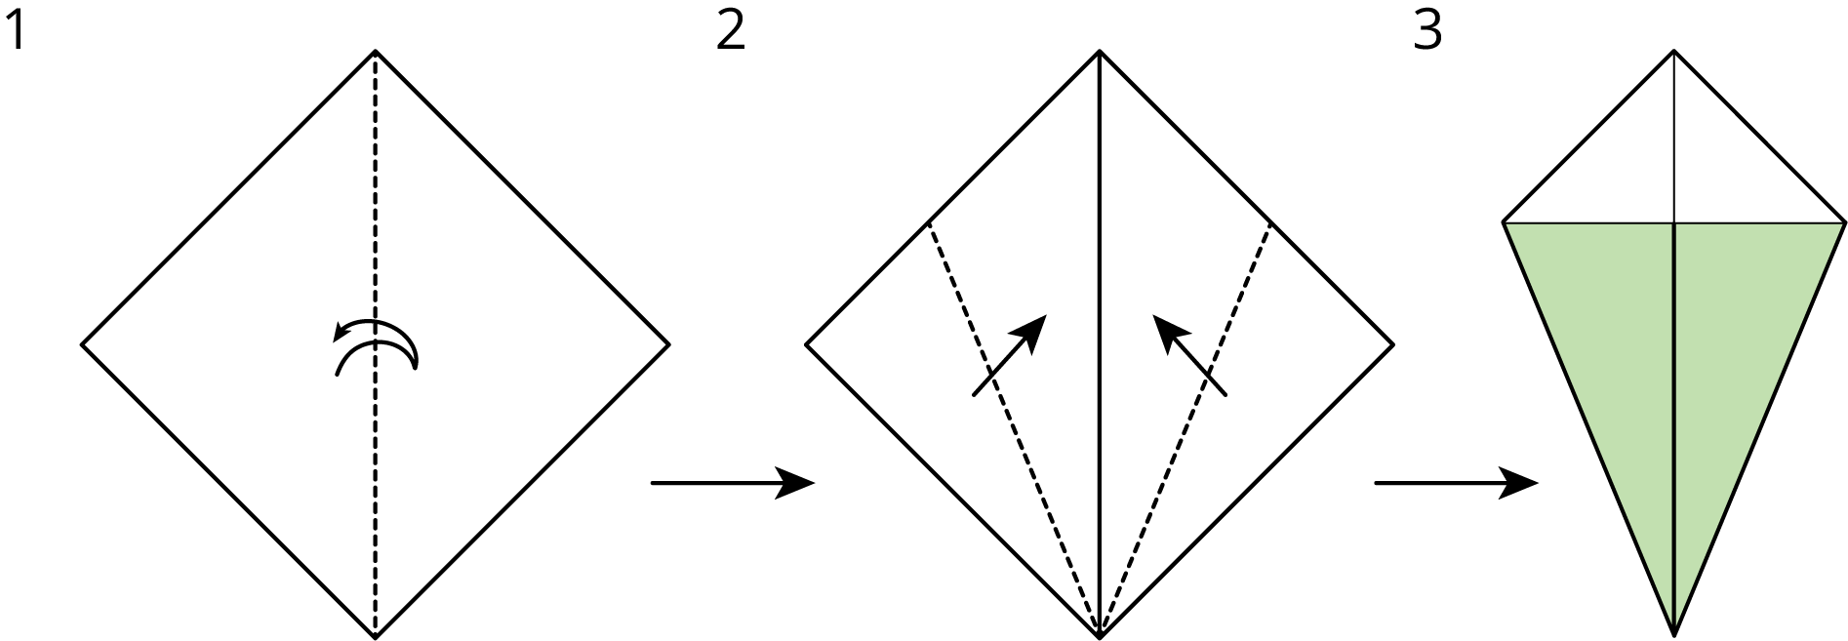
Can you find the measurement of each labeled angle on the kite? If so, show your reasoning. If not, explain why not.
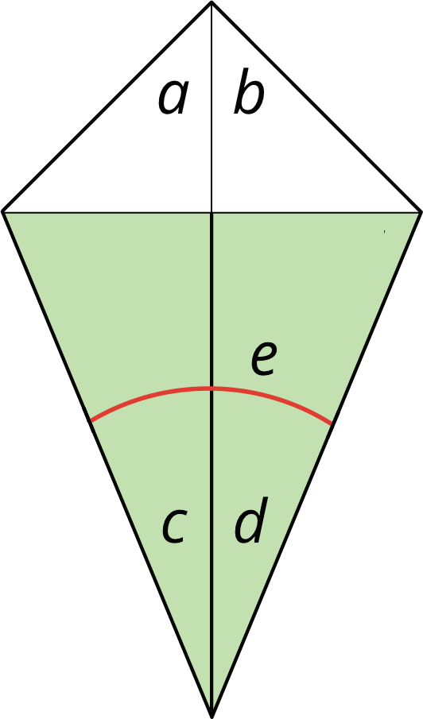
© CC BY 2021 Illustrative Mathematics®

