Unit 7 Lesson 4 Cumulative Practice Problems
- Evaluate:
  - ${10}^{0}$
  - $\frac{{10}^{3}}{{10}^{3}}$
  - ${10}^{2}+{10}^{1}+{10}^{0}$
- Write each expression as a single power of 10.
  - $\frac{{10}^{3}⋅{10}^{4}}{{10}^{5}}$
  - $({10}^{4})⋅\frac{{10}^{12}}{{10}^{7}}$
  - ${\left(\frac{{10}^{5}}{{10}^{3}}\right)}^{4}$
  - $\frac{{10}^{4}⋅{10}^{5}⋅{10}^{6}}{{10}^{3}⋅{10}^{7}}$
  - $\frac{({10}^{5})^{2}}{({10}^{2})^{3}}$
- The Sun is roughly ${10}^{2}$ times as wide as Earth. The star KW Sagittarii is roughly ${10}^{5}$ times as wide as Earth. About how many times as wide as the Sun is KW Sagittarii? Explain how you know.
- Bananas cost $1.50 per pound, and guavas cost $3.00 per pound. Kiran spends $12 on fruit for a breakfast his family is hosting. Let $b$ be the number of pounds of bananas Kiran buys and $g$ be the number of pounds of guavas he buys.
  - Write an equation relating the two variables.
  - Rearrange the equation so $b$ is the independent variable.
  - Rearrange the equation so $g$ is the independent variable.
- (From Unit 5, Lesson 3.)
- Lin’s mom bikes at a constant speed of 12 miles per hour. Lin walks at a constant speed $\frac{1}{3}$ of the speed her mom bikes. Sketch a graph of both of these relationships.
- 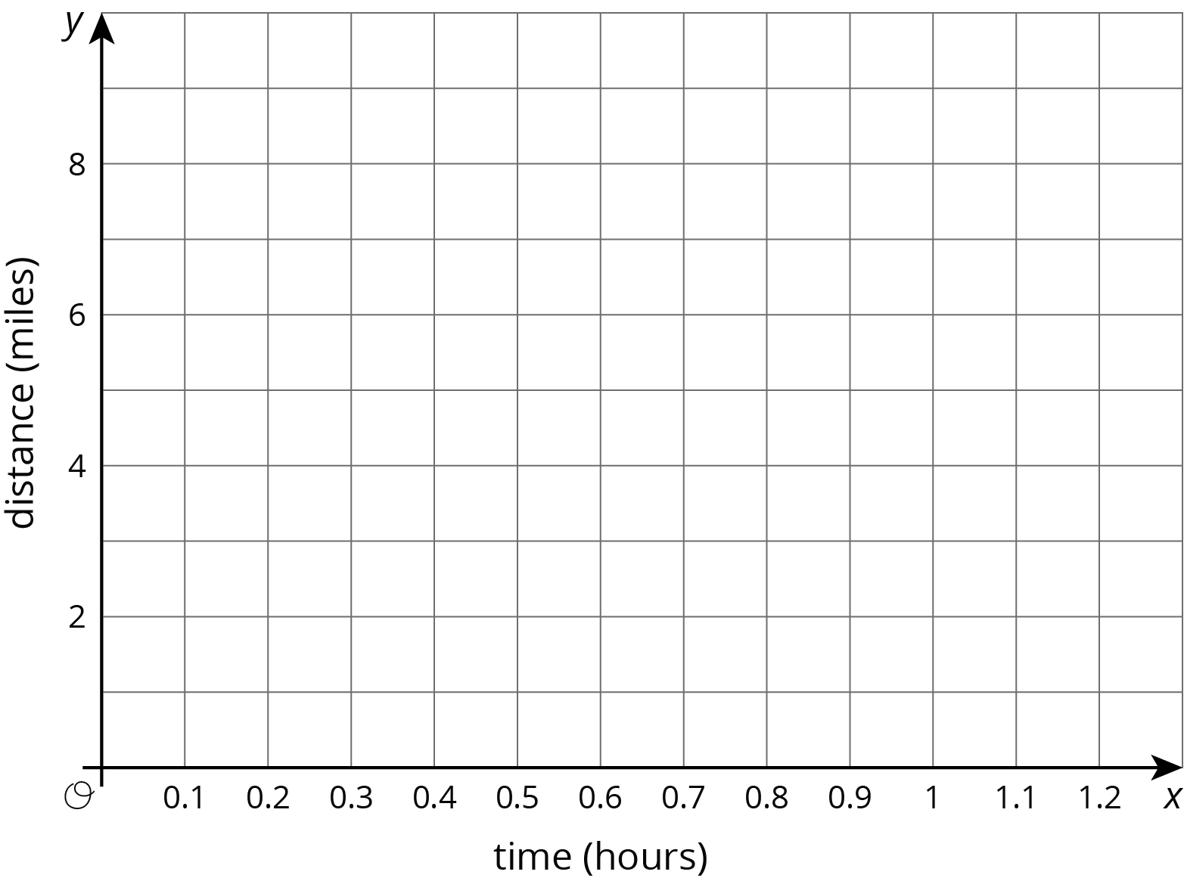
- (From Unit 3, Lesson 1.)
© CC BY Open Up Resources. Adaptations CC BY IM.

