Lesson 9: Multiplying Rational Numbers

9.1: Before and After
Where was the girl:
- 5 seconds after this picture was taken? Mark her approximate location on the picture.
- 5 seconds before this picture was taken? Mark her approximate location on the picture.

9.2: Backwards in Time
A traffic safety engineer was studying travel patterns along a highway. She set up a camera and recorded the speed and direction of cars and trucks that passed by the camera. Positions to the east of the camera are positive, and to the west are negative.
- Here are some positions and times for one car:
- position (feet) | - -180 | - -120 | - -60 | - 0 | - 60 | - 120
- time (seconds) | - -3 | - -2 | - -1 | - 0 | - 1 | - 2
  - In what direction is this car traveling?
  - What is its velocity?
  - What does it mean when the time is zero?
  - What could it mean to have a negative time?
- Here are the positions and times for a different car whose velocity is -50 feet per second:
- position (feet) |  |  |  | - 0 | - -50 | - -100
- time (seconds) | - -3 | - -2 | - -1 | - 0 | - 1 | - 2
  - Complete the table with the rest of the positions.
  - In what direction is this car traveling? Explain how you know.
- Complete the table for several different cars passing the camera.
 | - velocity  (meters per  second) | - time after passing  the camera  (seconds) | - ending  position  (meters) | - equation
- car C | - +25 | - +10 | - +250 | - $25⋅10=250$
- car D | - -20 | - +30
- car E | - +32 | - -40
- car F | - -35 | - -20
- car G | - -15 | - -8
  - If a car is traveling east when it passes the camera, will its position be positive or negative 60 seconds before it passes the camera?
  - If we multiply a positive number and a negative number, is the result positive or negative?
  - If a car is traveling west when it passes the camera, will its position be positive or negative 60 seconds before it passes the camera?
  - If we multiply two negative numbers, is the result positive or negative?

9.3: Cruising
Around noon, a car was traveling -32 meters per second down a highway. At exactly noon (when time was 0), the position of the car was 0 meters.
- Complete the table.
- time (s) | - -10 | - -7 | - -4 | - -1 | - 2 | - 5 | - 8 | - 11
- position (m)
- Graph the relationship between the time and the car's position.
- 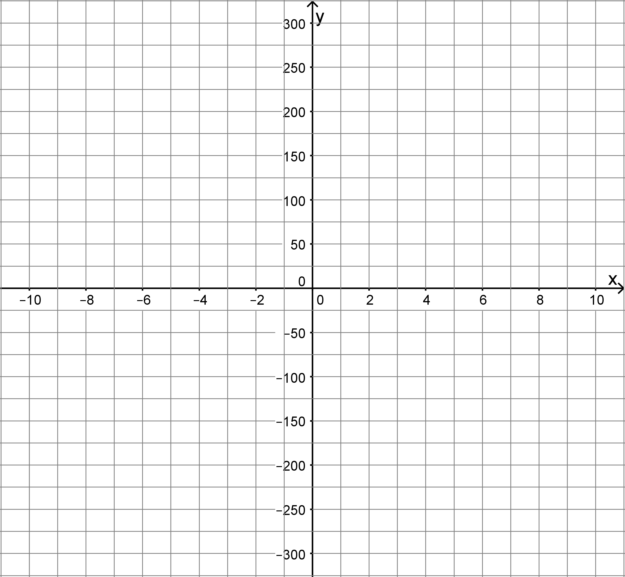
- What was the position of the car at -3 seconds?
- What was the position of the car at 6.5 seconds?

Are you ready for more?
Find the value of these expressions without using a calculator.
$(\text{-}1)^{2}$
$(\text{-}1)^{3}$
$(\text{-}1)^{4}$
$(\text{-}1)^{99}$

9.4: Rational Numbers Multiplication Grid
- Complete the shaded boxes in the multiplication square.
- 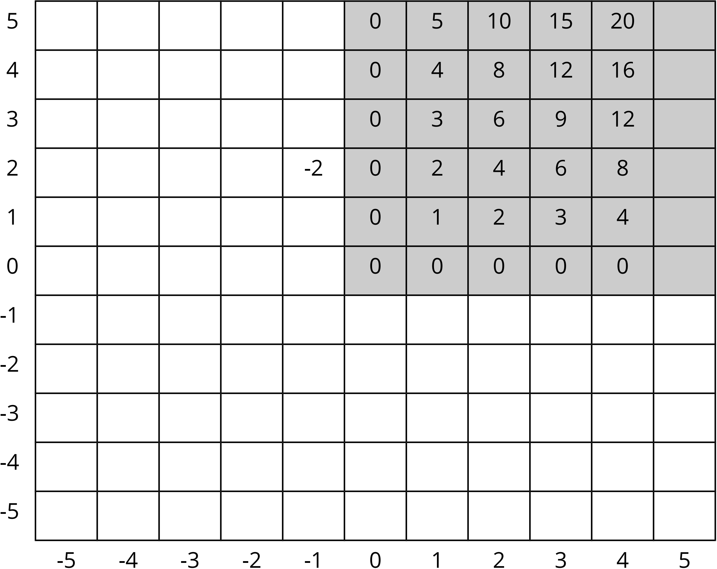
- Look at the patterns along the rows and columns. Continue those patterns into the unshaded boxes.
- Complete the whole table.
- What does this tell you about multiplication with negative numbers?

Lesson 9 Summary
We can use signed numbers to represent time relative to a chosen point in time. We can think of this as starting a stopwatch. The positive times are after the watch starts, and negative times are times before the watch starts.
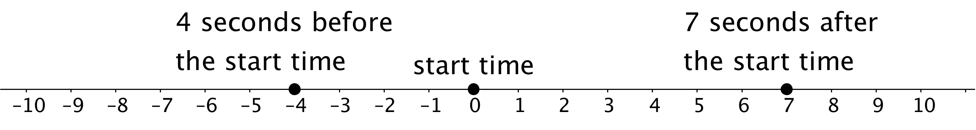
If a car is at position 0 and is moving in a positive direction, then for times after that (positive times), it will have a positive position. A positive times a positive is positive.
If a car is at position 0 and is moving in a negative direction, then for times after that (positive times), it will have a negative position. A negative times a positive is negative.
If a car is at position 0 and is moving in a positive direction, then for times before that (negative times), it must have had a negative position. A positive times a negative is negative.
If a car is at position 0 and is moving in a negative direction, then for times before that (negative times), it must have had a positive position. A negative times a negative is positive.
Here is another way of seeing this:
We can think of $3⋅5$ as $5+5+5$, which has a value of 15.
We can think of $3⋅(\text{-}5)$ as $\text{-}5+\text{-}5+\text{-}5$, which has a value of -15.
We know we can multiply positive numbers in any order: $3⋅5=5⋅3$
If we can multiply signed numbers in any order, then $(\text{-}5)⋅3$ would also equal -15.
Now let’s think about multiplying two negatives.
We can find $\text{-}5⋅(3+\text{-}3)$ in two ways:
- Applying the distributive property:
$\text{-}5⋅3+\text{-}5⋅(\text{-}3)$
- Adding the numbers in parentheses:
$\text{-}5⋅(0)=0$
This means that these expressions must be equal.
$\text{-}5⋅3+\text{-}5⋅(\text{-}3)=0$
Multiplying the first two numbers gives
$\text{-}15+\text{-}5⋅(\text{-}3)=0$
Which means that
$\text{-}5⋅(\text{-}3)=15$
There was nothing special about these particular numbers. This always works!
- A positive times a positive is always positive.
- A negative times a positive or a positive times a negative is always negative.
- A negative times a negative is always positive.
© CC BY Open Up Resources. Adaptations CC BY IM.

