Unit 7 Lesson 6 Cumulative Practice Problems
- A rectangle has side lengths of 6 units and 3 units. Could you make a quadrilateral that is not identical using the same four side lengths? If so, describe it.
- Come up with an example of three side lengths that can not possibly make a triangle, and explain how you know.
- Find $x$, $y$, and $z$.
- 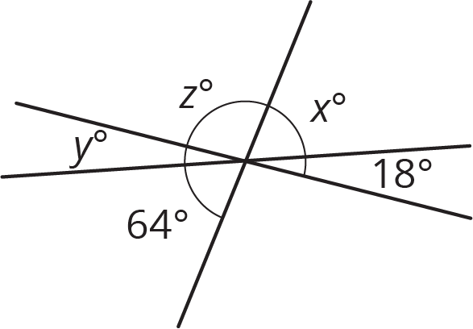
- (From Unit 7, Lesson 3.)
- How many right angles need to be put together to make:
  - 360 degrees?
  - 180 degrees?
  - 270 degrees?
  - A straight angle?
- (From Unit 7, Lesson 1.)
- Solve each equation.
- $\frac{1}{7}(x+\frac{3}{4})=\frac{1}{8}$
- $\frac{9}{2}=\frac{3}{4}(z+\frac{2}{3})$
- $1.5=0.6(w+0.4)$
- $0.08(7.97+v)=0.832$
- (From Unit 6, Lesson 8.)
  - You can buy 4 bottles of water from a vending machine for $7. At this rate, how many bottles of water can you buy for $28? If you get stuck, consider creating a table.
  - It costs $20 to buy 5 sandwiches from a vending machine. At this rate, what is the cost for 8 sandwiches? If you get stuck, consider creating a table.
- (From Unit 4, Lesson 3.)
© CC BY Open Up Resources. Adaptations CC BY IM.

